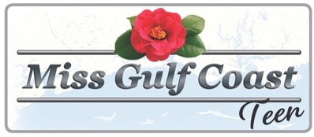
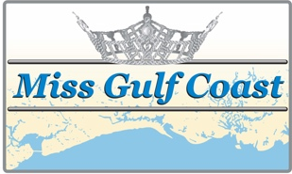
Sixty-Third Annual

Miss Gulf Coast
&
Miss Gulf Coast Teen

Advertising space is now available in the 2021 Miss Gulf Coast & Miss Gulf Coast Teen Program Book!
Please support providing scholarships to these incredible young women and the sight and hearing projects of the Biloxi Lions club by placing an order.

You may submit artwork, a business card or text you wish printed. If you have specific needs, please call Melinda Claytor Freeman at (228) 365-7878.
Please Email your order to Melinda.freeman@bxs.com
Deadline is Monday, November 15, 2021

Advertiser:______________________________________________________________

Address: ______________________________________________________________

City: _____________________________________ State: ___________ Zip: ___________________

Phone: ___________________________ E-Mail: _________________________________________

Contact Person: ___________________________________________________________________

Please check appropriate size:
Full Page ( 8 ½ x 5 ½) ______________ $100.00
¾ Page ( 6 5 ½ ) ______________ $ 80.00
½ Page. ( 4 ½ x 5 ½ ) ______________ $ 60.00
¼ Page. ( 2 ¼ x 5 ½ ) ______________ $. 40.00

Please bill me: (sign here) _________________________________________________________

Payment is enclosed: The Biloxi Lions Club
P.O. Box 196
Biloxi, MS 39533

Sold by: ______________________________________________________________________

