Record Range Training Facility

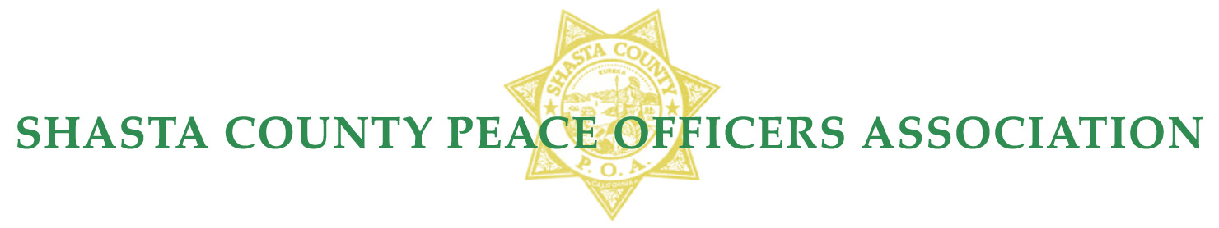
2020 Membership & Daily Rental Fees
SCPOA Membership Shasta County Law Enforcement Agencies:

Annual Agency Membership Fee, per member…….$ 168.00
Annual Active Membership Fee……………………$ 168.00
Annual Honorary Membership Fee………………....$ 168.00

SCPOA Retired L.E. Membership Fee (Shasta County resident & Requires ID for proof of retirement)

Retired LE Annual Membership dues………………$ 70.00
Retired LE Lifetime Membership dues (Over 50)….$ 500.00
Retired LE Lifetime Membership dues (Under 50)...$ 600.00

SCPOA Rental Fees – Members Only (Excludes L.E. Member Agency Training)

Clubhouse Only (Daily)……………………………..$ 225.00 *
Range only (Daily Per Range)…………………….....$ 175.00
Clubhouse & All Ranges (Daily)….…………………$ 700.00 *
Authorized CCW Classroom…………………..$ 75.00 up to 4 hours $100.00 up to 8 hours.

SCPOA Rental Fees – Non- Members (Requires Board Approval)

Clubhouse Only (Daily)……………………….……..$ 450.00 *
Range Only (Daily Per Range)……………………… $1,500.00
(Daily Two Ranges)……………………..$2,500.00
(Daily All Ranges)………………………$3,500.00
Clubhouse & All Ranges (Daily).…………………… $3,500.00 *
Non-Member attending LE Agency Training………...$ 75.00
Non-Member HR 218 Qualification (Daily).…………$ 25.00
Non-Member Qualification (Daily)…………………...$ 25.00

All rental fees are payable prior to use, unless approved by the Board of Directors.

* A $250.00 security deposit and a completed “Clubhouse Rental Agreement” will be required for use of the Clubhouse before access.

Pursuant to the By-Laws of SCPOA the Board of Directors approved these rates on September 10, 2018.

