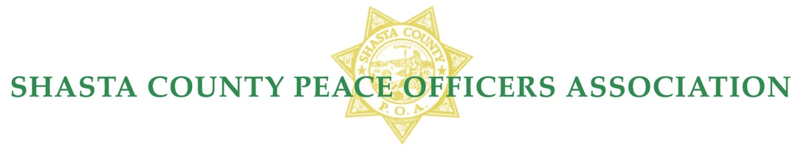
Record Range Training Facility
2021Membership & Daily Rental Fees
SCPOA Membership Shasta County Law Enforcement Agencies:

Annual Agency Membership Fee, per member…….$192.00
Annual Active Membership Fee……………………$ 192.00
Annual Honorary Membership Fee………………....$ 192.00

SCPOA Retired L.E. Membership Fee (Shasta County resident &Requires ID for proof of retirement)

Retired LE Annual Membership dues………………$ 70.00
Retired LE Lifetime Membership dues (Over 50)….$ 500.00
Retired LE Lifetime Membership dues (Under 50)...$ 600.00

SCPOA Rental Fees – Members Only (Excludes L.E.Member Agency Training)

Clubhouse Only (Daily)……………………………..$ 225.00*
Range only (Daily Per Range)……………………....$175.00
Clubhouse & All Ranges (Daily)….………………...$ 700.00*

SCPOA Rental Fees– Non- Members (Requires Board Approval)

Clubhouse Only (Daily)………….…………….……..$ 450.00 *
Range Only (Daily Per Range)……………………… $1,500.00
(Daily Two Ranges)……………………..$2,500.00
(Daily All Ranges)………………………$3,500.00
For Profit Rental ……………………………………...$ 300.00 per range**
($25 per student/shooter**)
Authorized CCW Classroom…………………..$ 75.00 up to 4 hours $100.00 up to 8 hours.
Non-Member attending LE Agency Training………...$ 75.00
Non-Member HR 218 Qualification (Daily).…………$ 25.00
Non-Member Qualification (Daily)…………………...$ 25.00

All rental fees are payable prior to use, unless approved by the Board of Directors.
* A $250.00 security deposit and a completed “Clubhouse Rental Agreement” will be required for use of the Clubhouse before access.
** Instructor must submit class roster with payment
Pursuant to the By-Laws of SCPOA the Board of Directors approved these rates on September 8, 2021.

