Name: Date:

Sentence Structure

All sentences need to have a subject and a verb
“Her black hair was drawn into a tight bun.”
Subject | Verb

- Look at the sentences below, tick the box next to the full sentences. All of them have no punctuation.

- a giant of a man was standing in the doorway |  | 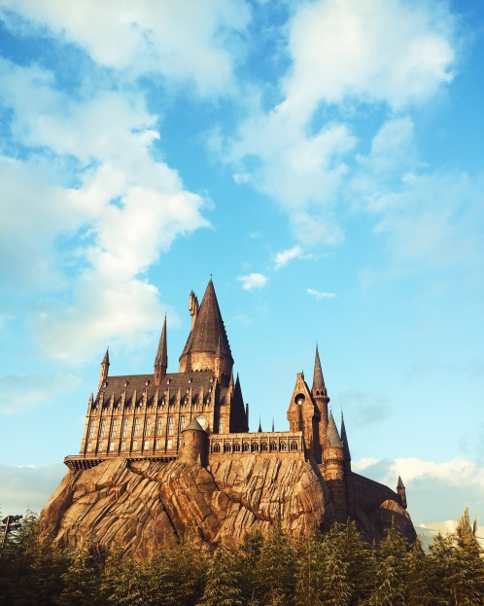
- looking very angry
- now there were woods twisting rivers and dark green hills
- harry where have you been
- the following week dragged by
- on top of the tower
- they walked on though the dense dark trees
- they stared at him
- after dinner the three of them

- Put the correct punctuation into the complete sentences above.

- Unscramble the sentences below and add in the correct punctuation:

it dinnertime was

the she book pushed them towards

he start had somewhere to

