Name: Date:
Create your own wizard profile.
 |  |  | 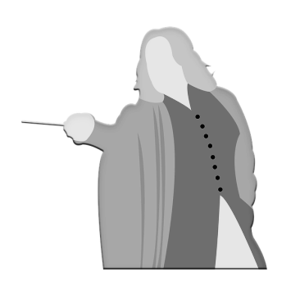
My Wand: | Me: | Magic pet:
Core:
Unicorn tail hair
Dragon heartstring
Phoenix feather
 |  | Name:
Favourite magical beast: | Animagus: | Patronus:
 | My house:

