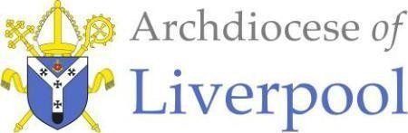
Holy Communion Badge
Competition 2026

Instructions:
Guide size

Please use the circle above to draw your design/image.
- Don’t draw outside the line.
- No more than 5 colours (including white).
- Keep it simple – remember it will be a lot smaller in real-life.

Please use the box below to tell us what you’ve drawn and why.
Thank you for taking part in the Archdiocese of Liverpool Holy Communion Badge Competition. We can’t wait to see your entries!

In order for your child’s entry to be considered for the Holy Communion Badge Competition, this permission must be given and attached to the entry.

I [Parent/ Guardian] , (being the person with parental responsibility) of: (Child’s full name) age from
(name of school) give the Liverpool Archdiocese
(registered charity number 1199714) full permission to use the design created by (name) for the ‘Holy Communion Badge Competition’ 2026.
Approved uses:
- I permit my child’s first name and age to be published on the Liverpool Archdiocese website and social media pages, alongside their badge design.
- I agree that this design could be used for creating badges that may given out for free but may also be distributed as part of a ‘suggested donation’ initiative.
- I agree that my child will not be entitled to any money that is donated, as part of this initiative
- I agree that this design may also be used on banners, leaflets and posters in parishes and other buildings connected to the Liverpool Archdiocese.
- I agree that this design may be used as part of communications from the Liverpool Archdiocese both on the website and associated social media pages.

I expressly consent to use of my child’s first name, age and design used for the Approved Uses described above: Yes [ ] No [ ]

This consent is permanent and cannot be withdrawn.

Signed…………………………………Date…………………………………………

Address………………………………………………………………………………...……………………………………………………………

…………………………………………………………………………………………………………………………………………………………… Postcode…………………………Tel………………………………………

St Margaret Clitherow Centre
Liverpool Archdiocesan Office | Croxteth Drive | Liverpool | L17 1AA
Archdiocese of Liverpool (Registered Charity No 1199714

