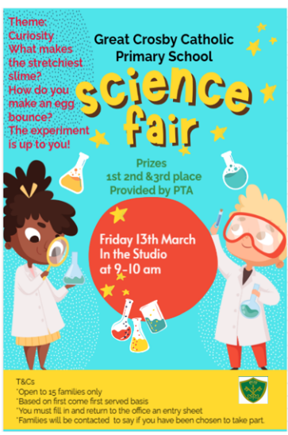


Great Crosby Catholic Primary School
Science Fair 2026
Entry Form

Family Name: ___________________________________________
Children’s Names: ________________________________________________________________________________________________________________________________________________________________________
Classes of Children: ____________________________________
Give a brief description about your experiment:_____________________________________________________________________________________________________________________________________________________________________________________________________________________
Please tell us about the adult who will accompany the children on the day and provide contact details and email address.________________________________________________________________________________________________________
Please sign to agree to the terms, that you understand this is based on a first come basis. if you are successful in your entry, you will be contacted by a member of staff. If you do not hear you have not been successful this year.

Signed_________________________________________________ Date:___________________

