Name: .................................................................. Date: .............................................

Many well-known children’s books have been made into films or animations. Your task is to compare a book you have read with the film version.
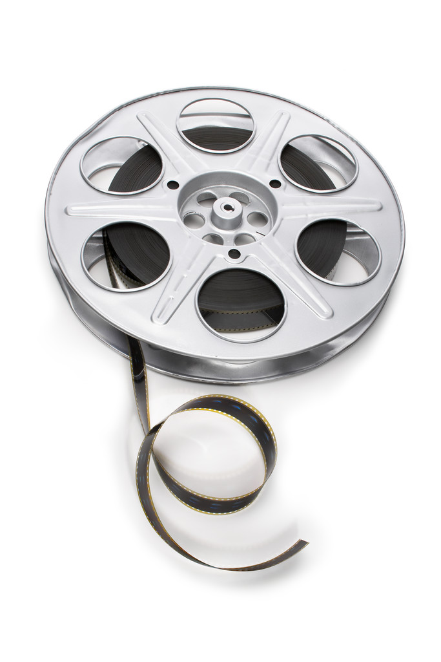
Here is a checklist to remind you which things to write about.
- Title and author of the book
- Did you see the film first or read the book first?
- Are the characters the same?
- Are the characters the way you imagined them to be?
- Is the storyline the same or has it been changed?
- What was your favourite bit in the book and was it your favourite bit in the film? Is it the same, if not why?
- Which version do you prefer and why?

If you haven’t read a book that has been made into a film, your job is to think of as many books which have been made into films as possible. Here are a couple to get you started.

Book/film | Author
Matilda  Harry Potter and the Philosopher’s Stone | Roald Dahl  J.K. Rowling

