The Daily Prophet

The wizarding world rejoices as He Who Must Not Be Named is defeated.

How could this small boy defeat him?

Name: ......................................................................................... Date: ...............................................

The characters

Can you use the descriptions from the book to draw the characters?

Mr Dursley was the director of a firm called Grunnings, which made drills. He was a big, beefy man with hardly any neck, although he did have a very large moustache. | Uncle Vernon
Mrs Dursley was thin and blonde and had nearly twice the usual amount of neck, which came in useful as she spent so much of her time craning over garden fences, spying on the neighbours. | Aunt Petunia
Dudley looked a lot like Uncle Vernon. He had a large, pink face, not much neck, small, watery blue eyes and thick, blond hair that lay smoothly on his fat head. Aunt Petunia often said that Dudley looked like a baby angel – Harry often said that Dudley looked like a pig in a wig. | Dudley Dursley

If the motorbike was huge, it was nothing to the man sitting astride it. He was almost twice as tall as a normal man and at least five times as wide. He looked simply too big to be allowed, and so wild – long tangles of bushy black hair and beard hid most of his face. | Hagrid
Harry had always been small and skinny for his age. ... Harry had a thin face, knobbly knees, black hair and bright green eyes. He wore round glasses held together with a lot of sellotape because of all the times Dudley had punched him on the nose. The only thing Harry liked about his appearance was a very thin scar on his forehead which was shaped like a bolt of lightning. | Harry Potter
She pointed at the last and youngest of her sons. He was tall, thin and gangling, with freckles, big hands and feet and a long nose. | RonWeasley
“Has anyone seen a toad? Neville’s lost one,” she said. She had a bossy sort of voice, lots of bushy brown hair and rather large front teeth. | Hermione

Name: ............................................................................. Date: ....................................

Letters, letters everywhere!

The mysterious letters keep on coming! If you were Uncle Vernon, what would you do to try and escape them?

If I were Uncle Vernon I would

Name: ............................................................................. Date: .................................... I’m a wizard ???!!!

“Harry – yer a wizard.”
There was a silence inside the hut. Only the sea and the whistling wind could be heard.
“I’m a what?” gasped Harry.
“A wizard, o’ course,” said Hagrid, sitting back down on the sofa, which groaned and sank even lower.

Imagine you are Harry. How would you feel finding out you were a wizard? You thought you were a normal boy and then a giant arrives to tell you this surprising news!

Dear Diary,

Hogwarts School of Witchcraft and Wizardry
Headmaster: Albus Dumbledore
(Order of Merlin, First Class, Grand Sorc., Chf. Warlock, Supreme Mugwump, Int. Confed. Of Wizards)

Dear Student,
We are pleased to inform you that you have a place at Hogwarts School of Witchcraft and Wizardry. Please find enclosed a list of all necessary books and equipment.
Term begins on 1st September. We await your owl by no later than 31st July.

Yours sincerely,
Minerva McGonagall
Deputy Headmistress

Can you find all of the items on your list sent by Hogwarts?

cat
cauldron
cloak
gloves
hat
owl
phials
robes
scales
toad
telescope
wand

h | a | p | f | g | s | w | a | m | d
a | d | g | b | d | x | s | a | a | h
t | m | m | c | b | e | f | o | g | j
v | d | c | l | v | s | t | v | b | n
c | r | r | o | b | e | s | l | k | u
a | e | l | a | g | f | d | s | a | g
t | g | s | k | h | j | k | l | n | s
c | a | u | l | d | r | o | n | l | c
g | t | u | w | a | n | d | a | b | a
d | f | l | q | a | y | i | c | v | l
u | w | i | p | z | h | z | x | q | e
o | a | i | u | p | i | u | e | w | s
b | h | o | l | o | o | y | r | t | y
p | t | e | l | e | s | c | o | p | e

You will not be able to start your new term at Hogwarts without the correct equipment.

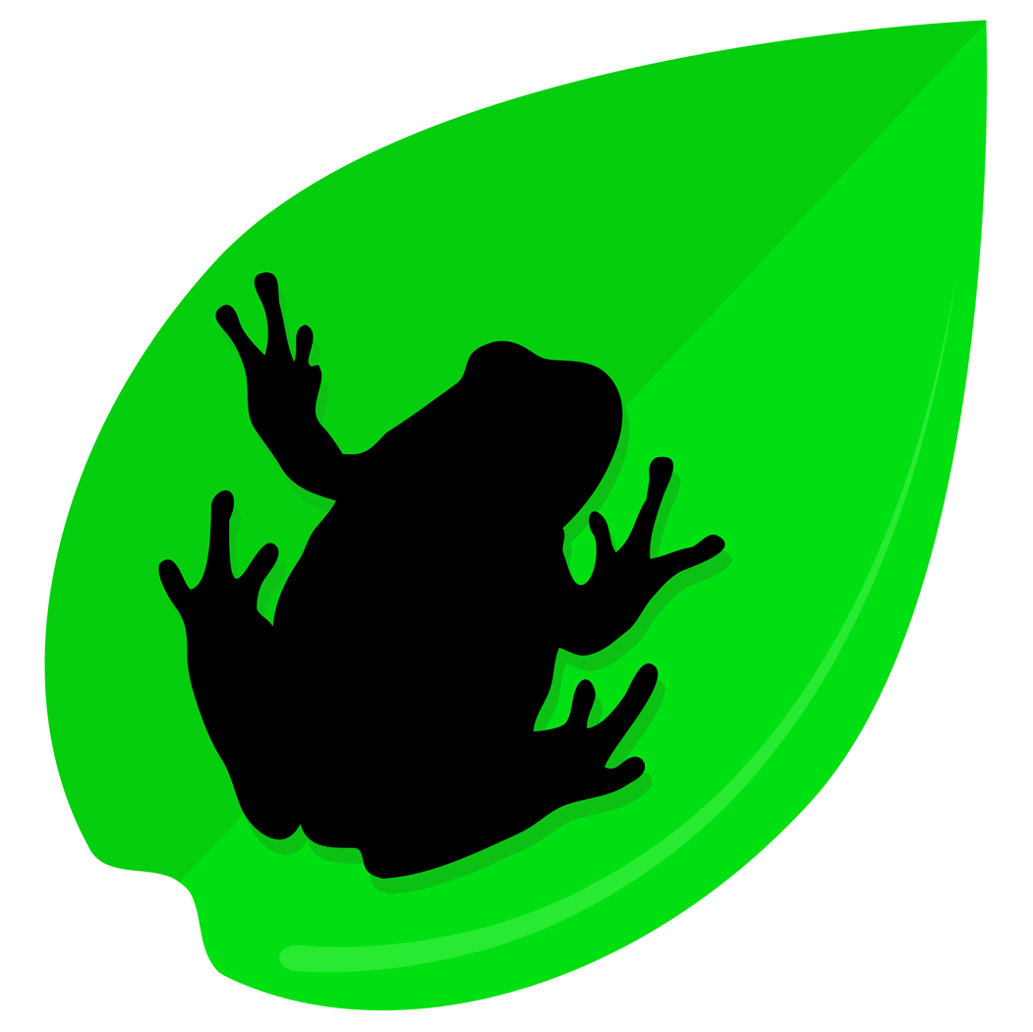
Chocolate frogs

“Chocolate frogs have cards inside them, you know, to collect – Famous Witches and Wizards. I’ve got about five hundred, but I haven’t got Agrippa or Ptolemy.”
Harry unwrapped his Chocolate Frog and picked up the card.

Can you design a new wizard card?

Draw a witch or wizard on one side and then write about why they are famous on the other. Cut out the card, fold it in half and glue.

Draw a magical frame with your witch or wizard inside. Put their name on this side too.

Why is your witch/ wizard famous? What have they done? Write about it here.

The Sorting Hat

Which words describe you best? Circle four words or phrases which you would use to describe yourself and the hat will sort you into Gryffindor, Hufflepuff, Slytherin or Ravenclaw.

kind
brave
patient
wise

fair
clever
selfish

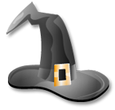
funny

cunning

fearless

studious

daring
devious

loyal
sly

caring

Name: ................................................................. Date: ......................

Potions

Can you make this magical mixture?

You will need:
- two egg-cups of custard powder
- one egg-cup of water.

Mix two egg-cups of custard powder with one egg-cup of water, making sure to stir in the water a little at a time so you don’t get any lumps. The result is a strange yellow substance that can act either like a solid (if you punch it quickly or roll it into a ball) or like a liquid (if you touch it gently). WEIRD!

HAVE A GO!

How did it feel?

Name:.......................................................... Date: ..................................
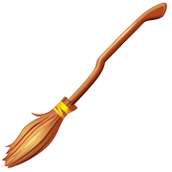
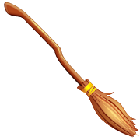
Quidditch

“Right,” said Wood. “Now, Quidditch is easy enough to understand, even if it’s not too easy to play.”

- Read p124 – 125 of Harry Potter and the Philosopher’s Stone.
- Can you draw a Quidditch pitch including the players?
- Draw Harry on his broomstick on a separate piece of card.
- Cut him out and stick him to a paperclip.
- Using a magnet, guide Harry through the game to catch the snitch.

Now..
Can you write Lee Jordan’s commentary for your game?

Name: ............................................................................. Date: ....................................

A brilliant yet mysterious gift

Harry looked down at his feet, but they had gone. He dashed to the mirror. Sure enough, his reflection looked back at him, just his head suspended in mid-air, his body completely invisible. He pulled the Cloak over his head and his reflection completely vanished.

What would you do if you had received an invisibility cloak?



Name: ............................................................................. Date: ....................................
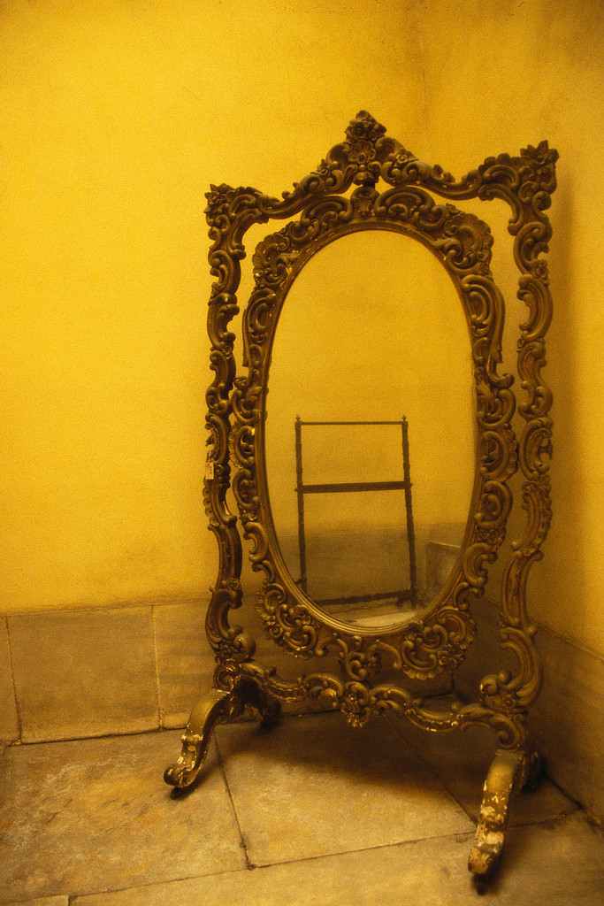
The mirror of Erised

“The happiest man on earth would be able to look into the mirror of Erised and see himself exactly as he is.”
Harry thought. Then he said slowly, “It shows us what we want…whatever we want…”
“Yes and no,” said Dumbledore quietly. “It shows us nothing more or less than the deepest, most desperate desire of our hearts.”

Draw a picture of what you might see
if you looked into the mirror of Erised.

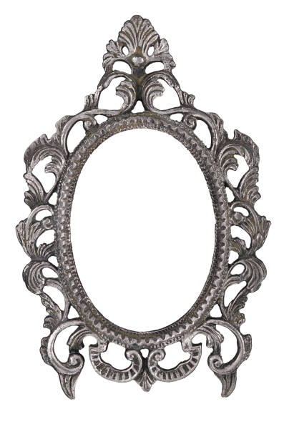

Nicholas Flamel

‘They had almost given up hope of ever finding Flamel in a library book. Once term started, they were back to skimming through books for ten minutes during their breaks.’

Can you find Nicholas Flamel four times?

n | i | c | h | o | l | a | s | f | l | a | m | e | l
l | i | n | i | c | h | o | l | a | s | l | a | l | c
c | e | c | n | i | c | h | o | l | a | s | s | o | h
h | f | m | h | n | i | c | h | o | l | a | s | h | l
o | l | a | a | o | n | i | c | h | o | l | a | s | a
l | a | n | i | l | l | n | i | c | h | o | l | a | s
a | m | c | i | n | f | a | f | l | a | m | e | l | f
s | e | h | l | c | l | s | s | l | n | o | f | c | l
f | l | o | a | a | h | a | a | f | i | h | l | i | a
i | n | l | s | m | o | o | a | l | l | c | a | n | m
a | f | a | m | e | l | s | l | e | o | a | m | l | e
m | l | s | c | l | h | f | l | a | m | h | m | e | l
e | a | n | i | n | i | c | h | o | s | l | c | e | n
l | m | n | i | c | h | o | l | a | s | f | l | i | l
l | e | m | a | l | f | s | a | l | o | h | c | i | n


‘The ancient study of alchemy is concerned with making the Philosopher’s Stone, a legendary substance with astonishing powers. The Stone will transform any metal into pure gold. It also produces the Elixir of Life, which will make the drinker immortal.

There have been many reports of the Philosopher’s Stone over the centuries, but the only Stone currently in existence belongs to Mr. Nicholas Flamel, the noted alchemist and opera-lover. Mr. Flamel, who celebrated his six hundred and sixty fifth birthday last year, enjoys a quiet life in Devon with his wife, Perenelle (six hundred and fifty eight).’

Mythical creatures

There are many mythical creatures in Harry Potter.

Unicorn few magical creatures have struck the imagination as deeply as the elegant unicorn. Even in Harry’s wizard world, with so many wonderous beasts, the unicorn is a symbol of the sacred.

Cerberus ‘Fluffy’ is actually a magical creature from Greek mythology known as Cerberus. He was the sentry who guarded Hades, the underworld, where the souls of the dead go to live for eternity. It was his job to keep all living beings away, and to eat anyone trying to escape.

Centaur these are mythical beasts with the legs and bodies of horses, but with human torsos, arms and heads.

Dragon these are probably the best-known magical creatures in literature. Usually dangerous and terrifying, they are often the most challenging foe a hero can face.

Phoenix this is a magical, eternal bird. When the phoenix completes a full five centuries of life, it dies in a burst of flames and from the ashes rises a new phoenix.

Now try and create your own magical creature:

- First fold an A4 piece of paper into thirds.
- Then draw a head on the first third, fold the paper underneath and pass it on.
- Now the next person will draw the front part of the body, including the arms, on the second third.
- After this the third person will draw the other half of the body, including the legs.
- Finally, when each third has been drawn, open the paper out and you will reveal your creature.

Name: ....................................................................... Date: ..........................................

The Final Task

Use the cipher to decode the clue!

A | B | C | D | E | F | G | H | I | J | K | L | M
1 | 2 | 3 | 4 | 5 | 6 | 7 | 8 | 9 | 10 | 11 | 12 | 13

N | O | P | Q | R | S | T | U | V | W | X | Y | Z
14 | 15 | 16 | 17 | 18 | 19 | 20 | 21 | 22 | 23 | 24 | 25 | 26

9 6 / 20 8 5 18 5 / 9 19 / 15 14 5 / 20 8 9 14 7

/ 22 15 12 4 5 13 15 18 20 / 3 1 14 14 15 20 /

21 14 4 5 18 19 20 1 14 4 / 9 20 / 9 19 /

12 15 22 5.

How did this save Harry?

Name: ....................................................................... Date: ..........................................

Money, money, money!

“The gold ones are Galleons,” he explained. “Seventeen silver Sickles to a Galleon and twenty-nine Knuts to a Sickle, it’s easy enough.”

Can you total the two amounts? Remember, if you have 29 Knuts you make a Sickle and if you have 17 Sickles you make a Galleon!

2 Galleons, 12 Sickles and 3 Knuts | 1 Galleon, 9 Sickles and 2 Knuts

Total:

Are you feeling clever? Try adding these amounts!

4 Galleons, 10 Sickles and 25 Knuts | 6 Galleons, 13 Sickles and 15 Knuts

Total:

You should get a job at Gringotts!
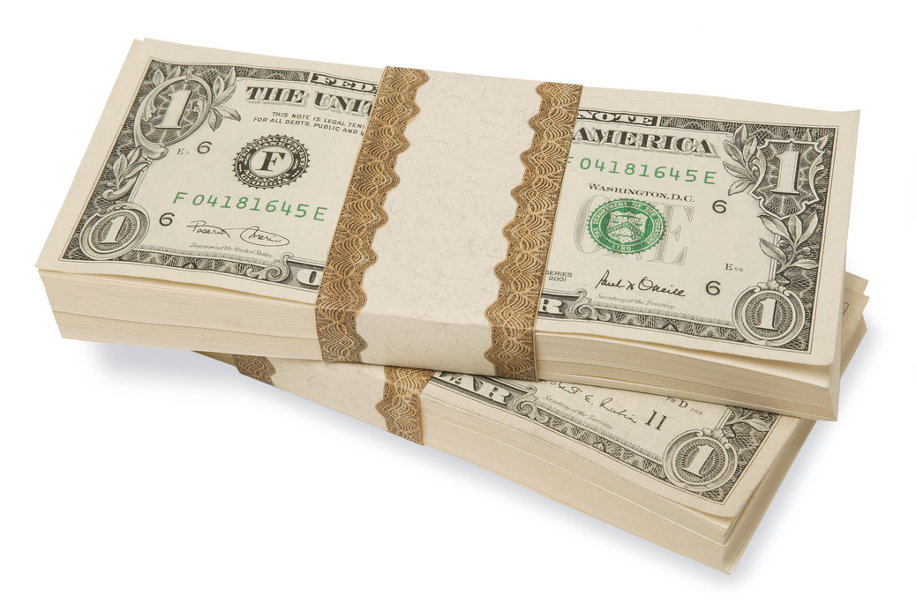
Name: ....................................................................... Date: ..........................................
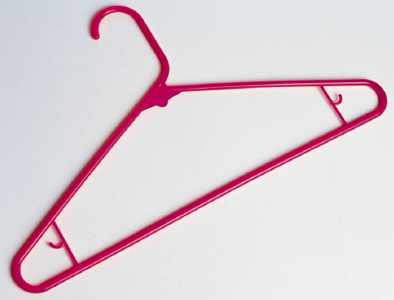
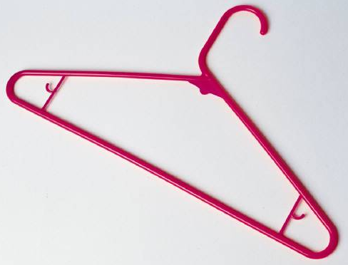
Wizarding wardrobe

Can you design yourself a magical outfit?
Remember to think about what kind of spells you might be casting while wearing it and what equipment you might need to carry it it.

Name: ....................................................................... Date: ..........................................

•  •  •  Glossary  •  •  •

There are lots of weird and wonderful words in Harry Potter. Can you explain the words below and add any unusual words you may come across as we read the book?

Muggle
Quidditch

