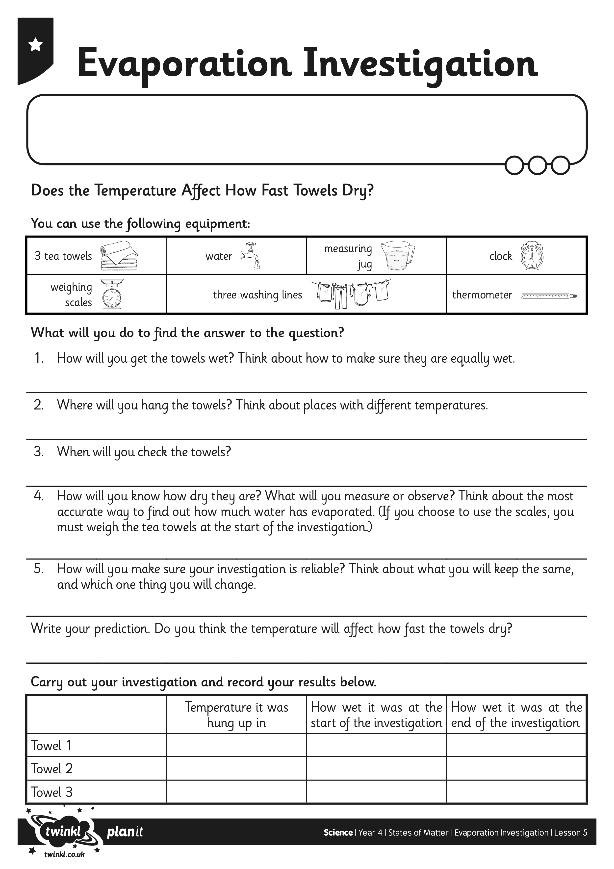
I can plan and carry out a comparative test.
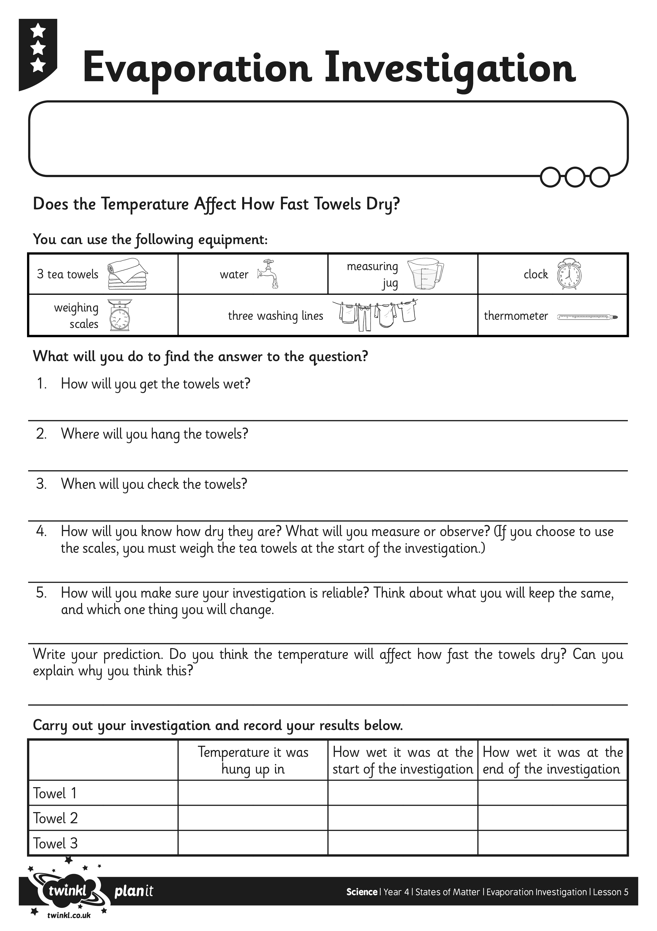
I can plan and carry out a comparative test.

