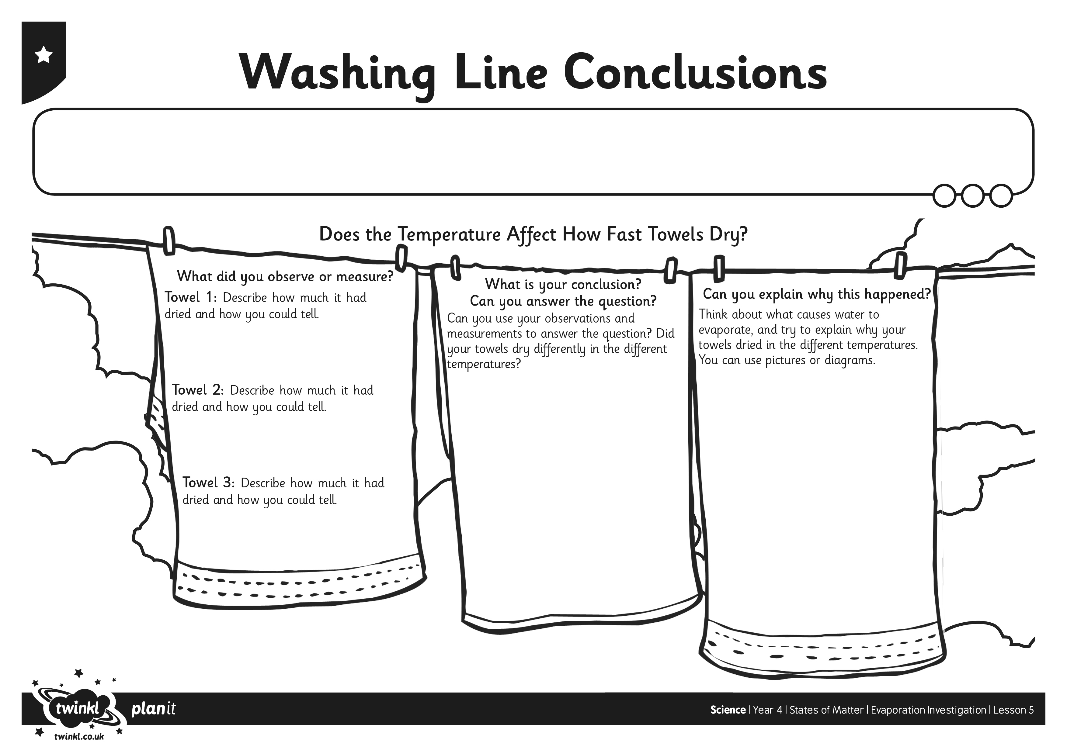
I can display my results and my conclusion.
I can describe the effect of temperature on drying washing.
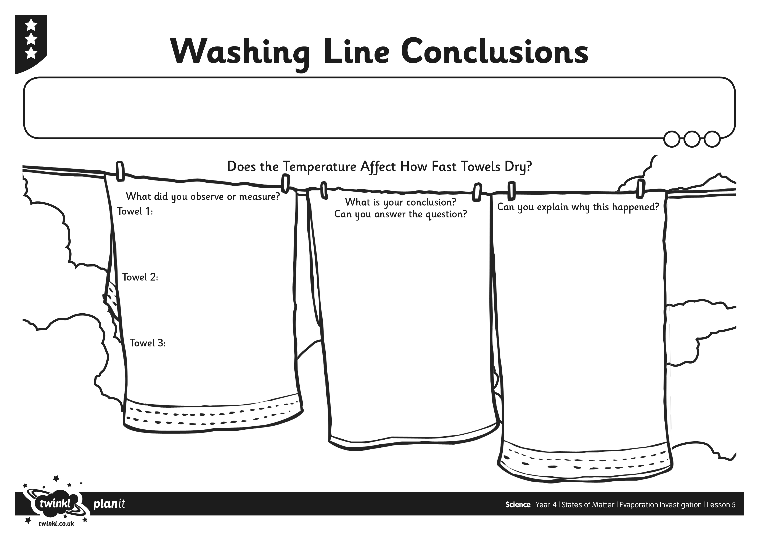
I can display my results and my conclusion.
I can describe the effect of temperature on drying washing.

