Day four-writing excellent sentences.
Here are some examples of sentences to write for each section of the film. Then, there is an adverbial phrase to start your own sentence. You can say a similar thing.
Stage of the story | Words to describe the girl’s appearance and feelings.
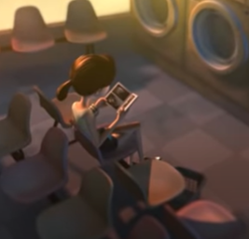 | Waiting patiently for her wash to finish, the girl read her book peacefully.  Now your turn:  On a dull, Sunday afternoon,
Bored stiff, the girl wished she could be somewhere else.

Now your turn:
Yawning fiercely,
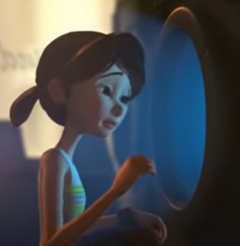 | Peering in to the mysterious beam of light, the girl stared through the round, gleaming porthole.  Now your turn:  Cautiously,
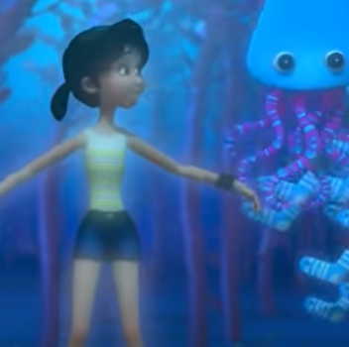 | In awe, the girl watched the darting fish, as they swam fearlessly around her.  Now your turn:  Reaching out,
As still as a statue, the girl’s mouth fell open in a silent scream.
Now your turn:

Frozen in fear,

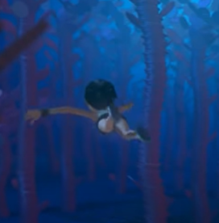 | Swimming as if her life depended on it, the girl turned and raced away faster than the speed of light.  Now your turn:  Heart pounding,
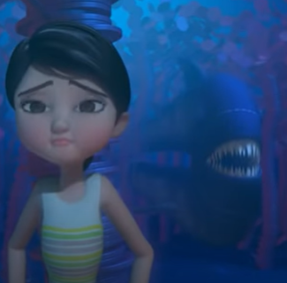 | Making herself as thin as she could, the girl clung helplessly to the tree trunk.  Now your turn:  Wondering what to do,
Up ahead, a small circle of light shone through.

Now your turn:

In the distance,
With the shark right behind her, the girl leaped through the water, desperately wanting to reach safety. Never again would the launderette seem boring!

Now your turn:
Pushing herself through the water,
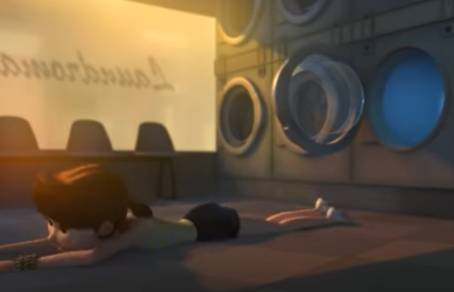 | Landing on the launderette floor, the girl wondered whether she was safe.  Now your turn:  Shooting through the washing machine door,
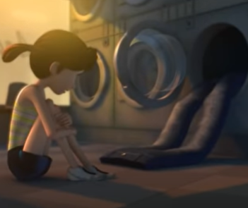 | Cautiously, the girl peered at the deep blue jeans in front of her.  Now your turn:  Staring at the jeans in front of her,
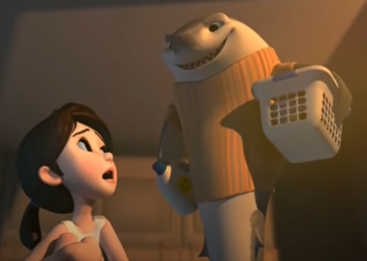 | Staring in disbelief, the girl gazed at the owner of the jeans.  Now your turn:  Mouth wide open,

