Day six and seven – Writing a story.
Write your own story next to the picture. Remember to describe the character and the setting too! Use capital letters . ? ! ,
Stage of the story | Words to describe the girl’s appearance and feelings.
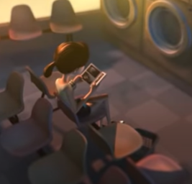 | Down at the launderette, absolutely nothing was happening. In fact, it was almost deserted. All except for one small girl, Sophie, who had volunteered to do her dear, darling grandmother’s washing for her.
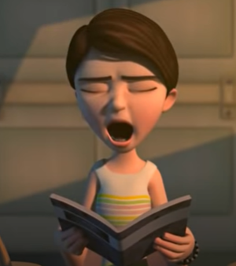
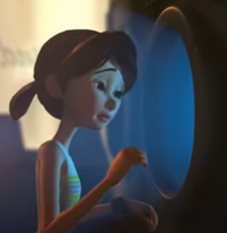
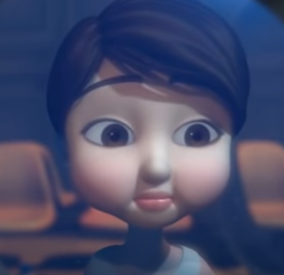

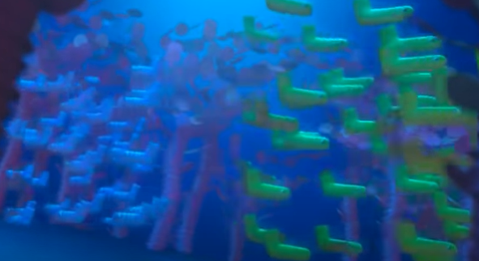
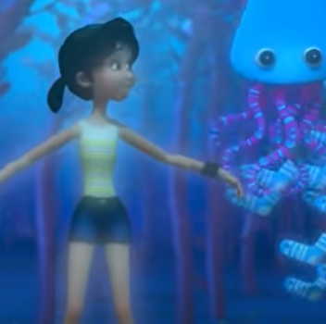


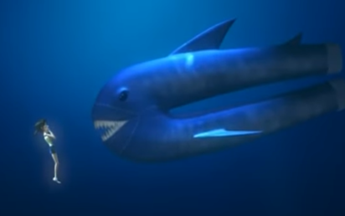
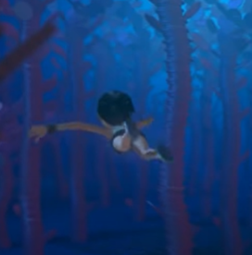
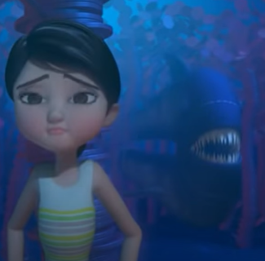

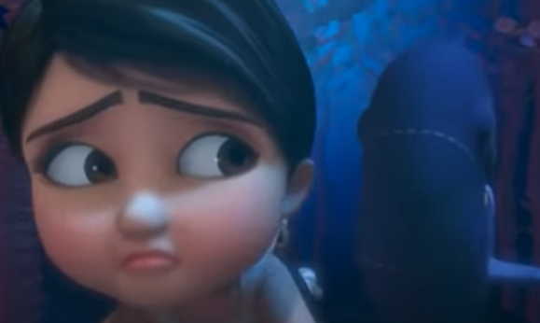
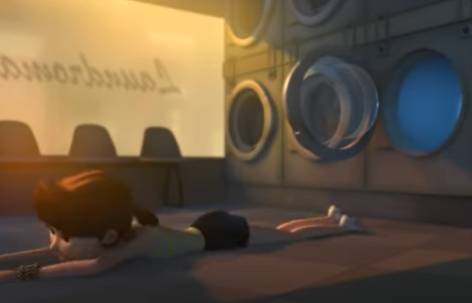
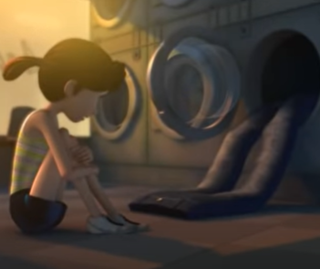
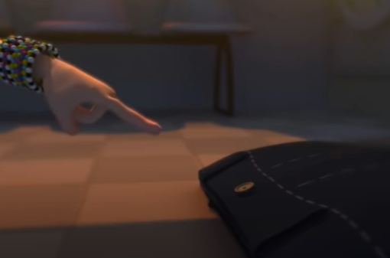
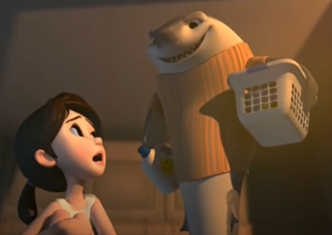 | “I think those are mine!” came a voice from behind. Turning around, heart pounding, Sophie stared in disbelief at the owner of the jeans. Where had he come from? The launderette had been completely deserted! A shark? On dry land? Walking? Talking?  Gingerly, she picked the predator jeans up and handed them over.  After the unbelievable day she’d had, Sophie imagined almost anything could happen! Wait ‘til she told granny!

