Day three- the Launderette.
Around the still from the film, write as many words as you can to describe the setting. Remember- sometimes in class, we label all the nouns in the setting first and then think of words or expanded noun phrases (two describing word to describe the object separated by a comma.) I’ll give you an example. Don’t worry! There isn’t too much to describe in the first setting because it’s soooo boring!! PLEASE FEEL FREE TO JUST ADD WORDS TO DESCRIBE EACH NOUN IF YOU DON’T FANCY THE SENTENCES!!
Washing machine
The dull, flat bottomed chairs waited patiently for someone to sit on them, casting a gloomy shadow across the launderette.

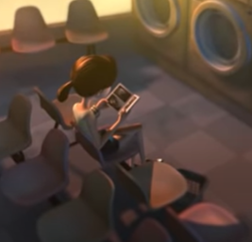
Floor
Laundry basket

