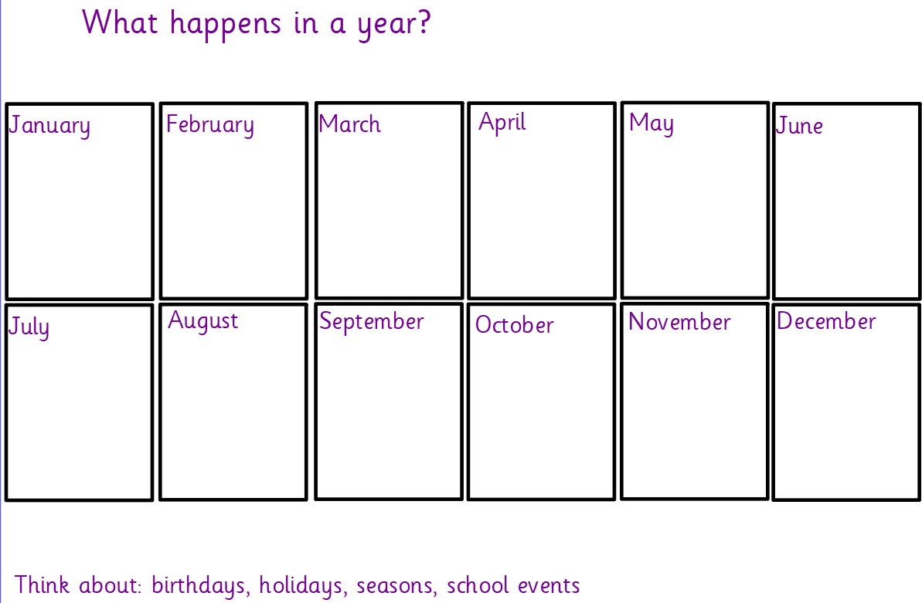

Date: Friday 8th Jan 2021  
Focus: Explore

Name:

Name: