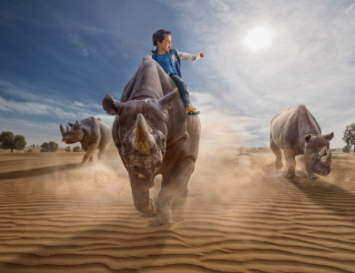
Stampede

Story starter!
“Charge!” he screamed, feeling mighty atop the lead rhinoceros. He jolted with every step they took, the rhino’s feet punching into the baking hot sand, sending up large clouds into the humid air so that he could taste the grains of sand in his parched mouth.
The herd stampeded across the desert sand, focused on reaching their goal…
Before you write, consider the following questions.
Who is the boy? Where is he from?
What is he doing there?
How has he managed to control the rhinos?
Where are the herd heading? What is their goal?
How do you think rhinos communicate?
Did you know that rhinos are endangered? Why do you think this is?
What do you think makes rhinos unique from other animals?

