Date : Lesson two Focus: To find out what a civilisation is and how and why the ancient Egyptian civilisation started.
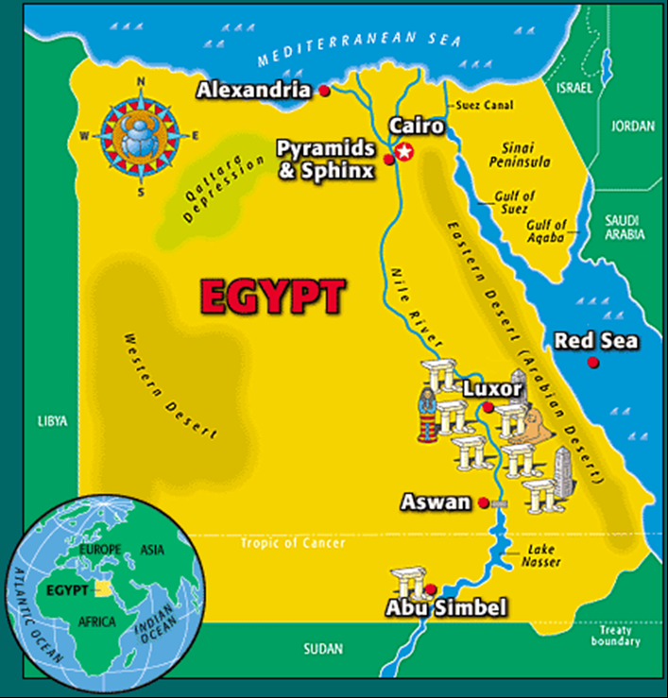
Look carefully at the map and make notes on your observations.

