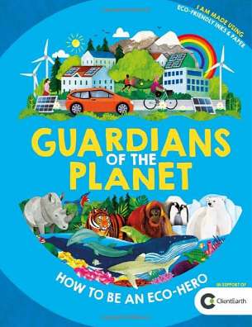
Guardians of the Planet Workbook
Name: _______________________________ Date: ________________

Lesson one – Summarising. Making sense of the text.
Focus: I can identify main ideas drawn from more than one paragraph and summarise these.

Summarize what you have read in each paragraph.
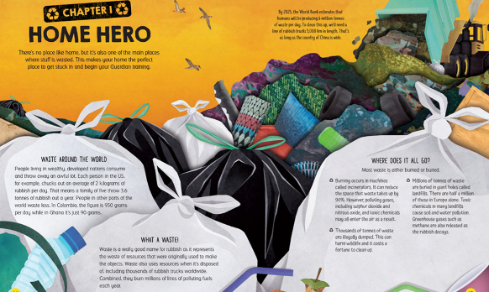

Lesson two – Vocabulary and language.
Focus: I can discuss words and phrases that capture the reader’s interest and imagination.

- What word does the author use which means get rid of or throw away?
___________________________________________________________________________________

- What other synonyms could have been used for ‘combined’?
- ______________________________________
- ______________________________________

- What do the words ‘costs a fortune’ tell us about the cleaning of illegally dumped waste?
The words cost a fortune tell us _____________________________________
_____________________________________________________________________________________

- Which word is used to tell us that the chemicals from landfills is harming the environment?
____________________________________________________

Lesson 3 – Retrieval
Focus: I can retrieve and record information.
 | True | False
One of the main places stuff is wasted is in the sea.
Bu 2025 it is estimated that humans will be producing 6 million tonnes of rubbish a day.
Burning occurs in places called incinerators.

Ghana and Columbia produce the most rubbish Per day.
There are a million landfills in Europe.

Lesson 4 – Inference
Focus: I can draw inferences from the text.

- Which words give you the impression that landfills are harming the environment?

The words ________________________________ give the impression that
landfills are harming the environment.

- What example does the author give to show us how much
rubbish will be disposed in the year 2025?

The author uses the example ____________________________________________

- Why does the author give us this example?

The author gives us this example to __________________________________
________________________________________________________________________________________
________________________________________________________________________________________

- In the introduction why does the author use the phrase,
‘we use more resources when disposing of rubbish’?

The author uses this phrase to ____________________________________________
__________________________________________________________________________________________
__________________________________________________________________________________________

Lesson 5 – Personal response
Focus: I can justify views using implied and explicit evidence in the text.
Think about what you have read about rubbish.

How could you be a guardian of the planet? Give reasons for your answers.

________________________________________________________________________________________________________________________________________________________________________________________________________________________________________________________________________________________________________________________________________________________________________________________________________________________________________________________________________________________________________________________________________________________________________________________________________________________________________________________________________________________________________________________________________________________________________________________________________________________________________________________________________________________________________________________________________________________________________________________________________________________________________________________________________________________________________________________________________________________________________________________________________________________________________________________________________________

