**Great Crosby Catholic Primary School Remote Reception Learning 2020**

**WB 04.01.21**

|  |  |  |  |  |  |
| --- | --- | --- | --- | --- | --- |
|  | **Monday** | **Tuesday** | **Wednesday** | **Thursday** | **Friday** |
| **Input 1** | **Inset Day** | **Literacy/phonics**  Talk about Christmas. How did you celebrate? Did you get any presents?  What was your favourite present? Write or draw a list of the presents you received.    Can you write a sentence about a present you got? Try writing it like this…..”I got a hat.”    **Phase 3 Phonics**  **Phonics**-  Revisit and revise previously learnt sounds (Phase 2)  [**https://www.youtube.com/watch?v=DIpcahxNSU4**](https://www.youtube.com/watch?v=DIpcahxNSU4)  **Focus on j.** Learn jolly phonics song and action.  [**https://www.youtube.com/watch?v=-b9asCO1Uxk**](https://www.youtube.com/watch?v=-b9asCO1Uxk)  Watch bbc bitesize clip about the letter j.  [**https://www.bbc.co.uk/bitesize/topics/zvq9bdm/articles/zv3cy9q**](https://www.bbc.co.uk/bitesize/topics/zvq9bdm/articles/zv3cy9q)  Encourage your child to sound out and read the following words;  **jam, Jill, jet, jog, Jack, Jen, jet-lag, jacket.** Can your child write the words or use magnetic letters to build the word?  Show your child the sentence **Jack had a jet.** Encourage children to read and write the sentence. Talk about capital letters, finger spaces and full stops. | Literacy/phonics  C:\Users\Mziegler\AppData\Local\Microsoft\Windows\INetCache\Content.Word\91pSnfsEBsL._AC_UY327_QL65_[1].jpgRead or listen to the story ‘Zog’ by Julia Donaldson.  <https://www.youtube.com/watch?v=75aXrJgMVow>  Draw and colour a picture of Zog. Can you add labels to your picture for example-wing, legs, claws, ear, tail  Write the caption underneath your picture e.g. “It is Zog.”  **Phase 3 Phonics**  **Phonics-**  Revisit and revise previously learnt sounds (Phase 2)  [**https://www.youtube.com/watch?v=DIpcahxNSU4**](https://www.youtube.com/watch?v=DIpcahxNSU4)  **Focus on v**. Learn jolly phonics song and action.  [**https://www.youtube.com/watch?v=iSQzhkzDSrk**](https://www.youtube.com/watch?v=iSQzhkzDSrk)  Watch bbc bitesize clip about the letter v.  [**https://www.bbc.co.uk/bitesize/topics/zvq9bdm/articles/zmp3pg8**](https://www.bbc.co.uk/bitesize/topics/zvq9bdm/articles/zmp3pg8)  Encourage your child to sound out and read the following words; **van, vat, vet, Vic, Kevin, visit, velvet**. Can your child write the words or use magnetic letters to build the word?  Show your child the sentence **A vet in a van.** Encourage children to read and write the sentence. Talk about capital letters, finger spaces and full stops. | Come & See  Our Come and See topic is ‘Celebrating’.  The Big Question  Discuss with your child the question,  What and why do we celebrate?  Scribe your child’s responses on a mind map. Teach the following key words and their meaning: community, celebration, celebrating, party, memory.  Talk about events that you have celebrated. Inside the balloon, draw pictures of different elements of a celebration e.g. cards, decorations. party hats. Label your pictures.  **Phase 3 Phonics**  **Phonics-**  Revisit and revise previously learnt sounds (Phase 2)  [**https://www.youtube.com/watch?v=DIpcahxNSU4**](https://www.youtube.com/watch?v=DIpcahxNSU4)  **Focus on w.** Learn jolly phonics song and action.  [**https://www.youtube.com/watch?v=PlDPegyV6XI**](https://www.youtube.com/watch?v=PlDPegyV6XI)  Watch bbc bitesize clip about the letter w.  [**https://www.bbc.co.uk/bitesize/topics/zvq9bdm/articles/zmnbnrd**](https://www.bbc.co.uk/bitesize/topics/zvq9bdm/articles/zmnbnrd)  Encourage your child to sound out and read the following words;  **will, web, win, wag, wig, wet.**  Can your child write the words or use magnetic letters to build the word?  Show your child the sentence **The wig is wet.** Encourage children to read and write the sentence. Talk about capital letters, finger spaces and full stops. | **Literacy/phonics**  Re-read/ remind chn of the story, Zog by Julia Donaldson.  <https://www.youtube.com/watch?v=75aXrJgMVow>   * Who are the characters in the book? * What happens first in the story? * What did Zog and the other dragons learn at dragon school? * How did the story end?   Think of something you have done well this week.  Design a golden star with a caption saying. “I am a star.”  **Phase 3 Phonics**  **Phonics**-  Revisit and revise previously learnt sounds (Phase 2)  [**https://www.youtube.com/watch?v=DIpcahxNSU4**](https://www.youtube.com/watch?v=DIpcahxNSU4)  **Focus on x.** Learn jolly phonics song and action.  [**https://www.youtube.com/watch?v=pSadirablKc**](https://www.youtube.com/watch?v=pSadirablKc)  Watch bbc bitesize clip about the letter x.  [**https://www.bbc.co.uk/bitesize/topics/zvq9bdm/articles/z7p3pg8**](https://www.bbc.co.uk/bitesize/topics/zvq9bdm/articles/z7p3pg8)  Encourage your child to sound out and read the following words;  **mix, fox, fix, box, tax, six, vixen, exit**  Can your child write the words or use magnetic letters to build the word?  Show your child the sentence **Fox in a box.** Encourage children to read and write the sentence. Talk about capital letters, finger spaces and full stops. |
| **Input 2** | **The World**  Winter:Hot/Cold  (Lesson 1) from Oak National Academy    <https://classroom.thenational.academy/lessons/to-understand-the-difference-between-hot-and-cold-6cukcr> | **Creative**    Linked to Come and See ‘Celebrating’.  Get ready for a celebration! Perhaps you can make a party hat and decorate it? Or maybe you would like to make some bunting or a banner for a celebration of your choice. | **PSED**  **Squeaky Clean**  (Lesson 2) from Oak National Academy  **Sing a song of soap**  <https://classroom.thenational.academy/lessons/singing-a-song-of-soap-6gt30t> | **Music**  **Habitats**  (Lesson 4 from 6) from Oak National Academy  **The Rainforest (Part 1)**  <https://classroom.thenational.academy/lessons/the-rainforest-part-1-c8r6cc> | **Physical Development**  Threading- Try any of these activities. You can thread pasta, cereal, pony beads onto string, ribbon or pipe cleaners. |
| **Input 3** | **Maths**  White Rose Maths  Alive in 5!  <https://whiterosemaths.com/homelearning/early-years/alive-in-5-week-1/>  Week 1 Session 1  Watch video clip and complete task | **Maths**  White Rose Maths  Alive in 5!  <https://whiterosemaths.com/homelearning/early-years/alive-in-5-week-1/>  Week 1 Session 2  Watch video clip and complete task | **Maths**  White Rose Maths  Alive in 5!  <https://whiterosemaths.com/homelearning/early-years/alive-in-5-week-1/>  Week 1 Session 3  Watch video clip and complete task | **Maths**  White Rose Maths  Alive in 5!  <https://whiterosemaths.com/homelearning/early-years/alive-in-5-week-1/>  Week 1 Session 4  Watch video clip and complete task | **Maths**  White Rose Maths  Alive in 5!  <https://whiterosemaths.com/homelearning/early-years/alive-in-5-week-1/>  Week 1 Session 5  Watch video clip and complete task |

Further Maths Challenges from White Rose Maths Digging Deeper

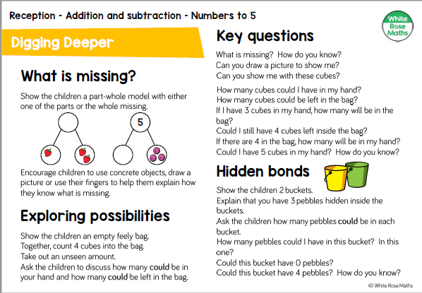

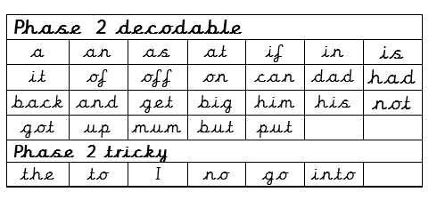

Come and See ‘Celebrating’