Great Crosby Catholic Primary School Remote Reception Learning 2020
WB 11.01.21
 | Monday | Tuesday | Wednesday | Thursday | Friday
Input 1 | Literacy/phonics  Read ‘Zog and the Flying Doctors’ by Julia Donaldson and talk about the beginning, middle and end.  https://www.bbc.co.uk/iplayer/episode/m000qq5j/zog-and-the-flying-doctors  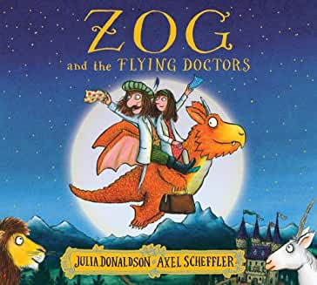  Phase 3 Phonics  Revisit and revise previously learnt sounds (Phase 2)  https://www.youtube.com/watch?v=DIpcahxNSU4  Focus on y. Learn jolly phonics song and action.  https://www.youtube.com/watch?v=futQOvUnHVs  Watch bbc bitesize clip about the letter j.  https://www.bbc.co.uk/bitesize/topics/zvq9bdm/articles/zfcwcqt  Encourage your child to sound out and read the following words;  yes, yell, yet, yum, yuck Use sound buttons, robot speak the words. Can your child write the words or use magnetic letters to build the word?  Show your child the sentence The yak had to yell. Encourage children to read and write the sentence. | Come & See  Our Come and See topic is ‘Celebrating’.  Look at pictures below, ‘Celebrations’. Next, draw and label examples of celebrations, sorting them into church celebrations and none church celebrations. | Literacy/phonics  Please share this activity on  Evidence Me  Try to think of any words that rhyme with Zog.  Which of these words rhyme with Zog?  Zog, bog, cat, dog, log, bus, fog, jog, Mog?  Write a list of words that rhyme with Zog. Can you see the pattern?  Phase 3 Phonics  Revisit and revise previously learnt sounds (Phase 2)  https://www.youtube.com/watch?v=DIpcahxNSU4  Focus on z. Learn jolly phonics song and action.  https://www.youtube.com/watch?v=YiSDOn3vWMo  Watch bbc bitesize clip about the letter z.  https://www.bbc.co.uk/bitesize/topics/zvq9bdm/articles/zrj6jhv  Encourage your child to sound out and read the following words;  zip, zap, buzz, Zak, jazz, zigzag. Use sound buttons, robot speak the words. Can your child write the words or use magnetic letters to build the word?  Show your child the following questions. Encourage your child to read each sentence and respond to each question.  Yes/No questions:  Is a zebra a pet?  Can a web buzz?  Is a zip on a van? | Literacy/phonics  Recap story ‘Zog and the Flying Doctors’.  Talk about your favourite parts of the story and discuss the beginning, middle and end. Draw a picture and write a simple sentence about your favourite part.  Phase 3 Phonics  Revisit and revise previously learnt sounds (Phase 2)  https://www.youtube.com/watch?v=DIpcahxNSU4  Focus on zz. Learn jolly phonics song and action.  https://www.youtube.com/watch?v=YiSDOn3vWMo  Watch bbc bitesize clip about the letter zz.  https://www.bbc.co.uk/bitesize/topics/zvq9bdm/articles/znrdrj6  Encourage your child to sound out and read the following words; buzz, fuzz, fizz, jazz  Can your child write the words or use magnetic letters to build the word?  Show your child the sentence The bee has a buzz. Encourage children to read and write the sentence. | Literacy/phonics  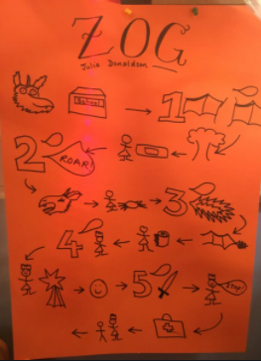  Draw a story map of Zog and the Flying Doctor (Similar to the Zog one below).  Phase 3 Phonics  Revisit and revise previously learnt sounds (Phase 2)  https://www.youtube.com/watch?v=DIpcahxNSU4  Focus on qu. Learn jolly phonics song and action.  https://www.youtube.com/watch?v=-b9asCO1Uxk  Watch bbc bitesize clip about the letter qu.  https://www.bbc.co.uk/bitesize/topics/zvq9bdm/articles/zrqtqp3  Encourage your child to sound out and read the following words;  quiz, quick, quit, quilt, quill, queen, quack  Can your child write the words or use magnetic letters to build the word?  Show your child the sentence The duck went quack. Encourage children to read and write the sentence.
Input 2 | The World  Winter: Hot/Cold  (Lesson 2) from Oak National Academy  https://classroom.thenational.academy/lessons/to-understand-how-humans-react-differently-to-hot-and-cold-6tj32d | Creative  Make your own dragon!  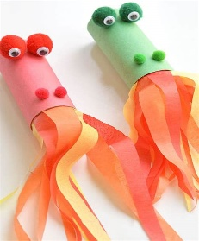  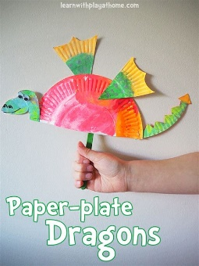  You could use kitchen roll tubes or a paper plate. | PSED  Hidden Germs  (Lesson 3) from Oak National Academy  https://classroom.thenational.academy/lessons/hidden-germs-cgrkce | Music  Habitats  (Lesson 5 from 6) from Oak National Academy  The Rainforest (Part 2)  https://classroom.thenational.academy/lessons/the-rainforest-part-2-64wk8t | Physical Development  Use the crown template below or make your own and decorate it using loose parts or craft materials.  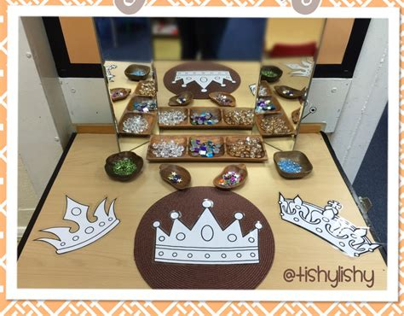
Input 3 | Maths  White Rose Maths  Alive in 5!  Week 2 Session 1  https://whiterosemaths.com/homelearning/early-years/alive-in-5-week-2/  Watch video clip and complete task  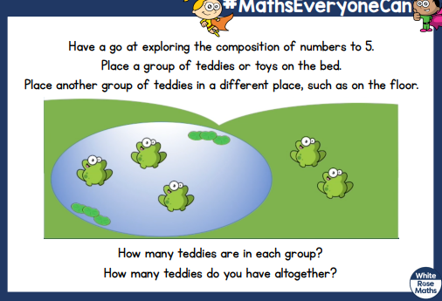 | Maths  White Rose Maths  Alive in 5!  Week 2 Session 2  https://whiterosemaths.com/homelearning/early-years/alive-in-5-week-2/  Watch video clip and complete task  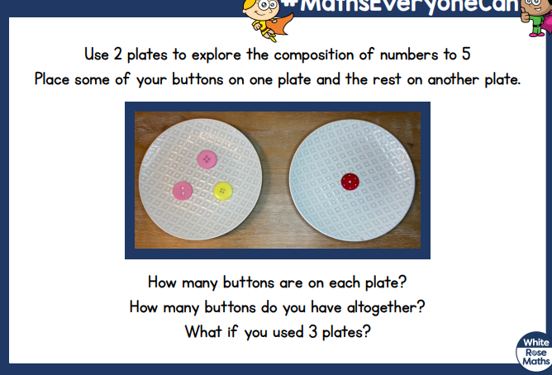 | Maths  Please share this activity on  Evidence Me (use the five frames below to record all the different ways of making 5)  White Rose Maths  Alive in 5!  Week 2 Session 3  https://whiterosemaths.com/homelearning/early-years/alive-in-5-week-2/  Watch video clip and complete task  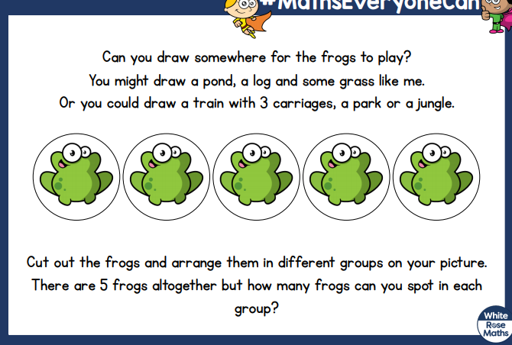 | Maths  White Rose Maths  Alive in 5!  Week 2 Session 4  https://whiterosemaths.com/homelearning/early-years/alive-in-5-week-2/  Watch video clip and complete task  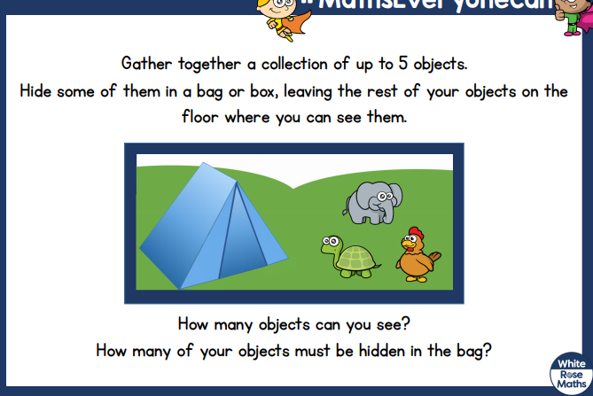 | Maths  White Rose Maths  Alive in 5!  Week 2 Session 5  https://whiterosemaths.com/homelearning/early-years/alive-in-5-week-2/  Watch video clip and complete task  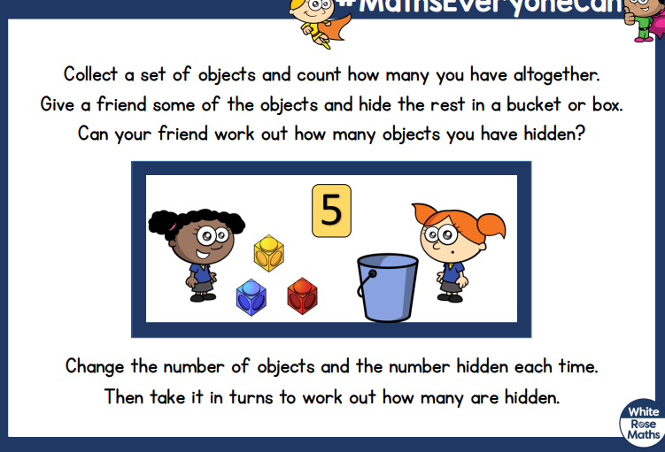

Further Maths Challenges from White Rose Maths Digging Deeper ‘Alive In 5!’

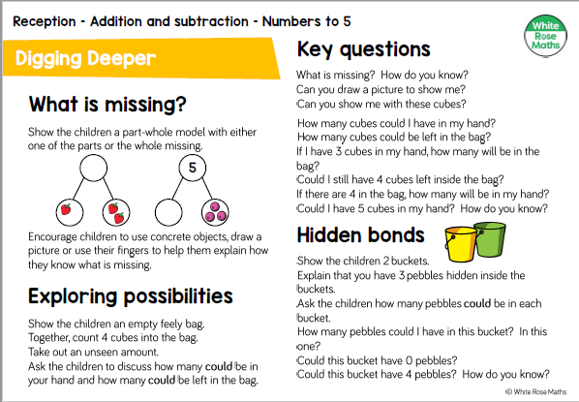

Come and see (Reveal 1)
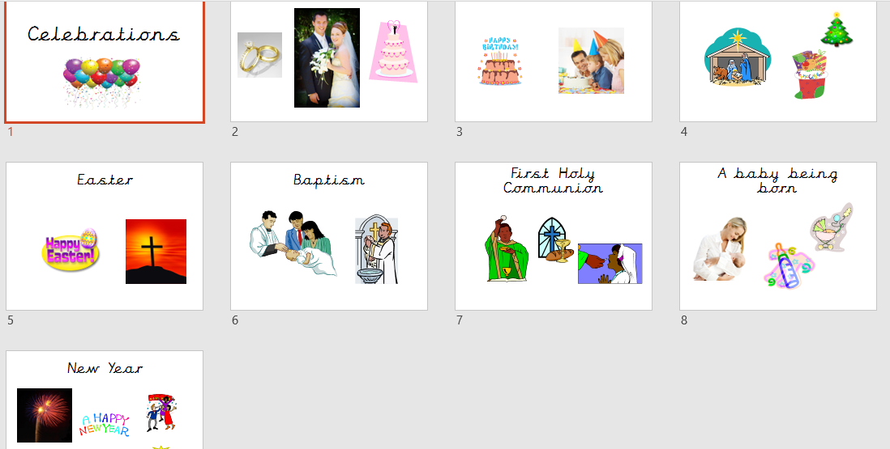

Church celebrations | Not in Church

Wednesday Maths –Alive In 5! Work to be sent in
How many different ways can you make five? (e.g. 1 red dot, 4 blue dots etc)

Physical development (Decorate a crown for Princess Pearl)

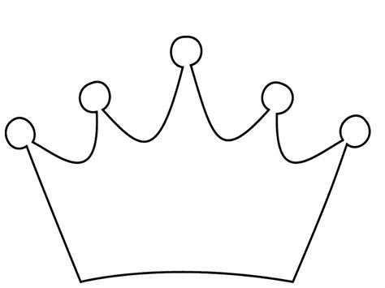

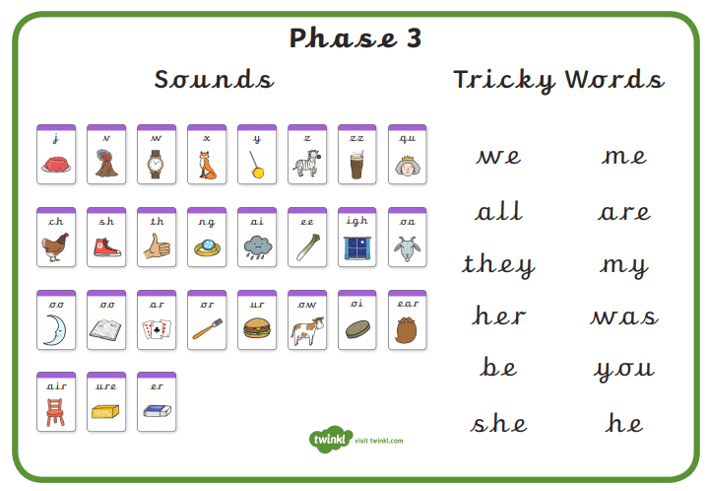
Look on Youtube for the Phase 2 and Phase 3 Tricky word songs

