**Reception Remote Planning for Mathematics and Phonics**

**Monday 21st June 2021**

|  |  |  |
| --- | --- | --- |
| **Mathematics**  White Rose Maths  **Find My Pattern**  **Week 3 Session 1**  **Even and Odd**  <https://whiterosemaths.com/homelearning/early-years/find-my-pattern-week-3/>  Note:  You can use any items to group e.g. socks, pegs for the activity below. | **Phonics**  Letters and Sounds  **‘oa’** digraph  [https://www.youtube.com/watch?](https://www.youtube.com/watch?v=rrGadCz2A1o)  Join in with the letters and sounds lesson. | **Literacy**  View the PP on the Reception page on the school website about Amelia Earhart. She was a famous aviator.    Can you make your own mini book about her? You might like to fold paper to make a zig zag book.  Have a go at writing sentences. Think, say and write your sentences down. |

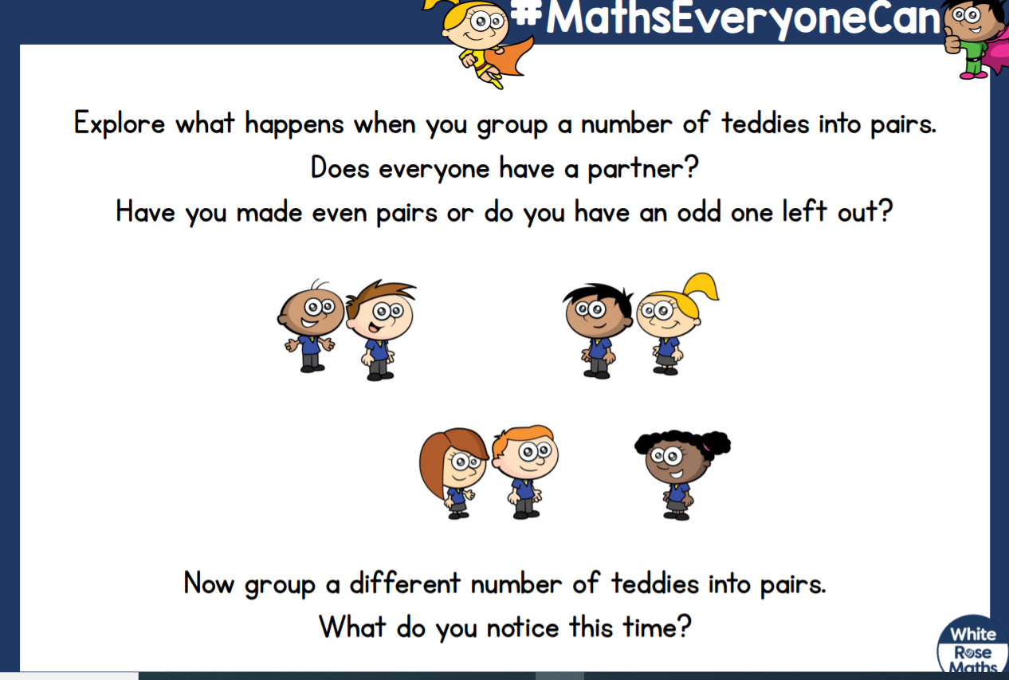**Try this Mathematics activity for yourself…..**