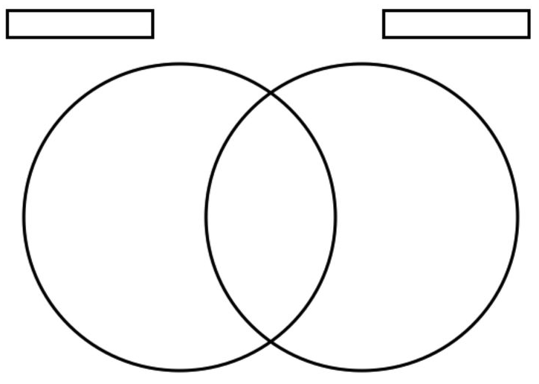

Modern Egypt

Ancient Egypt