Year 2 Reading Homework Mat Summer 2021 first half term
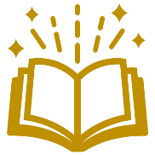  1. Act out your favourite part of a story to your grown up. Can they guess what it is? | 2. Draw a character from your favourite book and challenge your grown up to guess who it is. | 3. Ask your grown-up to quiz you on a book you have just read. Who was the main character? What was the main setting? How did it end?
4. Play ‘I spy with my little eye’ with your grown up, using only adjectives to guess what the answer is. | 5. Write an alternative ending to your favourite fairy-tale story. | 6. Use the common exception word cards to look, cover, write and check the spellings. Do a word hunt for them when you read your book.

