Newsletter 12 Attachment – 28th November 2025
From Sefton Family Hubs



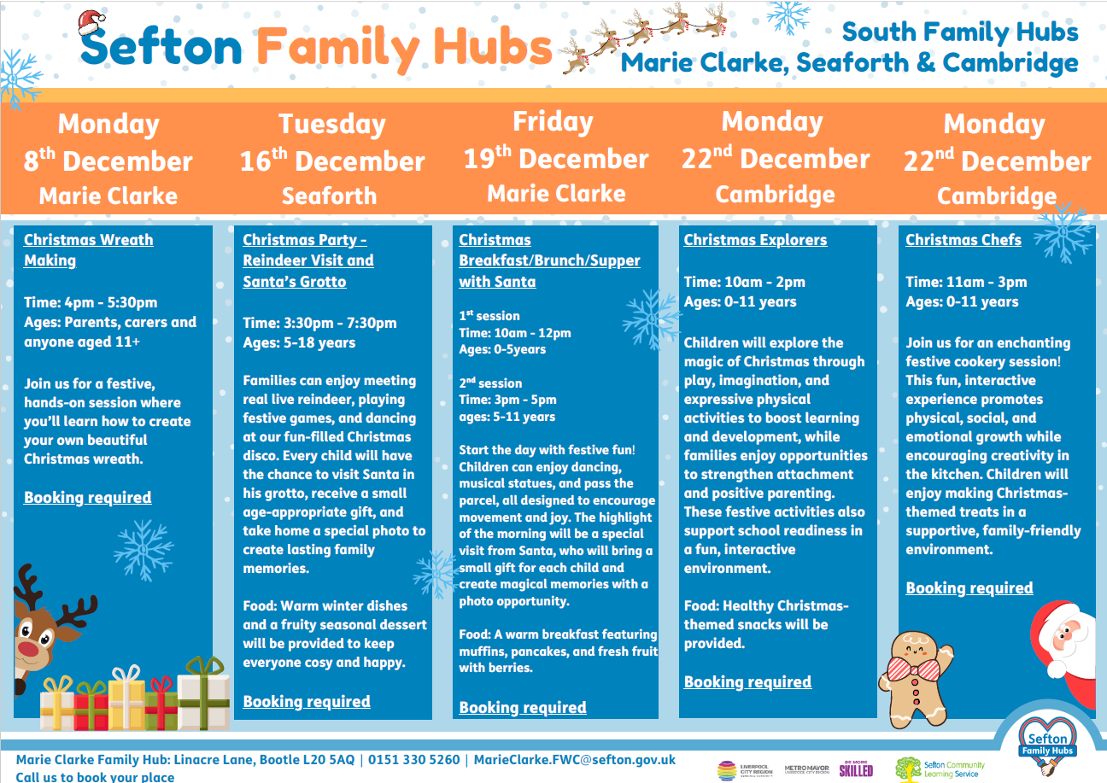

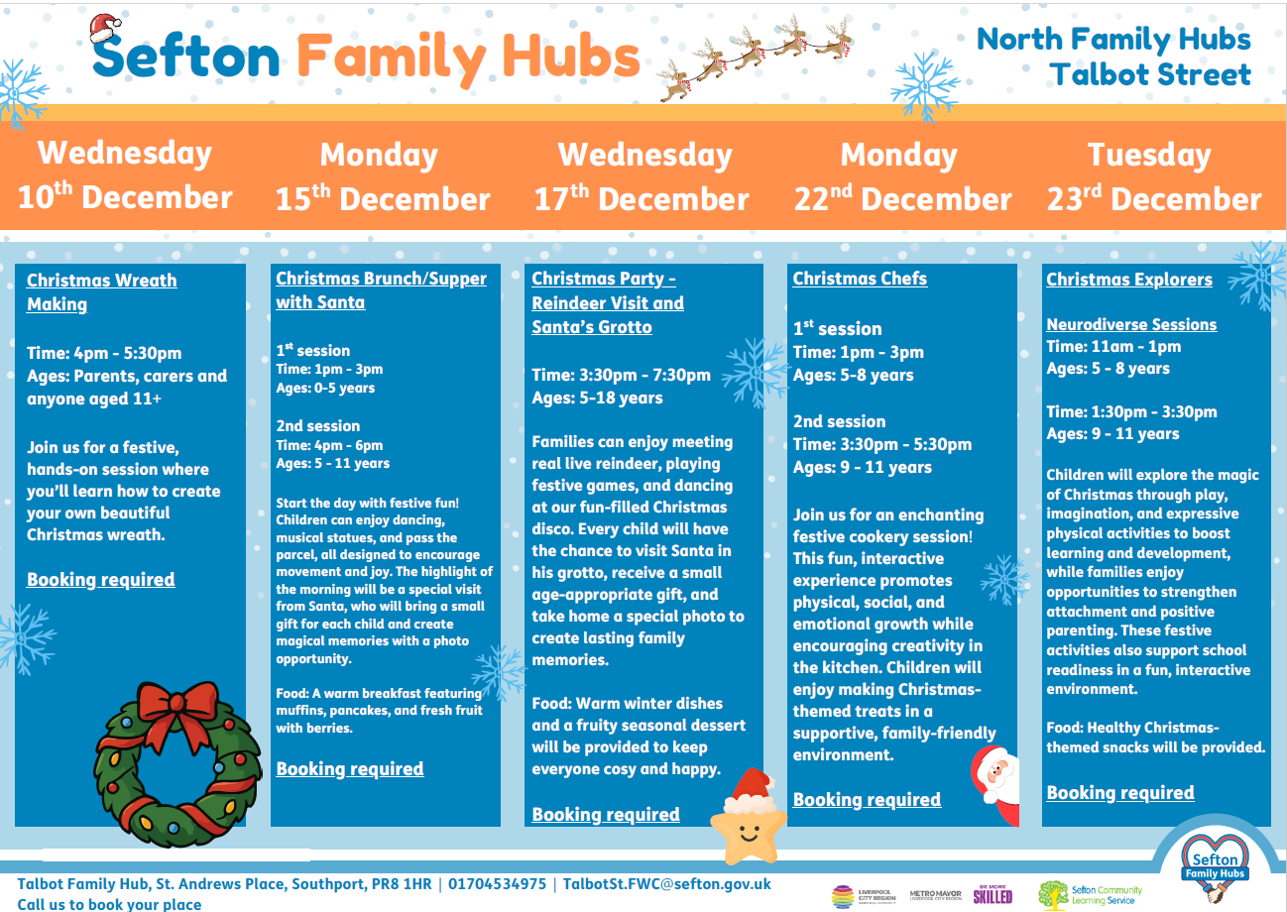
CAFOD Christmas Fun Run
All are welcome at CAFOD’s annual Christmas Fun Run at Wavertree Sports Park, L15 4LE on Saturday 27th December 2025. Registration open from 10am, and the run sets off at 11am. 3k and 5k route options available, pram friendly route and dogs on leads are welcome too. Festive attire is encouraged! We’d love to raise more sponsorship from this event. For a sponsor form or interest in volunteering at the event, please email Colette on cbyrne@cafod.org.uk or sign up now by visiting cafod.org.uk/christmasfunrun
Entry Fees: £10 adults | £5 children | £20 family ticket

Please Note: Due to planned works on The Mystery Park, this year's route will be adjusted to avoid the area. We’re looking for some extra help to marshal the route, as well as helping with the sale of raffle tickets and hot drinks on the day. If you know someone who could help us out, please do get in touch!



