
Great Crosby Catholic Primary School’s
Great Sponsored Run 2026!
Name_____________________________________ Class__________
I am raising money so that our school can improve the outdoor provision for all our pupils. I will be taking part in a Sponsored Run on 25th September and I would love it if you could help by sponsoring me.
On behalf of everyone at Great Crosby,
Thank you!
Name of sponsor | Amount sponsored | Tick when paid
 |  | 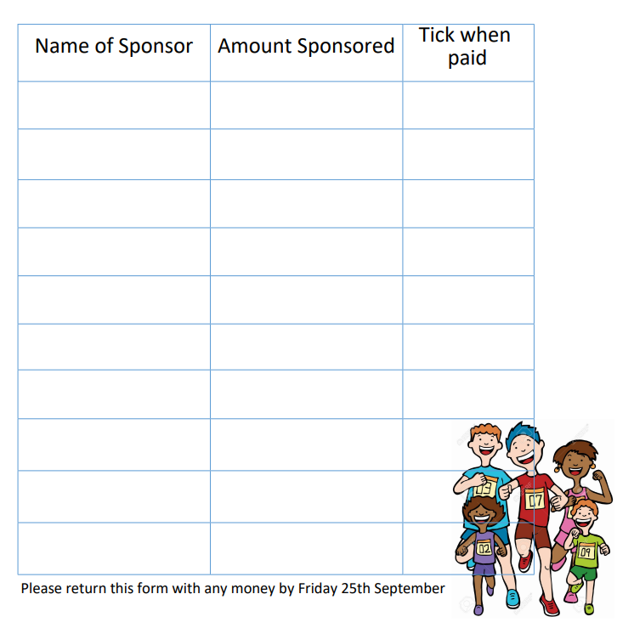
Please return this form with any money by Friday 25th September.

