
January 22, 2026
PUBLIC NOTICE

Legent Home Products Ltd. (Oakville, Ontario) and its manufacturer produced a series (refer to serial number range below) of Drain Water Heat Recovery Devices and mistakenly applied the UL Mark before UL authorization was granted.

The affected Drain Water Heat Recovery Devices (the “Subject Product”) were/are:
- Model No. LHP-338-PEX
- Manufactured between April 2025 and June 2025
- Serial numbers range between 12346 and 14598
Items (b) and (c) can be found in the red boxes on the product label affixed to the product. M See example below.
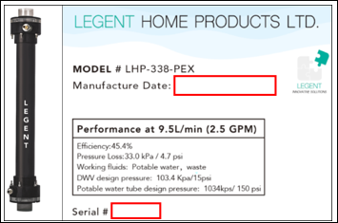
Suggested Action:
There are no issues with the manufacturing or functioning of the Subject Product.
If you have any questions to this product or the safety requirement, please contact Legent Home Products Ltd. at the phone or email below.
Contact: Peter Riley
Phone #: 1-416-567-1288
Email: peter.riley@legenthomeproducts.com

