Welcome to Worship. Welcome to our Sunday celebration. Called and gathered by Christ we are filled with expectation and joy. We have seen the light of his presence among us and our lives shall never be the same again.

Please Pray for Those Who are Ill, in Hospital, or Requested Special Prayers: Bev Barber, Mary Brown, Elinor Clifton, Esther Corrigan, Lorne Enright, Andrea Fairweather, Florence Felske, Marie Green, Leona Hein, Sheila Jonas, Bill Kennedy, Myrtle Lanthier, Alysia Lubitz-Beevis, Michael Martens, Rhonda Mau, Peter Oggel-Breedyk, Vince Rabishaw, Cindy Romain, David Rose, Anne, Betty, Helen Sabourin, Edith Scholtz, David Stresman, Wendy Tanner, Kaitlyn Vaillancourt, Dorian Verch, Sarah Verch.

Offertory Prayer
All – Your Spirit brings many gifts and these we offer in love and devotion to Christ and his body, the Church. May your blessings to us, your beloved children, be known to all the world in our sharing of what you have so generously given us. Amen.
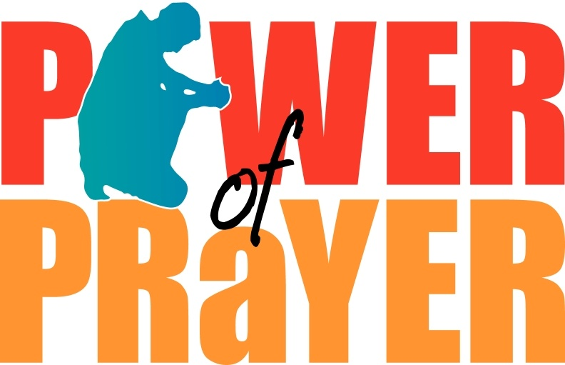

Post Communion Prayer
All – Gracious God, in this Blessed Sacrament we taste and see your goodness and grace, gifts of your everlasting love. Fill us with joy as your beloved ones and help us share your mercy and grace with all we meet, our brothers and sisters in your holy family. Amen.
Today’s Scheduled Worship Leaders

Altar Guild: Cheryl Sack
Counters: Susan Dupuis, Wayne & Linda Reiche
Greeter: Myrna Valliant
Projector Operator: Philip Vandersleen
Sexton: Diane Hammel
Ushers: Sonya Grife, Pam Duplessis, Al Kellough, Robbie Tremblay
Worship Assistant: Ellen Vandersleen

Weekly Statistics for January 19

Attendance - 66
Offerings - Regular - $2,207.00 Specials - $355.00

Monthly Pre-Authorized Remittance (PAR) for December
Regular - $3,813.00 Specials - $17.00, which equals $762.60 for Regular and $3.40 for Specials per week.

Liturgy taken from sundaysandseasons.com. Copyright 2019 Augsburg Fortress. All rights reserved. Reprinted by permission under Augsburg Fortress Liturgies Annual License #SAS026965

Setting One

Prelude
Words of Welcome
Gathering Song #798
Greeting p.98
Kyrie p.98
This is the Feast… p.101
Prayer of the Day (see bulletin front cover)
Children’s Homily
Reading Isaiah 9:1-4
Psalm (I Long for You, O Lord)
Reading 1 Corinthians 1:10-18
Gospel Acclamation p.102 (Cantor sings proper verse, followed by Alleluias)
Gospel Matthew 4:12-23
Sermon
Hymn #817
Prayers of the Faithful
Sharing of the Peace
Offering
Offering Song #184
Offering Prayer (see inside bulletin cover)
Great Thanksgiving p.107
Eucharistic Prayer #1 p.108 (with Acclamations)
Communion Songs #472,#306
Prayer after Communion (see inside bulletin cover)
Blessing
Sending Song #548 (alt. tune)
Dismissal
Postlude
You may remain for prayer and for reflection & to listen to the beautiful music of the postlude before leaving the Place of Worship today.

