When Doctors, experts, advocates, and patients join forces we can move mountains towards enacting legislation to once again protect the Doctor/Patient relationship and ensure that Doctors are ALLOWED to base medical decisions on the individual patient and their best clinical judgement.

For more information and to be connected with other professionals, please Visit, Email, Call, or Text:
www.PainWarriorsUnite.com
doctors@painwarriorsunite.com
(202)792-5600

Informational Packet for Medical Professionals to Join Pain Advocacy Groups

Stuck between the Hippocratic Oath, Suffering Patients, and Interference.

In todays environment, Doctors are being pulled in many different directions. I think it was said best by Dr. Grinspoon(1):
“When it comes to providing pain medications, and treating chronic pain patients, doctors can feel as if their moral universe is broken. We are assailed on all sides. Bureaucrats try to restrict our prescribing and intimidate or harass us into not prescribing opiates. Patients rage at us when we can’t or don’t prescribe these medications. The end result can be a rupture in the thing that most of us value above all else: the doctor-patient bond.
A good deal of the problem is that physicians are caught between two competing agendas; combating the opiate epidemic by curtailing the overprescribing of opiates and treating the chronic pain of people who, for better or worse, currently rely on opiates to alleviate this…”

So, what can be done to stop the damage being done and to further protect the doctor/patient relationship?
At this point in the game, a plethora of new bills have been rushed through the House of Representatives ‘HR6’ (2) without even one of our Representatives stopping to ask a very vulnerable population affected by them: patients that are being restricted by the new limits and possibly more important the doctors that see these patients every day. These same bills are sitting in the Senate waiting for the committees and senators to be completely back in session so that they can be quickly and quietly passed in an effort to look tough on drugs and compassionate towards the disease of addiction. Due to much political discourse in this election year, this vote may be pushed until after the November Midterm Elections to somehow sway the election(3). This is our chance!

Medical Professionals, Patients, and Advocates are now joining together in all 50 states to educate ourselves, our caregivers, the media, and policy makers. It is important that each Senator receive well informed and organized calls, letters, faxes, emails, and personal meetings with representatives from the chronic and intractable pain community. We have been organizing and working towards compiling information from contacts between ourselves and policy makers to discover who is beginning to pay attention and who is still advancing the common narrative.
Here is where the medical professionals come in: Join with us. Nearly without fail, new advocates joining this fight have similar questions when inquiring about specific action steps. First is either ‘What celebrity can we get to champion our cause?’ and/or ‘Where are our Doctors in this fight?’. We know there are many compassionate and excellent medical professionals that see what is happening and are doing their best to protect their patients while protecting themselves. With a coordinated and focused effort with specialists from every field, in addition to all patients and advocates, this community will be able to show the policy makers, the media, and the general public that our state and federal government has grossly overstepped their authority in a well-meaning attempt to curb addiction and overdose deaths. Medical professionals know the dangers of this environment of limiting the tools a doctor can use to care for his/her patients by government regulations solely recommended by politicians and doctors with limited or no clinical experience managing pain in patients with complex disease processes. When reaching out to our legislators a common response has been that they are surprised to discover the patients that benefit significantly from Opioid pain medications are not still receiving them in adequate doses. They have been told that no laws have been passed that prevent a doctor from prescribing adequate doses and that pharmacists do not deny legitimate prescriptions. They believe the tapers are voluntary and that patients are not being abandoned although they are thriving and following every aspect of their treatment plan. They seem to truly believe that the guidelines were written with good science and intentions and that they are not harming legitimate doctors and patients. Once they are told that patients are suffering by the thousands and that good doctors are being targeted for ‘over-prescribing’ without consideration of the specialty or types of patients that are being treated; they want to hear more, and some are ready to help, but are unsure how. We must give them solutions!

Through trial and error, a formula consisting of constituent chronic pain patients, well educated advocate(s), medical professional(s), and bedridden patients by Skype has been identified. These meetings are a large under taking to align everyone’s schedules with policy makers, but these meetings can be preceded and followed-up with personalized and well-organized correspondence campaigns. At the conclusion of these meetings, a binder of information can be left that contains high quality scientific studies, publications from government websites that contradict the current narrative, graphs and charts showing correlation/causation, as well as pages of patient stories that serve as ‘anecdotal proof’ of the benefits of allowing the physician and the patient to develop and implement a treatment plan based on clinical judgement and mutual respect.
Improving this situation will require educating even other professionals as new studies are being cherry picked to make the argument that opiates have little benefit to chronic pain patients while posing a severe health risk to the entire country. While there is little disagreement that opioids can and have been misused and mis-prescribed, there is much debate as to the role that adequately treating pain has contributed to addiction and overdose rates(4).
There are many layers to contend with, both in overcoming the current narrative and educating ourselves and others. It has been said by professional advocates that a two-hour, meticulously organized presentation is required to touch on each topic and explain how this happened. There are constitutional questions; possible human rights violations; conflict of interest claims from all sides; lack of transparency from the studies used to back the ‘mme’ calculators and subsequent CDC guidelines; CDC scientists claiming findings are misused and the data is flawed(5); insurance companies paying for ‘death with dignity’ but refusing cancer therapies and/or pain treatment; hospice and palliative care patients being made to suffer; media and interested parties that inflate and sensationalize the statistics for financial gains, political alliances and pressures; increasing suicide rates, a lack of willingness to take responsibility for instilling fear into prescribers, medical devices, medical marijuana, and so many more complex issues.
When the scientific evidence is looked at as a whole, patient experiences and function/quality of life are considered, and the true cost of untreated pain is discussed, the only opposition received is generally from those who are financially motivated to continue this current strategy. Know the truth!

This last section contains charts and links that can be used to familiarize yourself and staff with key players, true statistics that have not been sensationalized for impact, as well as citations for the information included. Thank you for taking the time to read and review the enclosed information, and we look forward to working with you to continue shedding light on the overstepping of our government agencies/regulators as well as the true issues facing the most vulnerable segments of our population and the medical teams that treat them!
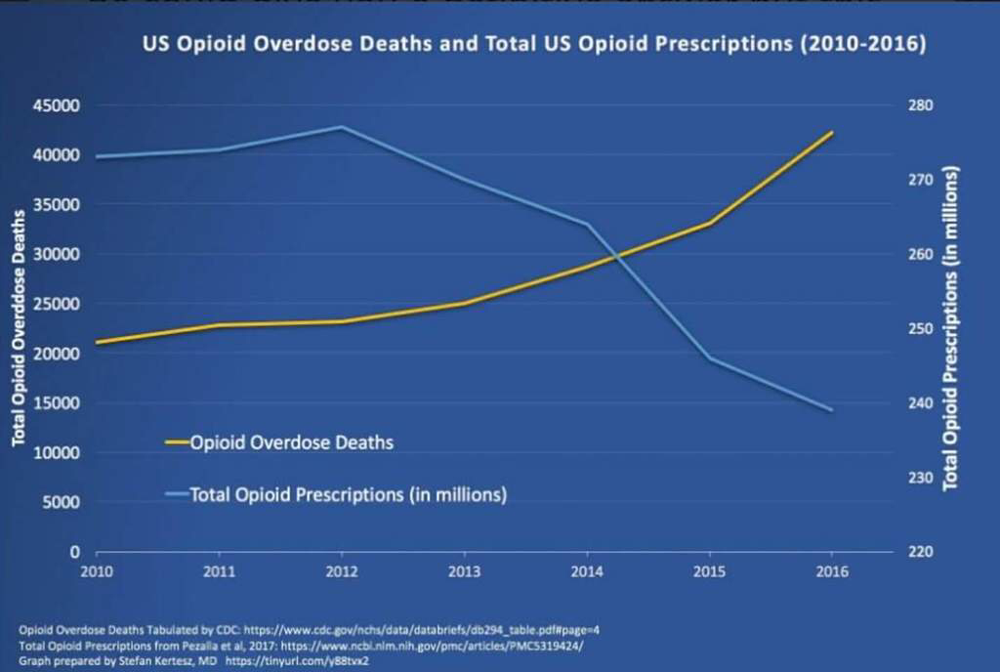
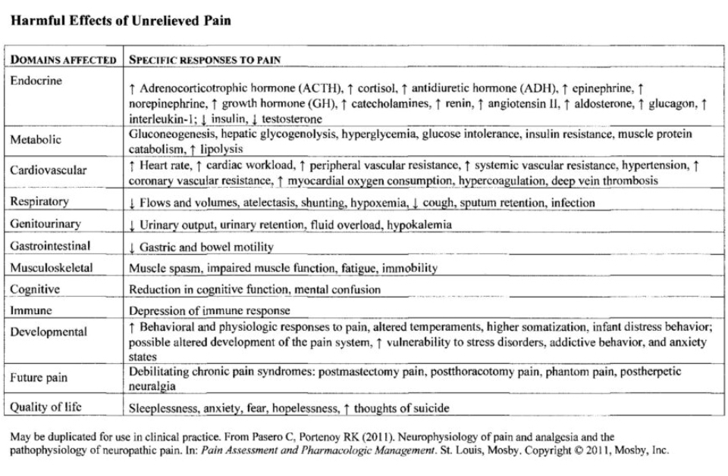

*Everyday the media and policy makers use this number for shock value, but do not always include the disclosure that it includes all Overdose Deaths with EVERY drug, legal or illicit.
**When pressured by ‘truth seekers’ for the data directly related to ‘opioid’ overdose deaths, this number is given but again the disclosure that it also includes illicit fentanyl and heroin are rarely made.
***After many advocate groups and other ‘truth seekers’ pressured further, this number is made available representing EVERY overdose death where a prescription opioid pain medication is present at death; but still, the disclaimer is rarely made that even this number includes Methadone (which can be used for both pain and medication assisted therapy for substance abuse disorder) and all prescription medicines without distinction as to where or how the medication was actually obtained or the reason (legitimate medical or recreational)

Suggested reading:
CDC Guideline quality of evidence: http://nationalpainreport.com/tracking-down-the-research-behind-the-cdcs-opioid-prescribing-guidelines-8831122.html
NY Times connect some financial dots in 2013: https://www.nytimes.com/2013/11/17/health/in-demand-in-clinics-and-on-the-street-bupe-can-be-savior-or-menace.html
FDA calls guidelines dangerous, but CDC adopts them? What’s really going on: https://www.acsh.org/news/2017/10/12/opioid-epidemic-6-charts-designed-deceive-you-11935
A link to the actual CDC Guidelines; although a “GUIDELINE”, they have now become “silent requirements” that have had a ‘chilling effect’:
https://www.cdc.gov/mmwr/volumes/65/rr/rr6501e1.htm

Citations:
- https://leanforward.hms.harvard.edu/2018/04/05/doctors-and-patients-treating-chronic-pain-as-a-team/amp/
- https://www.healthlawpolicymatters.com/wp-content/uploads/sites/8/2018/06/House-Opioid-Package-6-21-18.pdf
- https://www.washingtonpost.com/news/powerpost/paloma/the-health-202/2018/07/26/the-health-202-some-experts-think-mcconnell-is-playing-politics-with-the-opioid-crisis/5b58a5a61b326b1e64695547/
https://www.rollcall.com/news/politics/vulnerable-democrats-opioid-epidemic
- https://www.linkedin.com/pulse/attention-cdc-its-time-tear-down-your-stone-walls-richard-lawhern/?published=t (The published works by this scientist explain in detail nearly every angle from the perspective or medical professional)
- https://www.acsh.org/news/2018/03/19/cdc-quietly-admits-it-screwed-dishonestly-counting-pills-12717
https://www.cato.org/blog/cdc-researchers-state-overdose-death-rates-prescription-opioids-are-inaccurately-high

