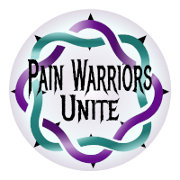
When you or a loved one are in pain, having many treatment options is Crucial
What works for one, may cause harm to another; because of this we need continued access to as many options as possible giving each individual patient the best possible chance of having their pain treated well enough to enjoy a good quality of life. By the time a patient has been in pain long enough to reach the status of ‘Chronic Pain Patient” most likely they will have tired 6 or more alternatives. In most cases, opioid pain medications are a last resort for chronic pain, but it is vital to keep it as an option.
Integrated Therapy Models include Opioid pain medications combined with alternatives such as:
- 1. Non-Opioid Pain Medications
- 2. Certain Steroid Injections
- 3. Physical Therapy
- 4. Topical Creams/Lotions/Patches
- 5. Heat/Ice Therapy
- 6. Disease Specific Medicines
- 7. Chiropractic Treatment
- 8. Massage
- 9. Elec. Stimulation or TENS Unit
- 10. Supplements
- 11. Acupuncture
- 12. Life Style Modification
- 13. Mindfulness
- 14. Hypnosis
- 15. Cognitive Behavioral Therapy

if you believe that you are not affected by the current policies and laws at the federal and state levels, you are wrong.
While you may not be currently in need of options to eliminate physical pain, right now someone in your life is, and odds are very high that at some point in your life, you too will need pain control for an accident or illness.
These over-reaching policy and laws are the direct result of a campaign to reduce prescribing of prescription Opioid pain medicines in the hopes of reducing the addiction and overdose crisis. While it likely began with good intentions, it has now reached to point of affect pain management in every disease and population.
Cancer patients, hospice patients, those awaking from major surgery are now being affected by the guidelines intended to reduce access to these medications for non-medical purposes. 7 out of 10 Doctors report reducing or discontinuing prescribing of Opioid pain medications while admitting that it is due to fear of prosecution and not because the patients’ pain was reduced or effective alternate treatments were found. Where does that leave the 30 million patients that benefit from Opioid pain medications?

On Facebook:
Pain Warriors Unite
Phone:
(202)792-5600
Website:
www.painwarriorsunite.com
Email:
warrior@painwarriorsunite.com
Visit, connect, text, or call to find out how to tell legislators you want them out of your exam room

“How much longer do we allow policy makers and insurance companies decide how our doctors treat us?”

we keep hearing shocking statistics that make it sound like prescription pain medicines and chronic pain patients are fueling the opioid epidemic, look at these charts and decide for yourself!
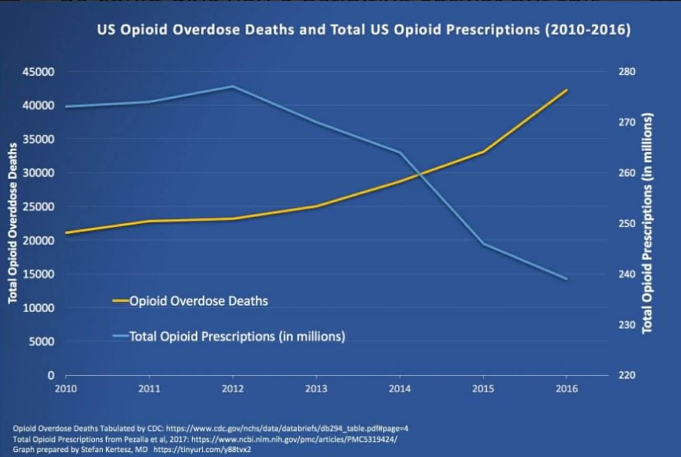
70,000
60,000
50,000
40,000
30,000
20,000
10,000
#OD Deaths
Most commonly misquoted stat, inc ALL drugs illicit opioids, meth, etc.
A little better, quoted as ‘Opioid’ stats inc heroin and illicit fentanyl
Actual OD deaths involving prescription Opioid pain medicines, but without regard to how the medication was obtained: legal script, stolen, street. It counts any OD death when prescription opioids are found even though an average of 6 substances are found in autopsy results (alcohol, benzos, marijuana, etc.)
All data found on CDC Website, even most reasonable data cannot account for the dozens of factors that can cause the data to be skewed to fit the narrative

who will not be here tomorrow

what kills us:

2016 Year in Review, what killed us:
6775 Americans will die EVERY DAY – from various reasons
2700 people WILL ATTEMPT SUICIDE
140 will be SUCCESSFUL – including 20 veterans
270 will die from hospital acquired antibiotic resistant “bug” because staff won’t properly wash hands and/or proper infection control.
350 will die from their use/abuse of the drug ALCOHOL
1200 will die from their use/abuse of the drug NICOTINE
1400 will contract C-DIF from Hospital or Nursing home because staff doesn’t properly wash their hands are adhere to infection control
80 WILL DIE – mostly elderly.
850 will die from OBESITY
700 will die from medical errors
150 will die from Flu/Pneumonia
80 will die from Homicide
80 will die in car accidents

80 will die from ALL drugs ODs

What YOU can do to ensure our Doctors are ALLOWED to treat pain appropriately

It is time for every Medical Professional, Patient, Caregiver, Patient Advocate, or anyone who may need medical attention in the future to contact their state and federal level policy makers to ask them to give our doctors back the right to treat their patients individually in a way that our licensed and trained Doctors feel is medically appropriate.

Over the last decade or so, the critical Doctor/Patient relationship has come to focus much less on what is medically necessary for the patient to insert insurance companies, politicians, pharmaceutical companies, and other financially interested parties into our Doctors’ offices. It is time to tell them all to leave the exam room!

There is no doubt that we have an overdose crisis in our country, nor is there debate that all patients regardless of diagnosis deserve fair and individualized treatment. Where there is debate, is how to best offer treatment for the <5% of the population suffering from addiction without denying quality of life to >100 million that suffer from Chronic pain!

Educate yourself with the facts instead of hype and then contact your state and federal congress person. Insist on protections against interference in the Doctor/Patient relationship, ask them to work towards a ‘National Pain Policy’ that protects the right of a pain patients (acute or chronic) to have their pain treated adequately, as well as to protect our compassionate Doctors that treat these complex cases from prosecution when they are doing nothing more than treating pain individually.

