Hi Parents,
Below are the dress guidelines for the Academy. All clothing should be kept in good condition throughout the school year (no stains or holes). Rather than bogging you down with volumes of rules I ask that you take it upon yourself to send your child to school wearing clothes that lend to the definition of “uniform” rather than individualism. The kids should look like they belong at the same place, from head to toe. Please do your part as parents to promote uniformity within the uniform.

Daily Dress
Shirt:
Red or White logoed polo
Red or White logoed long-sleeved shirt
Red or White logoed hoodie (Must have a school logoed t-shirt underneath)
Red or White logoed t-shirt

Bottoms:
All bottoms should be khaki style and TAN or BROWN color (not bone or white – pictures below)
Khaki pants...not jeans, not cords, etc.
Khaki shorts…

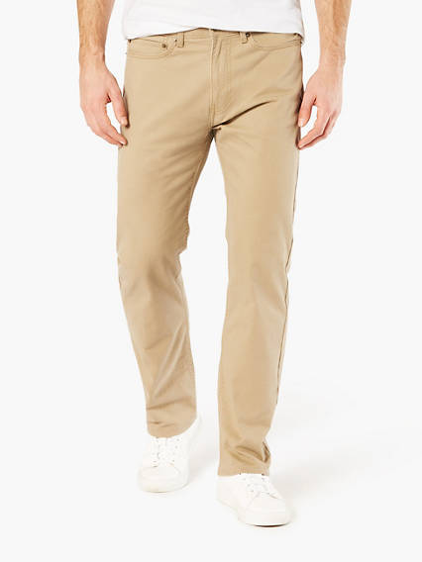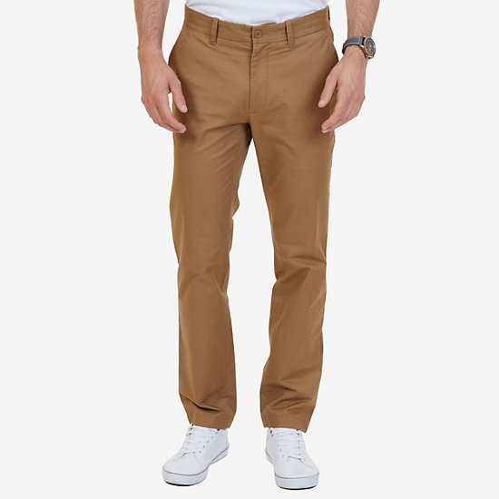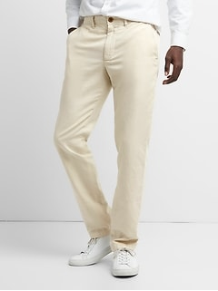
Tan – YES Brown – Yes Bone - NO

The guideline for short length is as follows:
When a child stands up straight, but relaxed as normal, and puts his arms straight down the side of his legs, with his fingers pointed straight down his legs, his fingers should be completely touching his shorts. If not, the shorts are too short for school.
Khaki skirts, khaki skorts, and khaki jumpers are authorized.
Leggings under skirts are okay and should be white or tan.

Belt:
If a student chooses to wear a belt it must be brown or black.

Shoes:
Rubber soled shoes, preferably tennis shoes. Open toed shoes and sandal (flip flops) are not permitted.

Socks:
Only completely black or white socks are permitted. Socks must be worn at all times.

Etcetera:
Female students are welcome to wear make-up but asked to refrain from bringing it to school. However, items that encourage good hygiene, ie. deodorant (non-aerosol), are welcomed at school.

PE Attire
Students should have tennis shoes that are made for running, a top and bottom that are made for exercising. Spandex shorts are permitted to be worn under regular bottoms to promote modesty. No tank tops or short shorts.

Restrictions:
Short length falls under same guidelines as mentioned above.
Shirts should not reveal cleavage, bare shoulder, or bare mid-drift.

Casual Dress Friday

SHIRTS:
T-Shirts non logoed are allowed
- Shirts should not reveal cleavage, bare shoulder, or bare mid-drift.
- May display images or text, so long as they are appropriate
  - No violent images, disturbing images, or scandalous images
  - No text containing profanity, slurs, or otherwise offensive language is permitted

BOTTOMS:
Jean pants, jean shorts, jean skirts are acceptable (any color, not torn, and follow short length guidelines)

JACKETs and SWEATSHIRTS:
Plain Jackets
- Jackets or Sweatshirts should not reveal cleavage, bare shoulder, or bare mid-drift.
- May display images or text, so long as they are appropriate
  - No violent images, disturbing images, or scandalous images
  - No text containing profanity, slurs, or otherwise offensive language is permitted

HATS:
Allowed so long as they are also appropriate, similar to shirts and jackets.

Picture Day
Students will have two picture days.

First picture day is for individual pictures. Students do not have to wear their school uniform. Hats are not permitted, and rubber soled shoes should be worn. Please help your child to understand this is not a day for them to wear whatever they want.

The second picture day is for class pictures. Students must wear either a uniformed polo or t-shirt. No hoodies or jackets.

Generally Speaking
It is never mandatory for a student to “dress up”. Also, students are always allowed to wear their uniform regardless of Free Dress, Picture Day, or any other special day or occasion as designated by the school. Uniforms are always welcome.

If at any time a student is wearing something that does not coincide with what the academy promotes parents will be notified and possibly asked to bring a change of clothes, and the student will be asked to refrain from wearing that article of clothing in the future.
If the student continues to violate the dress code on a consistent basis, heavier disciplinary measures will be taken including suspension and ultimate removal from the school.

Thanks,
Evan Vassar

