MSTI Basic Training Guide
Getting Started –
MSTI Website Demo for MST-PRV Teams



MST INSTITUTE June 2024

Table of Contents
The MSTI Website Homepage (msti.org) 3
Login Process 4
Initial Login 4
Privacy Policy 5
Access to MSTI.org for Training Purposes 5
Change Password and Update Profile 6
Forgotten Username or Password 7
Navigation and Features 9
Demonstration on Adding, Editing and Listing Forms 12
Edit Base Case Enrollment Form 15
TAM-R Form Demonstration 17
Add TAM-R Form 17
Edit TAM-R Form 17
Discharge Form Demonstration 18
Add MST-CAN Discharge Form 18
DATA DEFINITIONS FOR MSTI DISCHARGE FORM 19
CASE PROGRESS REVIEW ITEM 19
INSTRUMENTAL OUTCOME ITEMS: 21
ULTIMATE OUTCOMES ITEMS: 21
OPTIONAL OUTCOME- SUBSTANCE USE OUTCOMES 24
GUIDELINES FOR WHEN YOUTH IS ON RUNAWAY STATUS 28
Saving the MST-CAN Discharge Form 31
Edit MST-CAN Discharge Form 31
SAM Demonstration 33
Add SAM Form 33
Edit SAM Form 33
Parent SDQ Demonstration 34
Add a Parent SDQ Form 34
List Reports Demonstration 37
Viewing Existing SDQs 38
Accessing the SDQ Score Report 38

The MSTI Website Homepage (msti.org)

It is not possible to cover everything someone needs to know about the website in this initial training. We will focus on showing you how to navigate the website so you can explore on your own. The most important points will be covered here.
Before we begin, please take a minute to review the below overview of the homepage on msti.org. Save this site on your favorites for ready access to all the resources here.
If you explore the main menu, you will see links to important information, forms and resources.
*Please make sure that you review these, as they provide helpful tips and guidelines pertaining to QA, TAM- Rs and SAMs.



Login Process

Initial Login

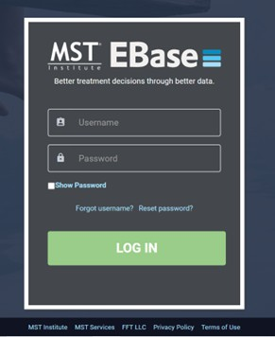
Please review the 'Managing Users' training guide, to learn how to add users, or have users added to the MSTI website. It can be found here: https://msti.org/training-and-education
When a user is added to the website, the system will automatically send 2 emails to that user (to the email address that was entered in their account). The user should receive these emails within 1 hour of the time that they were entered into the system.

One email will contain a username, and the other will contain separate information to confirm your account and set up your password. The user should immediately login and change the password (see section below). Make sure to keep the login information secure, as this allows access to your data! A valid email address is required.
Note: Users cannot use the MSTI website without a working email address and they should not be set up on the site until they have a working email address at your organization. Organizations that do not provide email to their staff will need to make sure that anyone that will be using the website sets up a personal email account (ex: Gmail).

Please make note that personal email accounts may give the user less control over what mail is considered spam/junk. Users that have accounts with Yahoo, AOL, Hotmail, etc. may not receive any email from our system, due to automatic blocking of all system generated emails.

In addition, personal email accounts are not as secure as email accounts that are managed and monitored by your organization’s IT staff. For this reason, we strongly suggest that you use your office email addresses, or a more secure, personal email account such as Gmail.

Note: You may have to initially check your junk folder in that account, for the emails from our system and specify that they are 'Not Junk', so you will receive them in the future.

Privacy Policy
Upon logging in for the first time, users will see the privacy policy for the MST Institute. MSTI is dedicated to maintaining a high level of security and privacy practices for all data housed on our websites. We are committed to following all necessary procedures to ensure we are compliant with the most stringent international data security standards, thus insuring that MSTI is both HIPPA and GDPR compliant.
In order to access the site, the privacy policy must be accepted. If you choose to not accept this policy and the way MSTI stores your information, you will need to work with your supervisor to create a plan to meet your job responsibilities without using our website.
For further questions, please reach out to the MSTI Helpdesk at msti@mstinstitute.org.
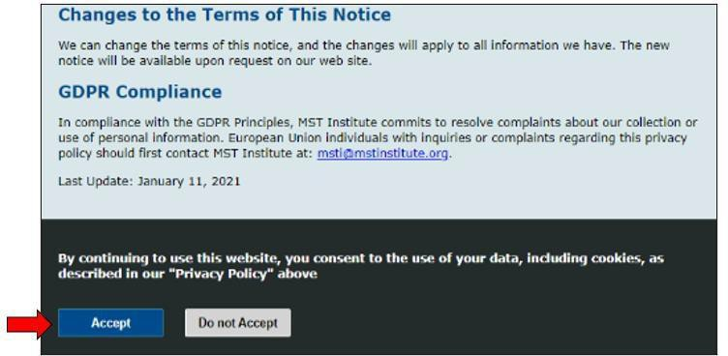

Access to MSTI.org for Training Purposes
An environment for demonstrations is available within the website to allow new users an opportunity to explore, edit and train.
To access the website and explore its functionality at each user level, please reach out to the MSTI Helpdesk directly (msti@mstinstitute.org) to obtain a demonstration login.

Change Password and Update Profile

On the main page, users will see a main menu, where they can select ‘Change Password’, to automatically change their password.
They will also see a selection to ‘Update Profile’. This selection will allow them to update their first and last names, username, or email address. It is extremely important that they provide us with an updated email address if it changes.

To change your password, simply click the ‘Change Password’ link shown above. You will be asked to enter the new password twice and you will need to follow the password rules to the right of the screen (shown below).
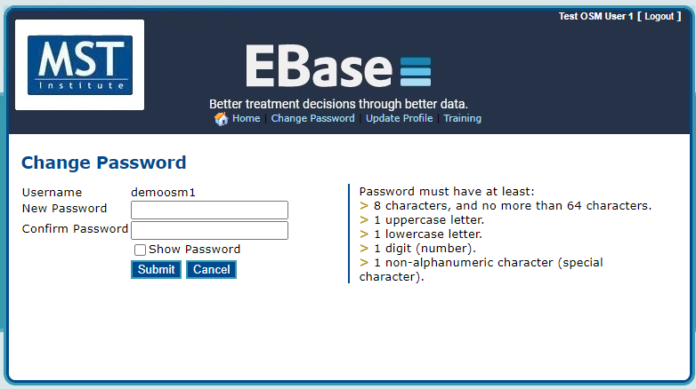

Continue’ and the system will automatically email the new password to you at the email address that we have in our system.

To update your profile, simply click the ‘Update Profile’ link shown above. Your existing profile information will be displayed (see screenshot below). You can edit any of the information on that screen and it will update all records in our system.
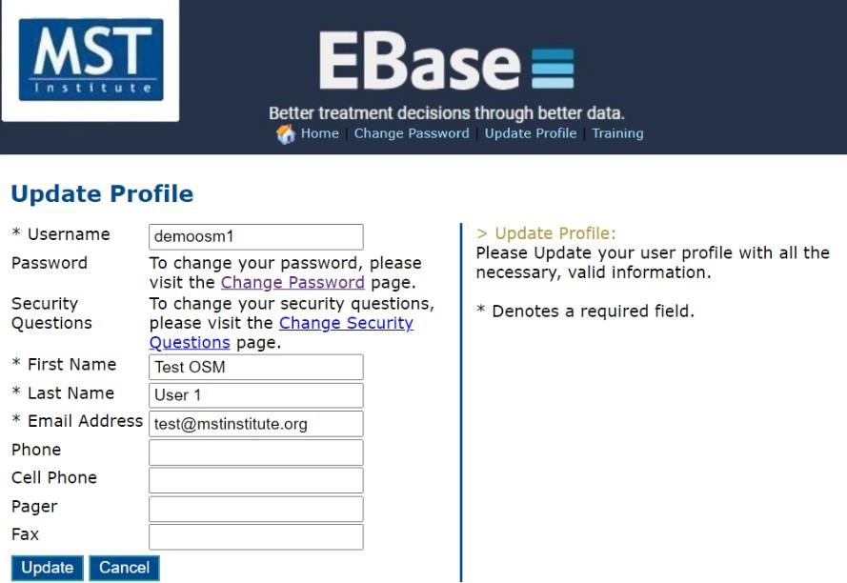

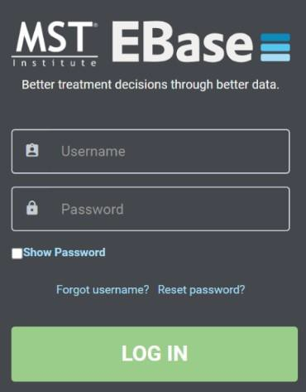
Forgotten Username or Password

Click ‘Forgot Username or ‘Reset Password’ to retrieve that information.

The ‘Forgot Username’ and ‘Reset Password’ are now built-in functions of the website. Users can go to the login page and select ‘Forgot Username’ or ‘Reset Password’.

Screen #1: Forgotten Login
Users will then be taken to the specified screen, based on the selection they made above.
The information is immediately sent to the email address that we have on file, so it must be a working, accessible email address.

Screen #2: Forgot Username

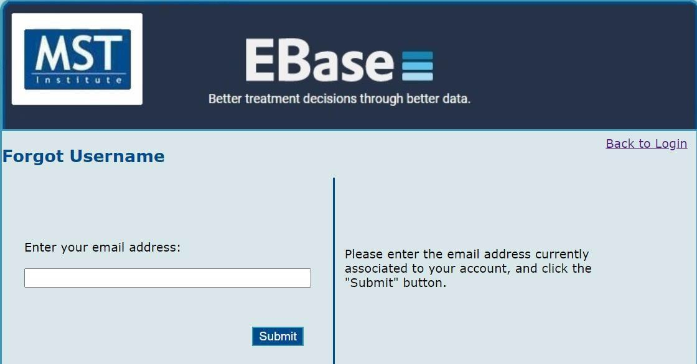

On the “Reset Password” option, an email is sent to the user with a link to confirm their identity. That link is only active for the time stated in the email, so the user will have to go back through the process to reset the password again, should the link expire prior to them clicking it and confirming the account.
Reminder *Again, the information is immediately sent to the email address that we have on file, so it must be a working, accessible email address. *
You will also have the option to “Answer Security Questions” that you previously set up. If you have not set
them up, or do not remember your questions and answers, you need to use the “Send Mail” option.

Screen #3: Reset Password

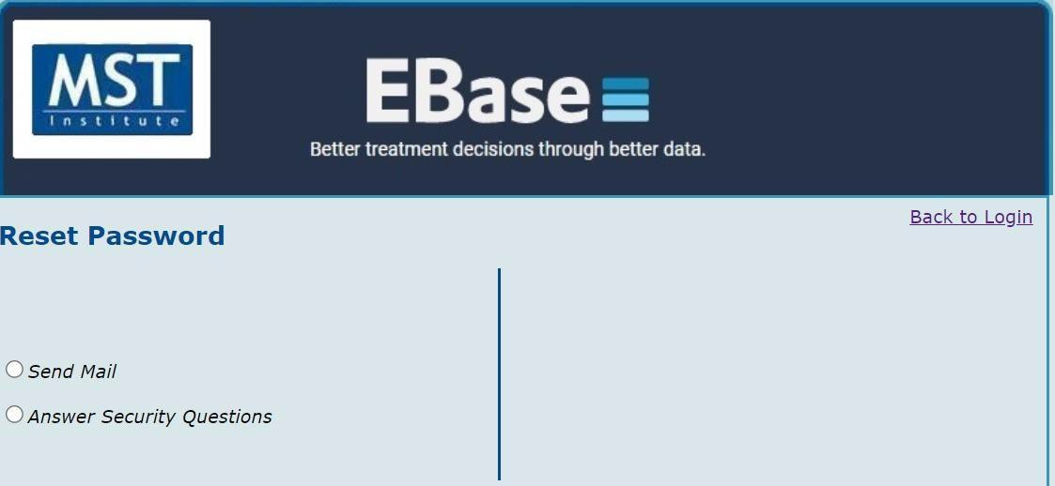

Navigation and Features

- Forms and Reports on separate tabbed menus.
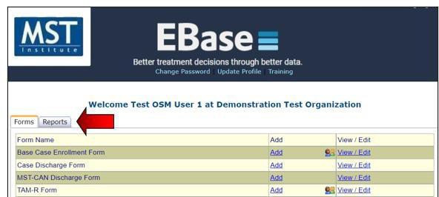

- Simple navigation… selections are 'Add,' or 'View/Edit' for forms.
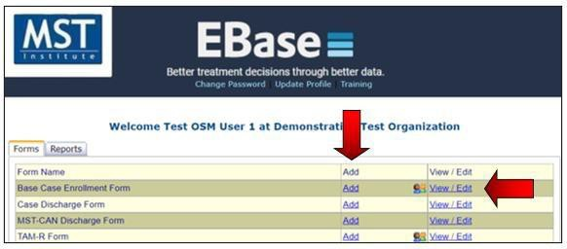

- Clicking on “View/Edit” will produce a list of all the records for the selected form that the user is entitled to see with their user privileges.

- The data in the list can be exported directly into Excel and Word. This action will export only what is on the screen. To export long lists first click “View all” or change Page Size to a large number.
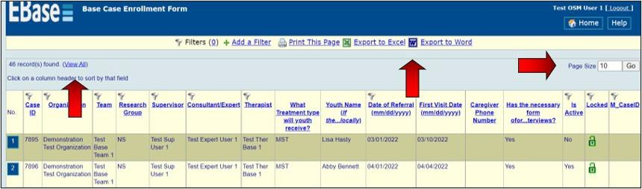

- Sort records with ease by clicking on the column header
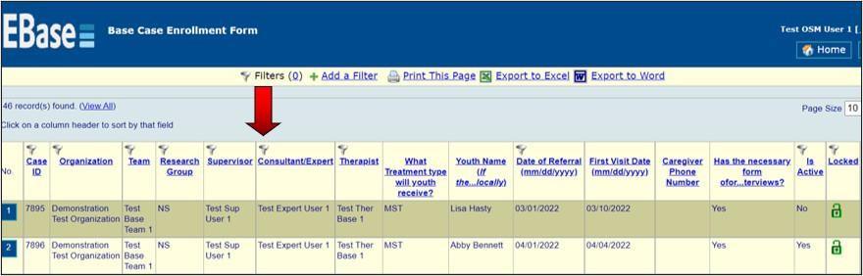

Simplified Filtering

- To add a filter, click on the tab called ‘Add a Filter’, select from the drop-down menu
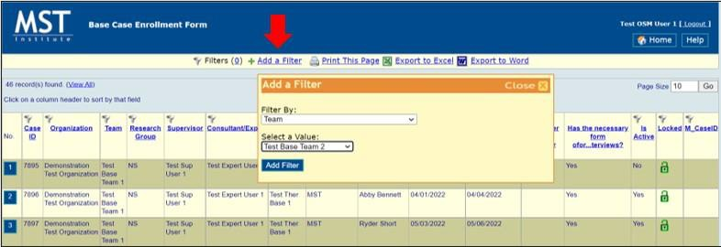

- Easily remove filters by clicking on the number in ( ) and then clicking “Remove”
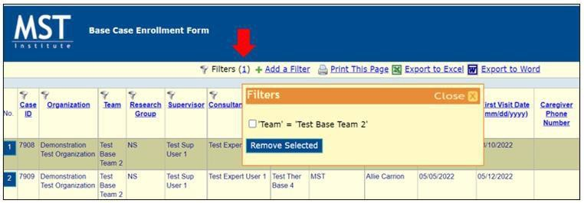

Demonstration on Adding, Editing and Listing Forms

Add Base Case Enrollment Form
A Base Case Enrollment Form is entered for the identified primary or target child when a referral is accepted.

Click on the link for “Add” next to Base Case Enrollment Form
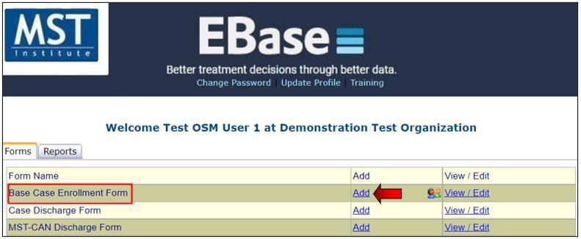
A pop-up drop-down selection will appear on your screen, with a list of teams that you have access to. Find the team that you wish to add the case to and click 'Select'.
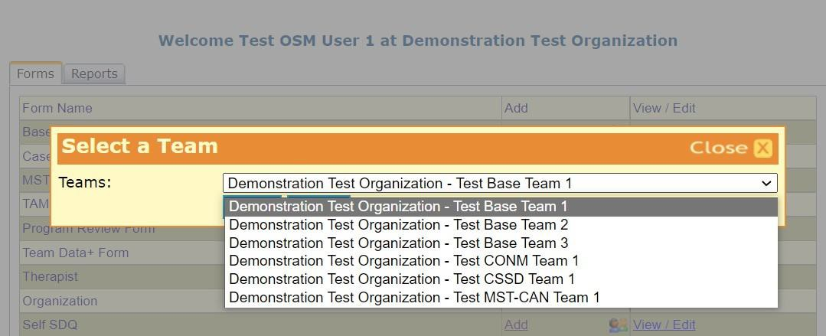
The following text describes elements on the Base Case Enrollment Form.
First, note that some of the information is already completed. This is based on the login code.
However, since there are multiple therapists for this team (see the drop-down list) we need to identify the therapist for this case.
Note: The therapist will default to the first in the list, based on alpha-order. Make sure to change it to the correct therapist.
The Research Group data element can be left with the default value of “Not Specified” unless your organization wants to be able to categorize your clients into groups. Then you would pick a letter to symbolize a particular group. The Report Codes 1-3 work the same way as the Research Group. Each of the Report Code data elements will default to “Not Specified” unless your organization wants to categorize your clients into additional categories to filter information.
For example, one organization needs to report to their primary funding source on a subset of youth who have a special legal designation. These youth are given a different code from the other youth and reports can be generated that include only these youth. Report Codes 1-3 allows organizations to further filter subsets of youth. Each organization should choose report codes for each desired filter area and consistently use them to run different subsets of youth. For example, The Research Group could be used to capture referral source, while a report code could be used to capture different team coverage areas.

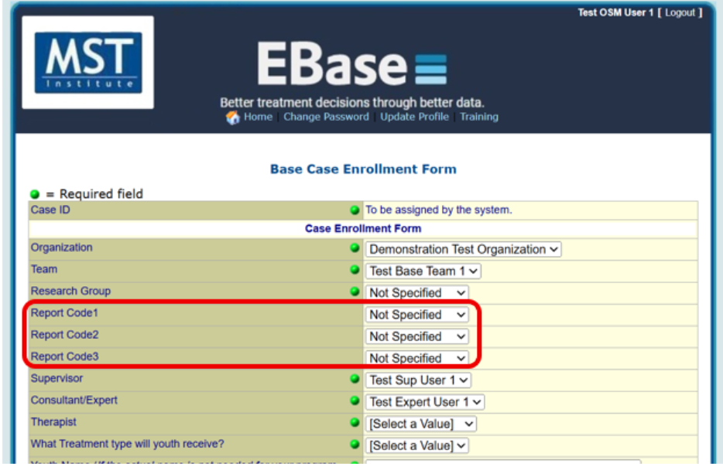
Now, notice the green dots in the right-hand column, these indicate the data elements that are required. For teams who are using a Call Center to collect TAMs, youth, caregiver name, and phone number are required because TAM-R interviewers need this information. Youth and caregiver name fields must be filled out with their actual name, when using a Call Center to collect TAMs.
For all other teams not using a Call Center to collect TAMs, any kind of code can be used for youth and caregiver name. If teams use a code, they need to keep a separate list of the codes and the youth’s name in case they need this information later.
Other required items include Date of Referral (the day you received the client contact information), Gender, Race, Date of Birth, Primary Referral Source.
The First Visit Date (date of your first face-to-face visit) is not listed as required as your Base Case Enrollment form may need to be entered before your first therapeutic meeting is scheduled. If the first visit date isn’t entered initially, it is imperative that you go back and edit the form later to add it since TAM collection and many reports are driven and calculated from that first visit date.
Please note: You should only put one number in the phone number field (other numbers should go in notes). If there is more than one phone number in any of the phone number fields, a Call Center used to collect TAMs will not be able to process that case.

Finally, for those programs that might want to combine this data with other data (e.g., arrest data, Demographic data from their organization’s information system) there is a place for a local case ID. (see image)
This should be a number that has some other meaning for you, like a probation case number, medical record number, etc. It is optional.

Enrollment notes – this is a great place to put in any information about TAM collection, particularly if you are using the MSTI Call Center. This can record best times to reach, and other calling preferences. You may also use it for notes pertaining to your case that you want to be kept with the record.

The question about consent in EBase is specifically about the family’s consent to participate in a research project that requires informed consent and that might require a follow-up interview after treatment ends. This item does not need to be ‘yes’ to collect the administrative data that will be used for quality assurance monitoring during treatment.
For teams that are required to follow GDPR standards; name, address, and phone numbers, as well as additional contacts, have been removed as required fields. Additionally, youth date of birth will be entered and recorded as year only.
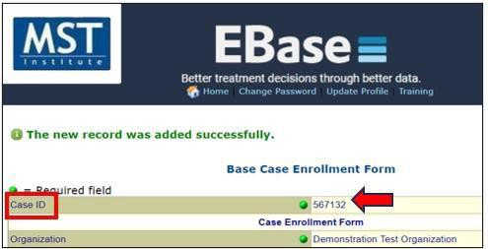
Once you save the records, you will see a confirmation notification that the record has been saved to the database and a system generated Case ID will be assigned to that case. That ID will always be the first field in every form and it should be used when referencing a case, or any other form, when contacting the MSTI Helpdesk.

To return to the main menu, select 'Home' button on the top-right corner of your screen. You should be back at the Main Menu.

Edit Base Case Enrollment Form

Click on the link for “View/Edit” next to Base Case Enrollment Form.
You are then displayed ALL records, for all sites and teams that you have access to. To narrow down the list, simply add applicable filters, by clicking 'Add a Filter', at the top-left of the menu.
The easiest way to find a specific case that you need to edit is by just adding the filter for 'Case ID'. The Case ID is the system generated ID number assigned to each case when it is added to the system. If you have that, then you can add that filter and type in the ID. That will pull up your case.
If not, you can try to narrow the results of your search down, by entering additional filters and sorting the data, by clicking on the column header that you wish to sort by (see screenshot below). Once you add a filter, a list of cases that fit those criteria will be displayed and you can continue to add additional filters, until you have narrowed down the data, as necessary.

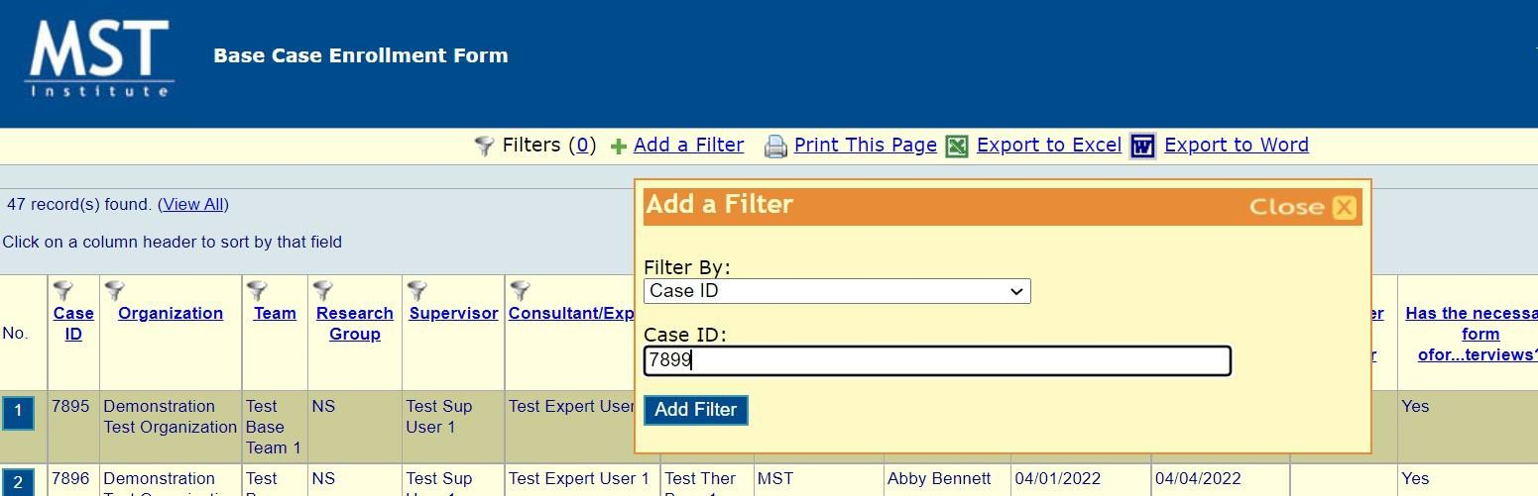


Once you find the case that you want to edit, simply click the numbered button, to the left of the record to drill down into that specific case. Once in the full case record, scroll to the bottom and click the ‘edit’ button.

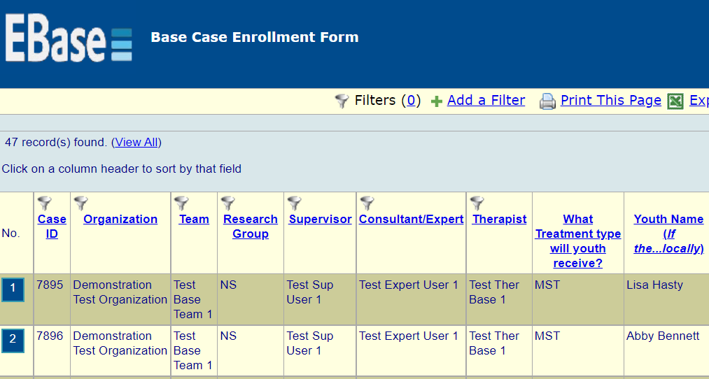

You will be taken to an editable version of the case, where you can edit the case information. Once you
have completed your updates, you must click the ‘save’ button.

Below is a screenshot to show how to filter by Report Code. You can also access and edit records by simply clicking the numbered button, to the left of the record.

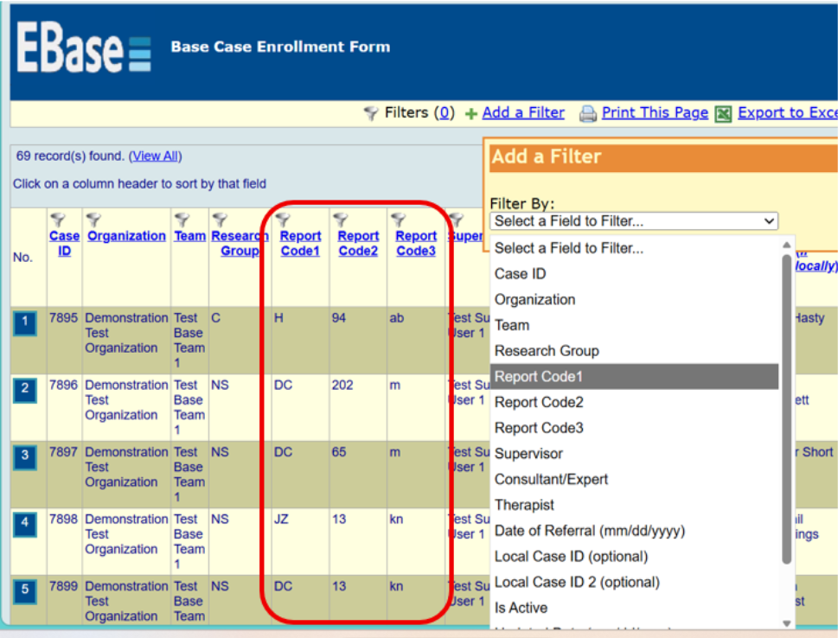

TAM-R Form Demonstration

Add TAM-R Form

Click on the link for “Add” next to TAM-R Form. Specify a team in the team drop down and click “Continue”.
The following text describes elements on the TAM-R Form.
You are then displayed the TAM-R form, where you can input your data. The case must already be enrolled and open it on the website, in order to enter a TAM-R.
Again, notice that some of the information/criteria are already completed. This is based on the login code and the team that you selected. You will need to select the Youth Name in the “Case” field and enter all the required information. Once complete, make sure that you click “Save” at the bottom of the screen.
Please note: if a case is already discharged, they will not show up in the dropdown list. If a final TAM-R needs to be entered and the case has already been discharged (or discharged in error), please go back to the case enrollment form and change the answer for ‘Is Active’ from ‘yes’ to ‘no’.
They will then be visible in the dropdown. Just make sure to go back after TAM-R entry and change the ‘Is Active’ back to ‘no’ or some reporting will be invalid.

Edit TAM-R Form
Click on the link for “View/Edit” next to TAM-R Form.
You are then displayed ALL records, for all sites and teams that you have access to. To narrow down the list, simply add applicable filters, by clicking 'Add a Filter', at the top-left of the menu (as noted in the 'EDIT BASE CASE ENROLLMENT' section above).
TIP: The easiest way to find a specific TAM_R that you need to edit, is by just adding the filter for 'TAM-R ID'. The TAM-R ID is the system generated ID number assigned to each case when it is added to the system. If you have that, then you can add that filter and type in the ID. That will pull up your TAM-R form.
If you do not know the TAM-R ID, you can try to narrow the results of your search down, by entering additional filters and sorting the data, by clicking on the column header that you wish to sort by. Once you add a filter, a list of TAM-Rs that fit that criteria will be displayed and you can continue to add additional filters, until you have narrowed down the data, as necessary. Once you find the TAM-R that you want to edit, simply click the numbered button, to the left of the record to drill down into that specific case. Once in the full TAM-R record, scroll to the bottom and click the ‘edit’ button.

Discharge Form Demonstration

Please note: In order to be able to report on child welfare outcomes, the MST-PRV teams will use the MST-CAN Discharge Form. Please make sure to select the correct form when entering discharge information.

Add MST-CAN Discharge Form
In order to close a case on the website, we are actually adding information to an existing case form. Therefore, the steps to add a discharge form are a little different.
Click the link for “Add” next to MST-CAN Discharge and then “Continue”.
This brings up a list of all cases that you have access to. They may already be discharged and closed, or they may not yet have a discharge form and therefore are still open. Those are the cases that you can still discharge.
The easiest way to find those cases is to sort by the Discharge Date field, so all records that do not yet have a discharge date, are listed first.
Step one: Select the record that you want to discharge, by clicking the numbered button in the far-left column.
Step two: Then an MST-CAN Discharge Form appears with the case information from enrollment already completed. Now to enter information, scroll to the bottom of this form and click “Edit” and fill out the discharge information.
Notice the Case Progress review section and review the following definitions for those items.
Definitions of outcome categories are listed below and included in a FAQ on ultimate outcomes. All data on this form is required. Some items related to Caregiver outcomes are only used to evaluate MST-CAN programs, e.g., “The parent is showing improvements in mental health functioning”. They should be completed to your best knowledge but are not used to evaluate MST-PRV programs. The item that is relevant to MST-PRV is “Parent or caregiver has not had a new report of maltreatment for an offense committed during treatment.” Guidelines for completing this item are included below.

DATA DEFINITIONS FOR MSTI DISCHARGE FORM
Case Progress Review Instrumental Outcomes Ultimate Outcomes
Optional Outcome- Substance Use Outcomes
School / Vocational Training / Working Data Guidelines Runaway Youth Discharge Guidelines
New Report of Child Maltreatment Guidelines

CASE PROGRESS REVIEW ITEM
- Completion: The youth was discharged based upon the mutual agreement of the primary caregiver(s) and the MST team.

The reason for case closure does not meet any of the other categories AND
team and family agree that there is evidence that overarching goals have been sustained over a period of 3-4 weeks, OR
team and family agree that overarching goals have not been met and treatment has reached a point of diminishing returns for the additional time invested.

Selection of this category does not assume that the case closed with all goals met, only that primary caregiver(s) and team agreed that no further progress on overarching goals is likely.

- Lack of engagement: The team never had engagement with the family; the decision to discharge the youth was made because the MST team was not able to engage the family in treatment, despite persistence on the therapist’s part to engage and align with the family.
  - Despite persistent efforts by the therapist, the family has not EVER been seen face-to-face for two consecutive weeks OR
  - Family formally declined MST services at the outset OR
  - Family states they do not want to continue (a statement to this effect should be included in note section) AND
  - The family was not actively involved in working on any goals AND
  - The consultant and team have identified and addressed barriers to inadequate engagement and agree that all engagement strategies have been exhausted.

Selection of this category indicates that the family has chosen not to participate in MST Services. In other words, this category documents that the team never had engagement. As long as the family was actively involved in working on at least one goal for some part of treatment, this category is NOT checked. This latter case would be counted as “completed” with lack of progress reflected in instrumental goals.

- Placement: A decision has been made that the youth will be, or already is, placed in a restrictive setting (detention center, residential placement), or foster care for a duration of time that precluded further MST involvement.
- Placement, prior event: The youth was placed in a restrictive setting (detention center, residential placement), or foster care due to an event or offense that occurred prior to the beginning of MST treatment.

Example: After MST is underway, the court or other key decision-maker (social welfare, etc.) makes a determination about an event that occurred prior to
treatment, but for which a decision had not previously been made. The key decision-maker determines that the youth must be placed for that event.
Do not use this code if the youth is placed for an event that occurred prior to treatment and for which the youth is on probation/bail status, or for which MST has been started to avoid placement (instead, use “Placement”)

- MST Program administrative removal/withdrawal: Youth was removed from the program by the MST program administration due to administrative issues or decisions unrelated to the progress of the case.

- Examples: discovery that youth does not meet MST eligibility criteria, including, for example, age requirements, or lack of caregivers. Use this discharge item for families that have not signed consent (no first visit date should be entered on MSTI)
- Funding/referral source administrative removal/withdrawal: Youth was removed from the program by the funding or referral source due to administrative issues or decisions unrelated to the progress of the case.

- Examples: youth no longer meets financial reimbursement criteria, or meets exclusionary criteria set by funder or referral source such as youth referred to multiple programs simultaneously

- Moved: The family moved out of the program’s service area.

INSTRUMENTAL OUTCOME ITEMS:

The Instrumental Outcomes are documented in the MST Goals and Guidelines as the criteria for determining whether a case was closed successfully or not. While some guidance in defining these items is provided, it is critical for each program to define these in terms of objectives for the case.
For example, if the case had an overarching goal of increasing involvement in pro-social activities as evidenced by attending one approved recreational activity a week, then the related instrumental outcome would be rated as met if the Overarching Goal is met. Therefore, responses to these items are not completely standardized across programs.

ULTIMATE OUTCOMES ITEMS:

These items provide some basic information about how the youth is functioning at the time of discharge. The meaning of the terms (e.g., ‘arrests’) may vary from county to county, state to state, and country to country; therefore, it is difficult for the MST Institute to establish a “one-size-fits-all” definition. The operational definition of each of the following should be made clear for each MST program and documented in the Goals and Guidelines document. The following definitions are offered as guidance based on common performance measures used in the United States.

- Youth is living at home. Home is defined as a private residence that is approved by the youth’s guardian. This could include a parent’s home, the home of an approved relative, or friend of the family. Foster homes or other types of placement would not be included in the definition of “home.” Youth who are on runaway status would not be at home. Youth marked as “placed” would not be rated “at home,” even if youth is temporarily at home on day of discharge.
- Youth is attending school (is not truant,) or vocational training or, if of the legally appropriate age to not attend school, has a paying job (at least half-time).

- Youth is attending school, a high school equivalency program (GED program,) or a vocational program in the youth's natural ecology or working. The primary objective of the program is educational or vocational. A youth in a correctional facility or treatment setting in which educational or vocational activities are provided, where the primary objective is treatment or correction, will NOT count as a "yes" for this item

- If the youth is in school, youth is attending frequently enough to meet expectations placed on youth by the school system or court. If the discharge occurs during the summer when school is not in
session, it is recommended that the response “yes” be selected if the youth was attending school at
the end of the last school year or is working.
This item should be answered for all youth, in addition to the choice of “yes” or “no” above. Please
select one item from the list that BEST describes the youth’s current setting.
Traditional school
Traditional school that includes a vocational component
Solely vocational training program
GED or other secondary school equivalency program
Alternative educational program or setting due solely to academic need
Alternative program or setting due to anti-social, offending, or disruptive behavior
In a correctional facility or treatment setting where the primary objective is treatment or correction (choose this even if educational or vocational activities are provided in the facility)
Not in any educational or vocational program, and working at least half-time
Not in any educational or vocational program, and not working at least half-time
Other- please specify
- Youth’s school status at discharge

This is an optional item at enrollment and discharge. Programs that collect this data have it defined in their team goals and guidelines document. Please consult with your supervisor for additional instruction if needed. Definition guidance for each category can be found below.

Attending Childcare and/or Preschool
Attending Primary School
Attending Secondary School
Dropped out/not regularly attending
Expelled
Graduated High School (Grade 12 Certificate)
Enrolled in tertiary course (technical training/university)
Not Answered
Other (field box to specify)

- Youth has not been arrested since the beginning of MST treatment, for an offense committed during MST treatment. Many MST programs have defined arrests as involvement with police that results in a charge for a new criminal behavior (i.e., not a violation of probation).

Each MST program should view the lack of a clear definition of arrest as an 'opportunity' to revise, clarify, and improve their existing Goals & Guidelines document. This will likely entail drafting a working definition and then seeking input from key stakeholders in order to establish a clear, specific, objective, and measurable definition to guide future entries on the website.
- If the family required an interpreter or bilingual therapist, were they able to receive services in the required language? This data point relates to a question on the case enrollment form assessing if an interpreter or bilingual therapist was required.

These data points are being collected for research purposes. This information is not exported on an MSTI report, though it can be found in the individual enrollment and discharge forms. If there is interest in your organization to access this data in a formal MSTI report, please contact your expert to work with MSTI.

Sometimes case information is not available at enrollment indicating that an interpreter or bilingual therapist was needed, it is appropriate to reflect that a family was not able to receive services in their required language at the time of discharge even if at enrollment the need was not identified.

Rarely is a case discharged because services could not be delivered in the required language, however, there are examples of a client being discharged due to administrative or referral withdrawal as a result of services not being provided and this data point will allow us to track that information.

Additional guidance related to serving families can be found in the following document: : Use of Interpreters by MST programs.docx

OPTIONAL OUTCOME- SUBSTANCE USE OUTCOMES
Optional Item
Substance use outcomes are tracked at the request of the program/system. Programs that track this outcome have been documented in their Goals and Guidelines, and reviewed with their MST Expert, a definition for this measure.

SUBSTANCE USE OUTCOMES

This item measures substance use outcomes only for youth for whom substance use is an identified MST treatment target. This item provides basic information about how the youth is functioning at the time of discharge. The meaning of the relevant terms (e.g., ‘reduction’ and ‘substance use’) may vary from county to county, state to state, and country to country; therefore, it is difficult for the MST Institute to establish a “one-size-fits-all” definition.

The operational definition of each of the following should be made clear for each MST program and documented in the Goals and Guidelines document. Substance use is measured objectively (e.g., by urinalysis tests, breath scans, etc.). Subjective evidence of substance use may also be collected; however, MST programs should prioritize and maximize collection of objective measures. The following definitions are offered as guidance based on common performance measures:

Substance use was an MST treatment target for this youth Substance use was a referral behavior and/or
Reduced substance use was an MST Overarching Goal and/or
Substance use interventions were identified in intermediary goals For youth in this subgroup (substance use was an MST treatment target):
Youth has reduced use of alcohol and/or other substances as evidenced by objective measures.
Objective means of measuring youth substance use include analysis of biological specimens: urine, hair, saliva, breath-air, sweat. These measures may be taken in the home or outside the home (e.g., in a lab or a court setting).
as evidenced by subjective measures.
Subjective indicators of youth substance use include but are not limited to, behaviors, physical appearance, youth self-report, performance, etc.
both

Each MST program should view the lack of a clear definition of the above as an 'opportunity' to revise, clarify, and improve their existing Goals & Guidelines document. This will likely entail drafting a working definition and then seeking input from key stakeholders in order to establish a clear, specific, objective, and measurable definition to guide future entries on the website.

GUIDELINES FOR SCHOOL/ VOCATIONAL TRAINING/ WORKING DATA ITEM

Background: Ideally, youth participating in MST are staying in school and are obtaining an education in traditional, mainstream school settings. While some individuals in the youth’s natural or service system ecology may advocate sending the youth to a non-traditional setting for educational purposes, evidence is lacking that such programs or settings will improve the educational and behavioral outcomes for youth.
Some youth in MST, however, may be participating in such programs or settings.

In order to gather more information about the range of those types of settings being used for MST youth around the world, the in-school data being collected at the time of discharge has been expanded. This data is being collected only to inform our learning at this time.

Data reporting: As we start to collect this data, there will not be a reporting option for providers or Network Partners to generate reports on the new information being collected. Instead, for now, MSTI will review the data collected over a year or so as part of our internal learning related to this project. We will determine over time how long we will be in this learning phase.

Examples of Each Category
Please find below a list of examples for each category included in the drop-down menu. This is not meant to be an exhaustive list, but rather to give a range of examples from multiple systems to help teams think through each category and identify what is most frequently used in their school systems. Please consult with your MST expert for guidance as needed.
- traditional schools, i.e.
  - Mainstream schools such as senior high, junior high, middle school, secondary school
  - municipal or community schools
  - charter or private schools selected by the family selected by the family.

- traditional school that includes a vocational component
Note: In some settings such as Europe, this combination is common. See next category for examples of vocational programs.
- solely vocational training program, i.e.
  - Local or community-based vocational-technological schools, vocational-technological schools connected to the youth’s/young person’s high school/secondary school.

  - college training that is vocationally based
  - Job-Corps
  - Some types of work-study program in which the youth/young person leaves his/her regular education and goes to a work-study/vocational program for training.

- GED or other secondary school equivalency program, i.e.
  - GED (General Equivalence Degree) preparation classes within the local school district or in a community-based setting OR settings which allows the youth/young person to study just for exams to catch up on education they have missed.

- alternative educational program or setting due solely to academic need, i.e.
1.) Public, charter, or private schools or settings that are mandated or selected by school personnel or caregivers that are designed to meet the academic needs of the youth/young person.
These could include but are not limited to the following:
- home-schooling, home-based tutoring, community-based tutoring such as in the local library where the youth/young person goes instead of going to school (either paid by the home-school district or by the caregivers),
- computer/on-line distant learning
- pupil referral unit
- boarding school
- an intermediate unit class, designed to meet academic needs.

- alternative program or setting due to anti-social, offending, or disruptive behaviors, i.e.
- Public, charter, or private schools or settings that are mandated or selected by school personnel or caregivers due to the youth’s/young person’s behavioral concerns. These could include but are not limited to the following:
  - alternative schools, day treatment programs, pupil referral unit, boarding school, military school, partial-hospitalization programs, or home, library, or computer-based schooling or
  - tutoring that is selected or
  - mandated based on the youth’s problem behaviors.
- in a correctional facility or treatment setting where the primary objective is treatment or correction (choose this even if educational or vocational activities are provided in the facility), i.e.
  - Daily classes provided to residents of an inpatient unit. Note that “correctional facility” and
“treatment setting” here refer to residential facilities.

- not in any educational or vocational program, and working at least half-time

Note: Determination of what constitutes half-time work should be based on the country’s standards for full-time work.

- not in any educational or vocational program, and not working at least half-time
Note: Self-explanatory.

- other - please specify
Note: Please only choose “other” after carefully considering and ruling out each of the categories above. When this category is chosen, please describe the details of the youth’s/young person’s school setting.

- Child/young person has not been arrested since the beginning of treatment, for an offense committed during treatment. Many MST-PRV programs have defined arrests as involvement with police that results in a charge for a new criminal behaviour (i.e. not a violation of probation).

Note: Each MST-PRV program should view the lack of a clear definition of arrest as an 'opportunity' to revise, clarify, and improve their existing Goals & Guidelines document. This will likely entail drafting a working definition and then seeking input from key stakeholders in order to establish a clear, specific, objective, and measurable definition to guide future entries on the website.

Examples of Each Category for Youth’s School Status at Discharge
Please find below a list of examples for each category included in the drop-down menu. This is not meant to be an exhaustive list, but rather to give a range of examples from multiple systems to help teams think through each category and identify what is most frequently used in their school systems. Please consult with your MST expert for guidance as needed.

- Attending childcare and/or preschool, i.e.
  - Childcare centers, daycare centers, Head-start programs, pre-kindergarten 1 and 2

- Attending Primary School, i.e.
  - Mainstream schools such as elementary school (grades k-5)
  - lower secondary, lower school, primary school- municipal or community schools, and
  - charter or private schools selected by the family.
*This category could include public/charter/private alternative education programs, virtual, home-based, or community-based learning.
- Attending Secondary School, i.e.
  - Mainstream schools such as senior high (grades 9-12),
  - junior high (grades 6-8), middle school, secondary school- municipal or community schools, and
  - charter or private schools selected by the family.

*This category includes GED (General Equivalence Degree) programs, virtual, public/charter/private alternative education programs, home-based or community-based learning.

- Dropped Out/Not Regularly Attending, i.e.
  - youth has formally withdrawn from education or
  - has excessive absences
  - considered formally truant or has truancy charges.

- Expelled, i.e.
  - Youth has been removed from education setting based on behavior or
  - due to other policy infraction

- Obtained Education Certificate, i.e.
  - Youth has received a certificate of completion.

- Enrolled in Tertiary Course (technical training/university), i.e.
  - Local or community-based vocational-technological school, vocational-technological schools connected to the youth’s/young person’s high school/secondary school,
  - college training that is vocationally based,
  - Job-Corps,
  - some types of work-study program in which the youth/young person leaves his/her regular education and goes to a work-study/vocational program for training

GUIDELINES FOR WHEN YOUTH IS ON RUNAWAY STATUS
Assumptions

- Being on runaway status is considered an antisocial behavior, just like any other antisocial behavior (e.g., being truant). From an MST perspective, it should be addressed like any other behavior, and a case should not be discharged based on this behavior alone.
- Different systems vary in how they respond to runaway behavior. This can present significant challenges to the team in being able to continue to provide MST, e.g., some systems have time limits for how long the case can remain open if the youth is on runaway status.
- Despite the legal parameters the MST team works within, if the family has had an opportunity for a full course of treatment, the case should be closed using one of the “clinical” reasons, e.g.,” closed by mutual agreement,” “lack of engagement” or “placed.”
- The case closure categories, “MST Program administrative removal/withdrawal” or “Funding/referral source administrative removal/withdrawal,” are limited to situations where the case is closed for reasons that are “unrelated to the progress of the case.” Therefore, careful consideration must be used when closing a case for this reason.
The following guidelines are provided to assist in deciding how to code the case progress review item when the team closes a case while the youth is still on runaway status.
  - Determine if the family has had an opportunity for a full course of treatment. An example of not having this opportunity might be if the youth was on the run at the time of referral, or shortly
thereafter, and the funder requests closure (preventing the therapist and family from having more than a couple of sessions). This case could be closed using the category “MST Program administrative removal/withdrawal” or “Funding/referral source administrative removal/withdrawal.”
  - Determine if the therapist has ever had engagement with the family. As long as the family was actively involved in working on at least one goal for some part of treatment, the category of “lack of engagement” should not be used.
  - Determine if the case should be closed as “placed.” This category is used only if the team is quite certain that once found, the youth will be placed, e.g., the youth is already a ward of the juvenile system and will be placed automatically without returning to court for sentencing for the runaway behavior.
  - Determine if the case should be closed as “completion” (due to diminishing returns). This closing category does not assume that the case closed with all goals met, only that stakeholder/funder, primary caregiver(s), and team agreed that no further progress on overarching goals is likely due to the youth not being in the home. The actual case progress on goals would then be documented using the ratings for instrumental and ultimate outcomes.
The following guidelines are provided to assist in deciding how to code Ultimate Outcomes when the team closes a case while the youth is still on runaway status.

- Coding Ultimate Outcomes:

  - “At home”: if a youth is on runaway status at the time of closure, this would be marked “no.”
  - “In school/working”: there are youth that may be on the run but are still attending school (or working); therefore, the team would need to verify whether the youth is attending school (or work) in order to determine how to mark the ultimate outcome of “in school/working.”
  - “Arrest”: this is completed based on stakeholder’s definition of arrest. Many MST programs have defined arrests as involvement with police that results in a charge for a new criminal behavior (i.e., not a violation of probation which is the typical charge for youth absconding/on the run).

Optional: Some major stakeholders want systems/organizations/teams to track the number of youth who are on runaway status at discharge. This is not defined by MST as an ultimate outcome; therefore, teams can consider tracking this by adding documentation of runaway status in the “notes field” of the Discharge Form or by using a research code.

GUIDELINES FOR NEW REPORTS OF CHILD MALTREATMENT ITEM

Answer “No” (a new report has occurred) if the following has occurred:

- If the therapist directly observes an incident of child abuse or neglect regardless of whether it is founded/indicated by Child Protection.
- If Child Protection receives a report of child abuse and neglect and based on their investigation, they find evidence that the child has been abused or neglected. Example: A neighbor calls Child Protection and reports the parent was beating the youth with a belt in the backyard. The Child Protection investigation produces enough evidence to find that this event did occur and the parent was abusive.
- If the parent acknowledges to the therapist and/or Child Protection that a reportable incident of child abuse or neglect has occurred regardless of whether there is a finding. This would not include parental behavior such as yelling at the children. Example: A parent tells the therapist that she was so upset with the teenager that she pushed her into the wall and it left a bruise.

Answer “Yes” (a new report has not occurred) under the following circumstances:

- A report is made to Child Protection, but no evidence is found to substantiate the report. Example: Teenager makes a call to Child Protection to say the parent is physically abusive. Child Protection does their investigation and finds no evidence to support youth’s claim.
- A report is made by the school or neighbor, and Child Protection does not take the report. Example: Child Protection receives a call from a neighbor that the parent is outside playing with the children at 6 a.m. The neighbor complains that this is too early, and the play is waking others in the neighborhood. Child Protection declines the report.
- If the behavior is poor parenting but is not a reportable offense. For example, if the parent yells at the child or says something pejorative to the child such as call the child dumb or stupid. While this is poor parenting and is something that would need to be addressed, it does not rise to level of child protection report.

Saving the MST-CAN Discharge Form
Once all the required data is entered, click “Save” and you will get a message that the update was successful.
*Additional things you can do from this form are as follows:
    - Click “Print” if you want a black and white hard copy
    - Click “Edit” if you see an error that you want to correct
    - Click “Return to List” if you want to complete a discharge form on another youth in the existing list
    - Click “Lock this Record” when you want to prevent anyone from making changes
(If a case is locked by accident, you must contact the MSTI Helpdesk at msti@mstinstitute.org and request that the record be unlocked)
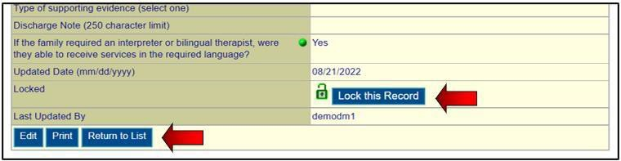

The discharge forms are completed by the team and reviewed by the Consultant or System Supervisor. Once the data is checked and there is consensus with the Consultant or System Supervisor, the data can be locked by the supervisor.
In order to go back to the Main Menu, scroll to top right and click on “Home”.

Edit MST-CAN Discharge Form
Click on the link for “Edit” next to MST-CAN Discharge Form.
You are then displayed the Record Selection Criteria Screen, where you can input criteria to pull up a certain case(s).
Again, notice that some of the information/criteria are already completed. This is based on the login code.
The easiest way to find a specific discharge form that you need to edit is by just entering the Case ID number in the first field on the Record Selection Criteria Screen. The Case ID is the system generated ID

number assigned to each case when it is added to the system. If you have that, then you can just leave everything else to default and click, ‘Continue’. If not, you can try to narrow the results of your search down, by entering criteria, sorting and clicking ‘Continue’. A list of cases that fit those criteria will be displayed.
You can find the case that you want to edit and click the numbered button, to the left of the record to drill down into that specific case. Once in the full case record, scroll to the bottom and click the ‘edit’ button.
You will be taken to an editable version of the case discharge form, where you can add and edit the case discharge information. Once you have completed your updates, you must click the ‘save’ button.

Here is an example of a Case Discharge Form. Note that Report Codes 1-3 can be edited at discharge.
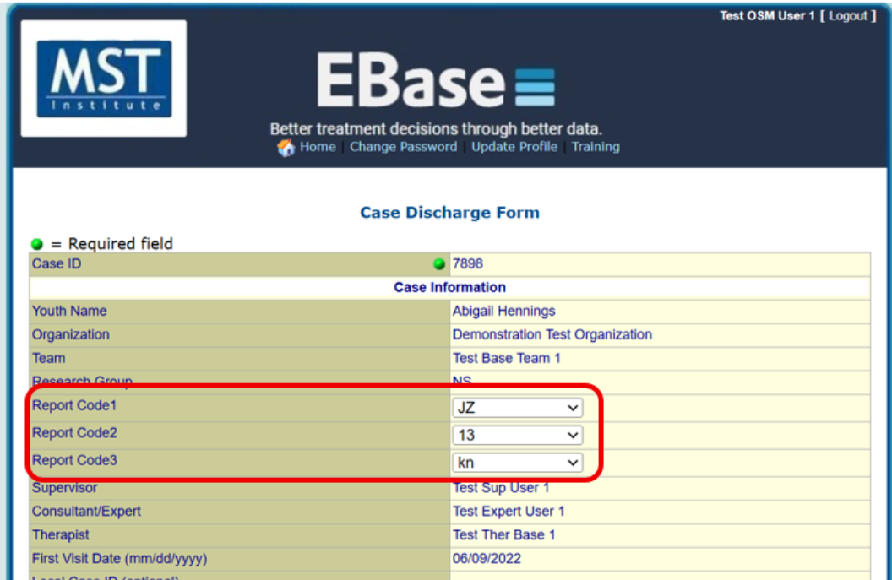

This screenshot shows how Report Codes appear on the list/view screen for discharge forms.
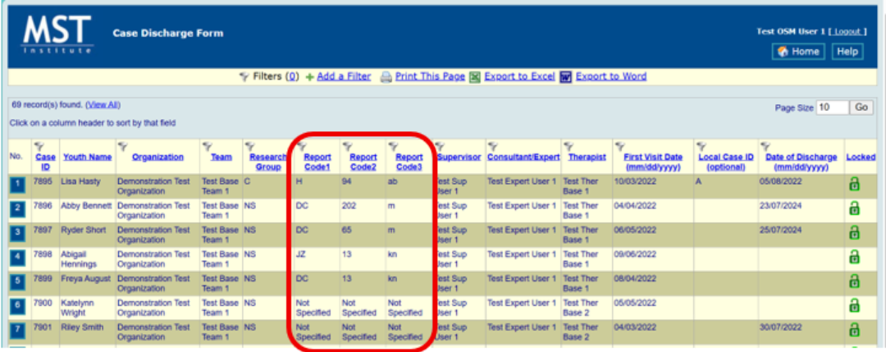

SAM Demonstration

Add SAM Form
- Click on the link for “Add” next to SAM Form.
- Select the team the Supervisor is on. Most therapists will only have one team displayed but if your team doesn’t show, click the drop down to find the correct team.
- Click on the team that you want to add the form to and click “Select”.
The following text describes elements on the SAM Form. Again, notice that some of the information/criteria are already completed. This is based on the login code, see roles:
- Therapists are the only user that can add SAMs. They only have access to add, edit and view their own SAMs.
- Consultants are the only user types that have access to view the therapists’ SAMs.
- Supervisors do not have access to these!

- Fill out the required information and click “Save”.

Edit SAM Form
Click on the link for “View/Edit” next to SAM Form.
You are then displayed ALL your SAMs. To narrow down the list, simply add applicable filters:

- Click on 'Add a Filter', at the top-left of the menu (as noted in the 'EDIT BASE CASE ENROLLMENT' section above).
The easiest way to find a specific SAM that you need to edit is by just adding the filter for 'SAM ID'. The SAM ID is the system generated ID number assigned to each case when it is added to the system. If you have that, then you can add that filter and type in the ID. That will pull up your SAM form.
If you do not know the SAM ID, you can try to narrow the results of your search down, by entering additional filters and sorting the data, by clicking on the column header that you wish to sort by.
Once you add a filter, a list of SAMs that fit that criteria will be displayed and you can continue to add additional filters, until you have narrowed down the data, as necessary.
- Once you find the SAM that you want to edit, simply click the numbered button, to the left of the record to drill down into that specific case. Once in the full SAM record, scroll to the bottom and click the ‘edit’ button.
Entering and editing the CAM Form works the same as the SAM Form. The CAM is available to both supervisors and therapists while the SAM is only available to therapists.

Parent SDQ Demonstration

Add a Parent SDQ Form
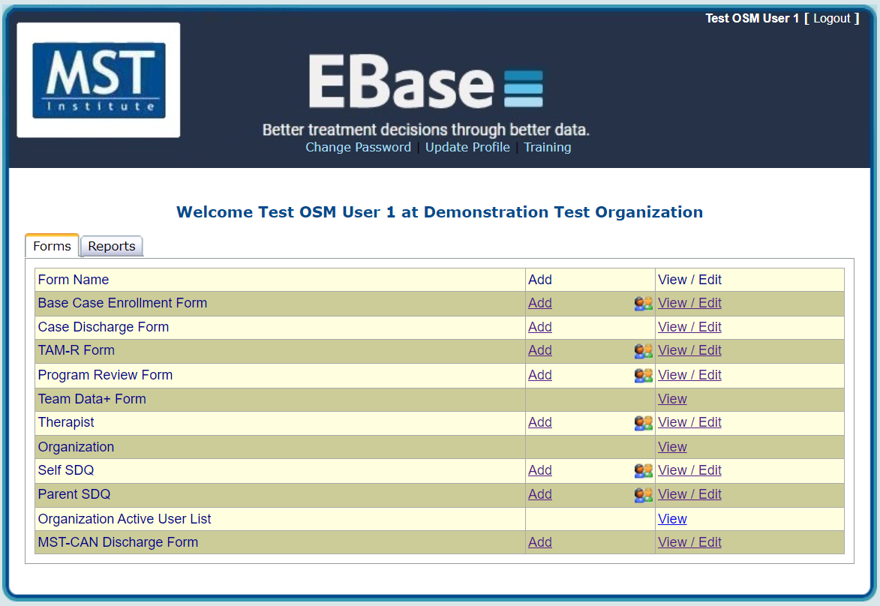

Click on “Add” next to the measure that you want to add, and a pop-up will come up with a drop down of options you can select from. It is important to make your selections from top to bottom so that the filtering works most efficiently.

Clicking the down arrow will display the options that you have based on your access level.

- Pick the team that is providing services to the family
- For “Cases”, you will see a list of active cases available for the user, select the target/primary child for the family. Note. If a case is selected that is not on the selected team, an error message will appear.
- Select the version of the measure that you want to enter. If there are multiple versions of a measure, make sure to select the version that fits the case. The versions are named according to when it is completed (Pre (“Pre”) is at intake and Follow-Up (“FU”) is at discharge) and age of the young person. The wording of some of the questions changes to be age appropriate so the majority of the MST-PRV cases will use the versions ending with “11-17”
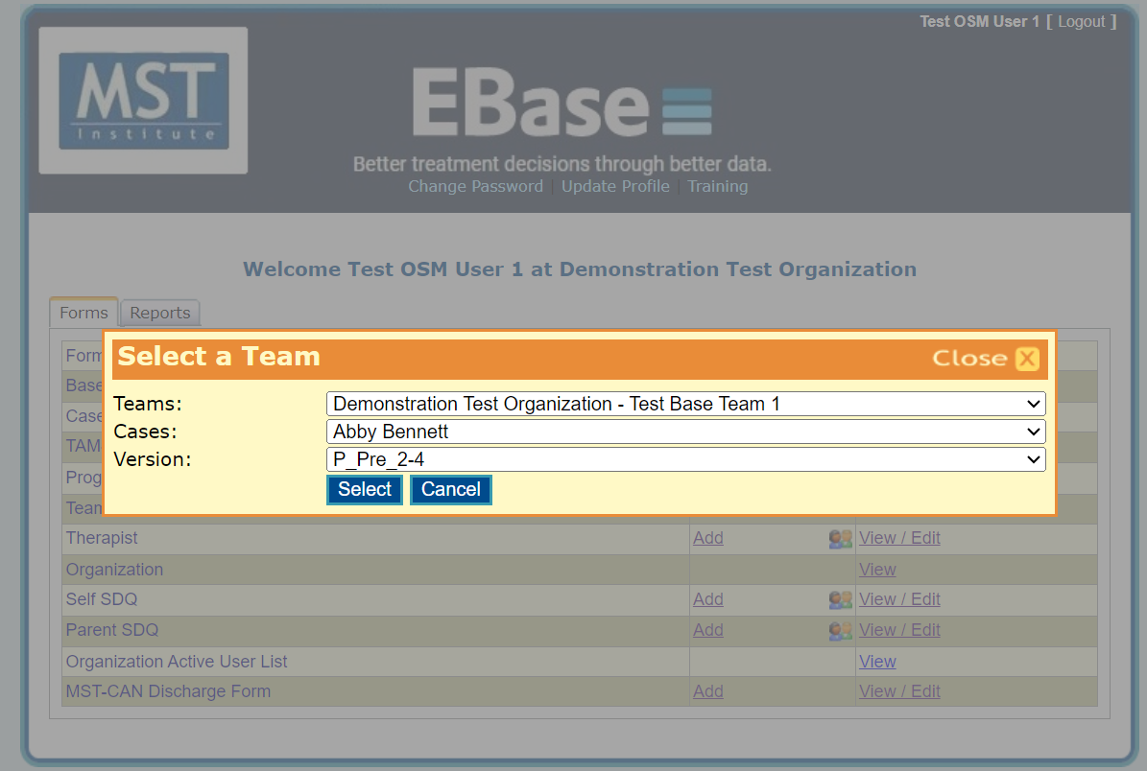

Click down arrows to view more choices.

- Once you make your selections and click “Select”, the appropriate questionnaire will appear with most of the identifying information about the record already prepopulated.

Fields at the top are prefilled with correct info for the case selected
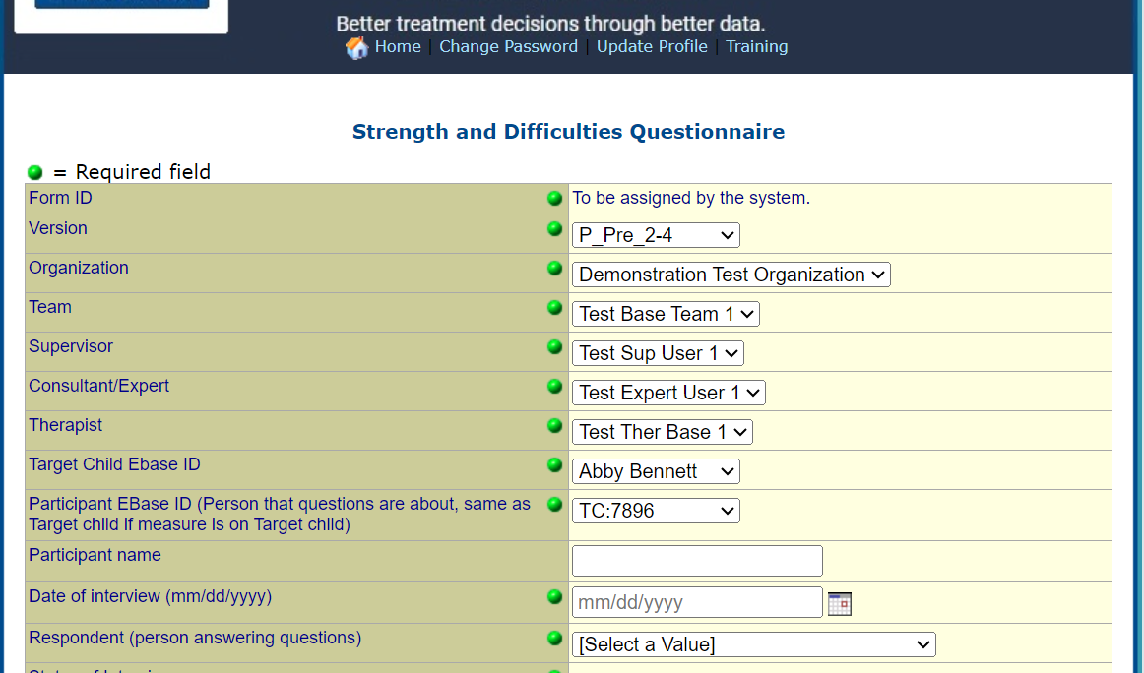

Drop down includes all IDs associated with case

For “Participant EBase ID (Person the questions are about)”, the form will show the EBase ID for the selected case preceded by “TC” to indicate this is the target/primary child. This item and the following, “Participant Name”, is only relevant to systems collecting data on multiple children in the family. For all other systems, it will display the same ID as the Target Child.

For “Respondent (person answering questions)”, there is a dropdown where you will select the deidentified label for the person who filled out the form about the child. This field will help identify whether the same caregiver filled out SDQs at the beginning and the end of treatment.
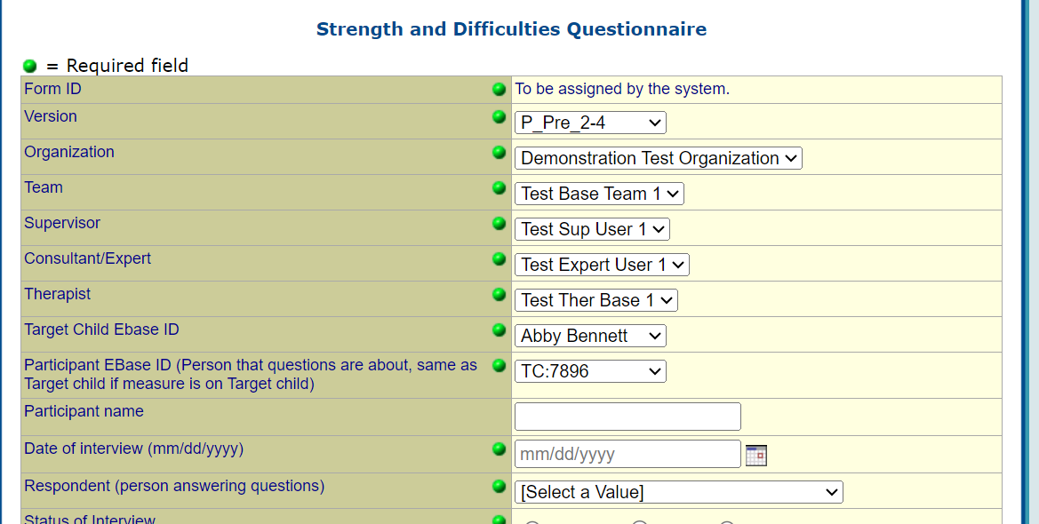

Several options are available for the Status of Interview (completed, missing or refused). A measure is completed when the participant answers the questions. It is also important to indicate when a measure was attempted but the caregiver refused that measure. In this situation, click “refused” for Status of Interview. When status is “refused”, you will notice that all subsequent questions for the measure are automatically greyed out, so that you do not have to go through and click "refused" for each individual question. The same is true if the status of interview is missing.
Then, you will only need to select an answer for ‘Time Period’, and then you are able to scroll to the bottom and save the form. The status would be “missing” if the interviewer makes a decision to not administer the measure for some reason.
Specific questions can be indicated as missing or refused. If the answer is truly missing, i.e., the question was skipped somehow, enter “missing” for that question. If the respondent agreed to complete the measure but does not want to answer a specific item, enter “refused” for that question.

Complete the questions and then click “Save” at the bottom of the form. If a required question is missing a response on the form, an error will appear. When all questions are answered and form is saved, a view of the form will be displayed with the scale scores calculated at the bottom. If an error in data entry is seen, click “edit” at bottom of form, make corrections, and resave. If the data is confirmed to be accurate, click “lock this record” which will prevent accidental changes being made in future.

*Please note that in MST-PRV, we have added additional items that are not scored, and therefore not entered on the SQQ form on MSTI. Those are items 11, 19 & 28. Please take care when entering the SDQ responses to ensure the correct responses are entered for the correct items.

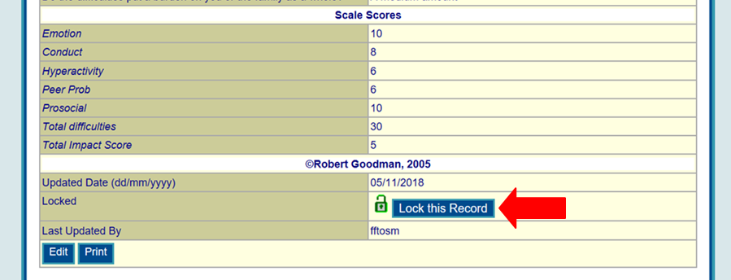

To exit, scroll to top of form and click “Home” or click the “back” arrow on your browser to return to the main menu.

List Reports Demonstration

All users have access to basic list reports, which are views of the raw data in the different forms (e.g., case enrolment form) to assist them in monitoring the accuracy of the data. The List Reports are accessed from the right column (called ‘View/Edit’), of the Main Menu.

If you want to see everyone that you served last year, click on ‘View/Edit’ for Base Case Enrollment form and then click ‘Continue’. Now you should see the list of records. 'Add Filter' will allow you to design your list. Select 'Add Filter' and select ‘Date of Referral’ as the filter. Then specify only cases referred from 01/01/2003 to12/31/2003. Then click 'Add Filter'. Then click on the ‘Date of Referral’ column header, to sort by the date.

To get back to the Main Menu, click on ‘Home’.

Viewing Existing SDQs

From the Main Menu click “View/Edit” on the main menu page next to the measure you are interested in. This will generate a “List Report” that shows a list of the forms that have been entered. This list will be restricted to those records that correspond to your level of access. For example, a therapist will only be able to view records on their own cases while data collectors can view records for the organization.

List Reports will display a few key items that can be viewed across multiple records. All measures will include the Case ID for the primary child, the version of the measure, time period, date of interview, status and scale scores. This report can be quickly scanned to check that the correct version and time period were entered and to see the scale scores. In addition, the list reports can be exported to Excel or Word if needed.

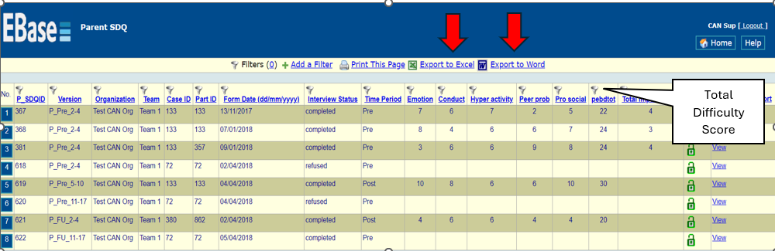

Accessing the SDQ Score Report

The authors of the SDQ have developed a report that provides the ability to interpret the scores in comparison to an Australian norm group based on age. The “SDQ Score Report” is accessed from the List Report by clicking the link “View” at the end of the row for the child/young person you would like to view the results for. It provides context for interpreting the scores from a specific SDQ administration. The reports are designed to be exactly like the reports available from the authors of the SDQ.
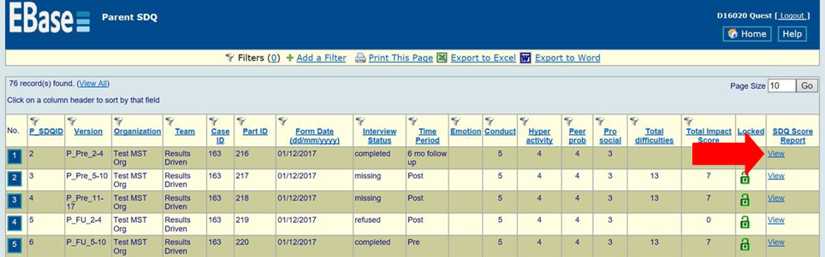
A sample report is included below as an example. The data displayed here is randomly generated and would not be representative of a typical discharge assessment. Please talk to your consultant about how to use this information. The reports can be exported in Word or pdf format and printed to share with the family if you choose.

Parent SDQ Score Report
Form ID: 30
For Family of Target Child ID 219 Versions: P FU 11-17
Scores refer to: 60
Gender: Male, Age: 17 years

Specific Scores:

The scores are grouped into four bands so that in the general population 80% of young people score ‘close to average’, 10% score ‘slightly raised’, 5% score ‘high’ and 5% score ‘very high’. The exception is the scale for kind and helpful behavior, with roughly 80% ‘close to average’, 10% ‘slightly low’, 5% ‘low’, and 5% ‘very low’.

Parent Questionnaire Completed on 7 Dec 2017 at Post-treatment

Score for overall stress | 17 | High
Score for emotional distress | 7 | Very High
Score for behavioural difficulties | 5 | High
Score for hyperactivity and attentional difficulties | 2 | Close to average
Score for difficulties getting along with other young people | 3 | Slightly raised
Score for kind and helpful behaviour | 6 | Low
Score for the impact of any difficulties on the young person’s life | 4 | Very High
Diagnostic Predictions Based on Parent Report
The information provided is used to predict how likely a young person is to have emotional, behavioural or concentration problems severe enough to warrant a diagnosis according to the ICD-10 or DSM-IV classifications. For each diagnostic grouping, there are three possible
predictions: ‘low risk’, ‘medium risk’ and ‘high risk’. In general, these predictions agree fairly well with what an expert would say after a detailed assessment of the young person. Around 25-60% of young people who are rated ‘high risk’ do turn out to have the relevant diagnosis according to experts. So do around 10-15% of ‘medium risk’ young people but only about 1-4% of ‘low risk’ young people.
Diagnostic prediction posttreatment
Any diagnosis - high risk
Emotional disorder (anxiety, depression, etc.) - medium Behavioral disorder - high risk
Hyperactivity or concentration disorder - low risk
Caution
If you think this report has missed the point, whether by exaggerating or underestimating the difficulties, you may be right. A brief questionnaire obviously isn’t the same as an individual assessment by an expert. Perhaps both are needed.

NOTE: Questions and requests, regarding the MSTI Website can be emailed to msti@mstinstitute.org. Email requests are responded to within 2 business days. Please make sure that any email requests are written clearly and in complete sentences. Make sure to provide as much information about the request in your original email. This will ensure a prompt response and assist in efficiency.

