The next section is the Therapist and supervisor adherence scores.
EditUse enter key to enable transcript edit mode

Program Performance Reports Guide



MST INSTITUTE |  | August 2026

Table of Contents
Program Performance Reports Guide 2
Monitoring Overall Program Adherence 4
Program Implementation Data Report: 4
Program Data 6
Therapist and Supervisor Adherence Scores 7
Case Progress Review 7
Ultimate and Instrumental Outcomes 8
Team Performance Over Time 8
MST PIDR Summary Report 9
MST Dashboard Report: 10

Program Performance Reports Guide

This guide is meant to accompany the Monitoring Overall Program Performance Training Webinar found on the MST Institute’s Training and Education page https://msti.org/training-and-education. This guide and the webinar will cover reports available to monitor overall program performance and allow a user to see how to navigate the reports, including a review of the following reports:

- Program Implementation Data Report
- MST PIDR Summary Report
- MST Dashboard Report

Please take a minute to review the standard report menu of the msti.org main menu page below. Standard reports are different from list reports which are summaries of raw data. Standard reports are canned/standard formats for reports providing summaries of the data of interest and are generated by choosing “Select” next to the desired item on the menu.

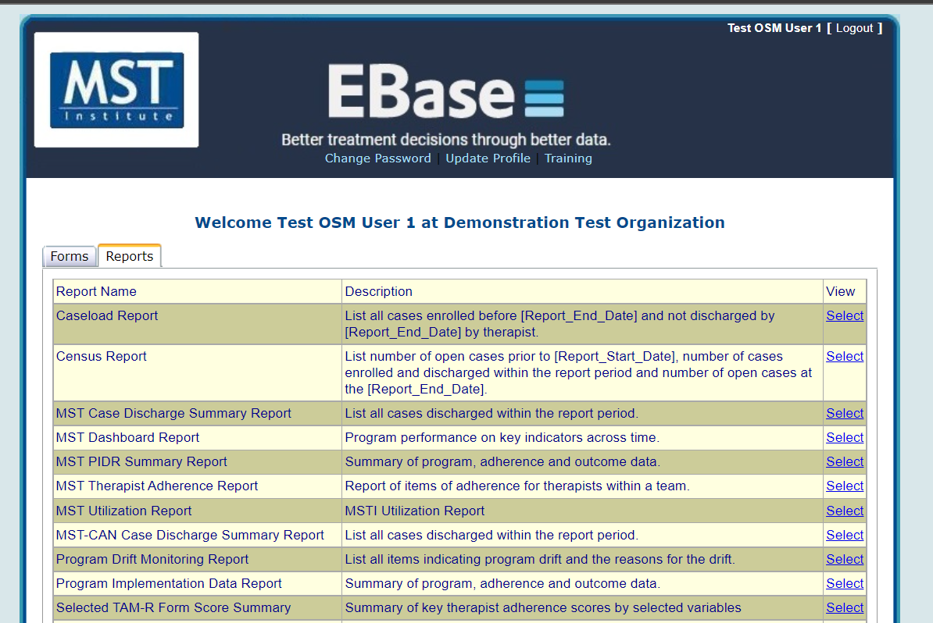
This section names all the standard reports available to you
This provides a brief description of the reports.
Click on this link to select the report.

Once a report is selected from the standard report menu, the system will always take you to the Report Field Filters screen. The Report Field Filters screen allows the user to specify the form, organization, team, research group, etc. he or she wants to report on. Furthermore, the Report Field Filters screen enables the user to run a report for a certain period of time.

- Example selection screen
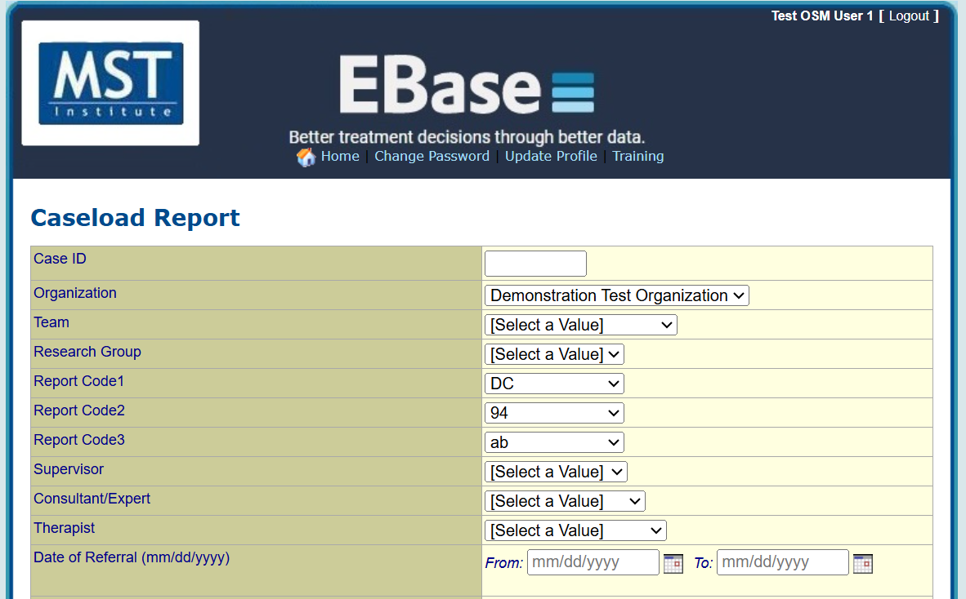
Click the dropdown arrows to make selections you would like to make.
All date fields provide a calendar selection pop-up. To utilize, click the calendar icon, next to the date field you are using.

If there are multiple teams, supervisors, or therapists for this organization, you will need to click the dropdown arrow to select the specific fields you want to filter by. Some of the dropdown menus may only allow one or certain selections. This would reflect that there is only information in the database for these selections.

When selecting the information for supervisor or therapist, you will also see names listed that do not appear as names. When a user is made inactive on the website, the system automatically deletes the person’s name. The name of the user is then stored with the first initial of the first and last name, and their MSTI ID number. Therefore, when running reports, you will see these de-identified user’s names along with the full names of the active staff in the filter dropdowns. You can remove these de-identified names from the reports themselves by filtering by active staff, when that option is available.

The Research Group dropdown can be left with the default value of “Select a Value” unless your organization wants to be able to run a report on a certain group that has been pre-selected. Then you would select the letter from the drop down that symbolizes the specific group you want to run a report on. Report Code 1, Report Code 2, and Report Code 3 are not required questions, and default to “Not Specified.” These are all site defined and you can use as many (or as few) as you would like. You can use just a Report Code field and leave the other two untouched, or you can use all three. The Summary Report Covering Period date range at the bottom of the Report Field Filters screen is required to customize a report.

Monitoring Overall Program Adherence

The reports used to monitor overall program adherence and performance combining information that is available separately in a variety of other forms and reports. Therefore, it might be helpful to first review the reports described in the Program Management Reports Guide before using the reports included here. The reports reviewed here are based on data collected via the Case Forms, the Therapist and Supervisor Adherence Measures, and the Program Review Form.

Program Implementation Data Report:

To run this report:
- Click “Select” for the Program Implementation Data Report in the Report Menu
- On the Report Field Filters screen, select the filters of interest, e.g., team, supervisor, or therapist
- At the bottom of the Report Field Filters screen, enter the dates of interest in the Summary Report Covering Period fields
- Click “Show Report”

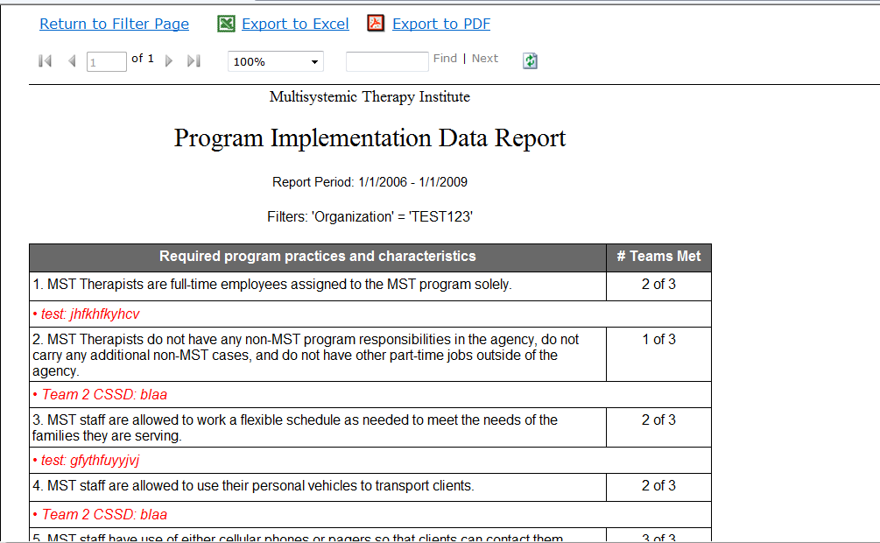

The Program Implementation Data Report (PIDR) summarizes key information about program practices (e.g., length of treatment, caseload size) therapist adherence, and discharge information about the program in a data table. This report is critical in identifying areas of strength and struggle (e.g., challenges in the referral process, low adherence, etc.) for the program. If data has been routinely monitored for accuracy, then this report should provide a valid “picture” of the program and should be reviewed with the MST Consultant/Expert around the time of each booster. In addition, the Program Implementation Review (PIR) uses this report to identify issues to target for continuous improvement of the MST program. The report exported to Excel can easily be copied and pasted into a Word document with 1” margins.

The Program Practices and Characteristics section displays information from the most recent Program Review Form for each team that has a “covered period end date” within the reporting period. If there is not data from a form completed during the selected period, the following message will appear at the beginning of the report, “No Program Reviews were found within the current report period.”

For each of the following categories, a count of teams is displayed:
- Status of each required program practice and characteristic
- Additional recommended program practices of note that are not met
- Factors identified as potential indicators of future or on-going challenges to program adherence and successful implementation that are present

The Program Review Form items 9, 21, 30, 31, 32, 34, 35, 38 have been demonstrated through analysis of MSTI data as critical items that have potential to provide meaningful information to the MST Consultant/Expert and the Program Leadership about potential risks to the team, as well as strengths to leverage for sustainability. The Program Review Form has been modified so that these items will be displayed in bold font on the PIDR reports. The report will only display items 19 and higher if they are identified as potential problems. Running the report against old data that included the response, “Don’t know,” will display items answered “Don’t know” as well as potential problems.

The Program Data Table is divided into sections as follows:

Program Data

The first 5 items of the PIDR summarize information about program operations. The “Total FTE for active therapists” figure is based on the summary of the full time equivalent for each MST staff instead of a count of the actual persons. This allows for a more accurate calculation of open cases per therapist (item #3) when staff are carrying less than a full caseload (e.g., supervisors who carry cases). Supervisors can edit the Therapist FTE if there are changes in status, for example, a therapist is new and only has one case assigned during the report period. The therapist FTE can be changed to 1/5 (20%) to more accurately reflect capacity. The calculation only includes therapists with at least one open case during the report period.

The “Current Census (open case)” figure calculates those cases with a Date of First Visit before the end of the report period who are not discharged. The “Average number of open cases per therapist” figure is calculated by first counting the number of treatment days per case during the report period, then creating a total number of treatment days, this is then divided by the total number of days in the report period (i.e., creating an estimate of number of cases served at any point in time during the report period). This proportional estimate of cases served is then divided by the total FTE in #1.

The “Cases served during the report period” figure reflects the total count of cases served with a date of first visit within the report period. Each case is counted even if they were only open a few days in the report period. The “Estimated annual service capacity” is calculated by taking the “Current Census” figure, multiplying it by 365 (days) and dividing it by the average length of stay in days for closed cases (item #26.)

Therapist and Supervisor Adherence Scores

The Therapist and Supervisor Adherence Scores section (items 6 - 13) on the PIDR provides information related to the collection of therapist and supervisor measures and key indicators of therapist adherence. Items 6 – 8 give the user the total number of TAM-R forms collected, the total number of incomplete TAM-R forms collected in the report period, and the percent TAM-R due that were completed for the selected organization or team. This latter item should be consistent with the “Percent completions” reported in the TAM-R Monitor Report for the same report period using the same data filters.

The key therapist adherence indicators include the “Percent of youth with at least one TAM-R interview” (#9), the “Overall Average Adherence Score” (#10) and the “Percent of youth with average therapist adherence score above threshold” (#11) in the report period for the selected organization or team. It is important to note that #9 is calculated by dividing the number of youths with a TAM-R by the number of cases open for more than 30 days, while #11 is based on the number of youths with a TAM-R.

The Supervisor Adherence Scores items include the total number of SAM forms collected; the average number of SAMs collected per therapist.

Case Progress Review
The Case Progress Review section (items 14 - 23) on the PIDR gives the user a summary of the discharge data collected in the report period. This section gives the total number of cases discharged excluding those cases without a date of first visit (#14) and also gives the number of referrals closed without services, i.e., cases closed without a date of first visit (#15). Cases without a date of first visit will be excluded from calculations of all the remaining items.

The “Percent of cases completing treatment” (#16) is calculated by taking the percentage of those cases closed by mutual agreement (#17) out of those cases where the team had the opportunity to provide a full course of treatment (Case Progress Review categories #17, #18, and #19).

The remaining Case Progress Review categories (i.e., client moved or was withdrawn by the referral source for reasons outside the control of the team) allow the team to track potential problems in the referral process. This section (items 17 - 23) describes the reason each case was closed.

Ultimate and Instrumental Outcomes

The outcome information reported in the first 2 sections is for the cases that had the opportunity to have a full course of treatment. Cases closed for non-clinical reasons (lines 20 – 23) are omitted from the counts.

The first section reports the total number of cases with opportunity for full course of treatment during the report period and the average length of stay in days (days between first visit date and discharge date) for youth. In addition, the percentage of youth who are doing well in three areas of primary interest to stakeholders is provided. These areas include:
Is the youth living at home?
Is the youth in school/working?
Is the youth with no new arrests?

The next section (items 29- 34) of the report contains the percent of cases closed in the report period that are evaluated at discharge as having sufficient changes in the key factors associated with problem behaviors to indicate that changes are likely to be maintained post discharge.

The final two sections (items 35 - 43) of the report include the same Ultimate and Instrumental outcome information but the percentages are based on all cases closed during the report period, regardless of the reason for case closure.

Team Performance Over Time

The final page of the report includes Team Performance Over Time to show how performance has changed from previous time periods equivalent to the selected time period. If the report includes data from multiple teams within an organization, it will be the average of those teams on the key performance indicators which is also color coded to indicate how close the performance is to the targets established by MST Services.

The data for the current period should be the same as that displayed in the Program Data Table on page 2 (or page 1 if there is no Program Review data) for all identical indicators, except for items “Overall Average Adherence Score” and “Percent of youth with average therapist adherence score above threshold”. These items will often not have the same result as the same item in the Program Data Table, as the calculation for that item is slightly different. The difference in methodology is as follows:

- The Program Data Table calculates these scores using all open cases.
- The Team Performance Over Time limits the calculation to discharged cases.

Finally, users can export reports to Adobe, and/or Excel. Users can print from the exported file. In addition, to include this report in a Word document, first open a blank Word document and ensure that it is in portrait orientation with 1” margins all around. Then export the report to Excel and copy/paste it into the Word document.

MST PIDR Summary Report

To run this report:
- Click “Select” for the MST PIDR Summary Report in the Report Menu
- On the Report Field Filters screen, select up to five different teams of interest
- At the bottom of the Report Field Filters screen, enter the dates of interest in the Summary Report Covering Period fields
- Click “Show Report” and the screen below will appear

The report allows the user to select up to five different teams to query, so as to compare the adherence of those five teams using those same items found on the Program Implementation Data Report (PIDR).

Furthermore, the report displays the averages or totals of the five teams selected for each of those items. This report will include all records for a team since there are no filters for supervisor or MST Consultant/Expert.

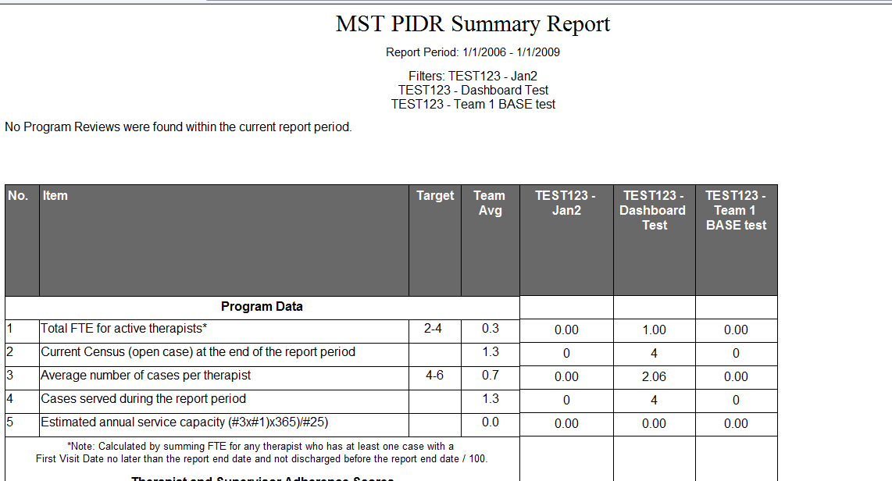

MST Dashboard Report:

To run this report:
- Click “Select” for the Dashboard Report in the Report Menu
- On the Report Field Filters screen, select the filters of interest, e.g., team, supervisor, or therapist
- At the bottom of the Report Field Filters screen, enter the dates of interest in the Summary Report Covering Period fields
- Click “Show Report”

The report can be restricted to standard MST or to MST adaptations. Additional filters can be added or removed as needed.

The MST Dashboard Report allows the monitoring of the key performance indicators "at a glance" for Organizations or Networks. The first section displays key performance indicators by team within the Organization or Network for the report period. Only teams with data during the report period will be displayed. These selections for the MST Dashboard Report are limited to a few key variables where MSTI has established empirical support for the ranges used to identify scores in the green (within target), yellow (potential concern) or red (identified need area) ranges. The color alerts let users know what needs to be paid attention to and monitored closely.

The second page displays performance over previous time periods of same duration. These calculations are based on the same methods at the Team Performance Over Time section of the PIDR. Data will be summarized for any team with data during the period; therefore, the time period might include different sets of teams. Users should be aware that it is critical to only pay attention to percentages based on a minimum of 15 records. Clicking on the indicator in the summary table will produce a color chart in a new window. The ranges for red and green are defined as yellow being between the colored lines.

