The next section is the Therapist and supervisor adherence scores.
EditUse enter key to enable transcript edit mode

Program Management Reports Guide

MST INSTITUTE |  | August 2026



Table of Contents
Program Management Reports Guide 2
Objectives of the Demonstration: 2
Monitoring Caseloads 5
MST Census Report 5
MST Caseload Report 6
MST Utilization Report 6
Data needed to run the report 7
MST Case Discharge Summary Report 8
Add a Program Review Form 9
List Program Review Forms 10
Other Report Options 11

Program Management Reports Guide

We will focus on providing you with an opportunity to ask questions and see how to navigate the reports on the website, so you can explore on your own. The most important points will be covered here. It is important that you review and become familiar with the FAQs, as many procedures and questions that you may have are included there. You can find them on MST Institute’s Training and Education page https://msti.org/training-and-education.

Objectives of the Demonstration:

Today, we will go over the following –

- Monitoring Caseload
  - MST Census report
  - MST Caseload report
  - Utilization report
- Monitoring Outcomes
  - Case Discharge Summary Report
- Monitoring Program Practices
      - Program Review Form

Please go to www.msti.org and click on “Login”. For today’s training, we will log in as a System Manager and look at the menus and reports available to that user.

Access to MSTI.org for Training Purposes

An environment for demonstrations is available on the website to allow new users an opportunity to explore, edit and train.

To access the website and explore its functionality at each user level, please reach out to the MSTI Helpdesk directly (msti@mstinstitute.org) to obtain a demonstration login.

From there the demonstration can still continue on the guide.

Please note that you can use this login information to explore the site on your own at any time.

Before we begin, please take a minute to review the standard report menu of the www.msti.org main menu page below. Standard reports are different from list reports which are summaries of raw data. Standard reports are canned/standard formats for reports providing summaries of the data of interest and are generated by choosing “Select” next to the desired item on the menu.

This section names all the standard reports available to you.

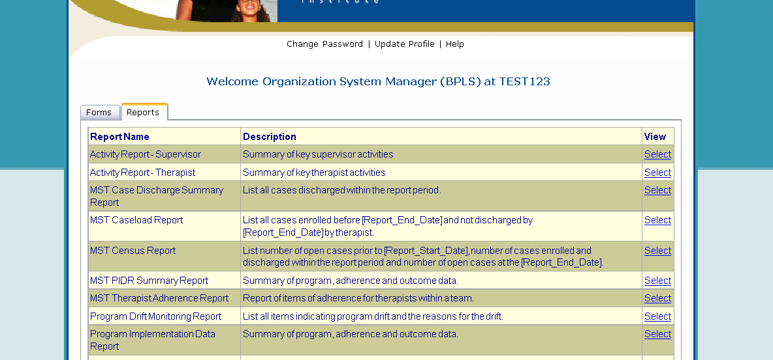
This section provides a brief description of the reports.
Click on this link to select the report.

Once a report is selected from the standard report menu, the system will always take you to the Report Field Filters screen. The Report Field Filters screen allows the user to specify the form, organization, team, research group, etc. he or she wants to report on. The Report Code 1, Report Code 2, and Report Code 3 options allow you to specify segments of a team’s caseload if you choose. For example, the caseload could be run for a geographic region for the team or the type of funder. Report Codes 1-3 are optional and will default to “Not Specified” if you choose not to use them. Furthermore, the Report Field Filters screen enables the user to run a report for a certain period.

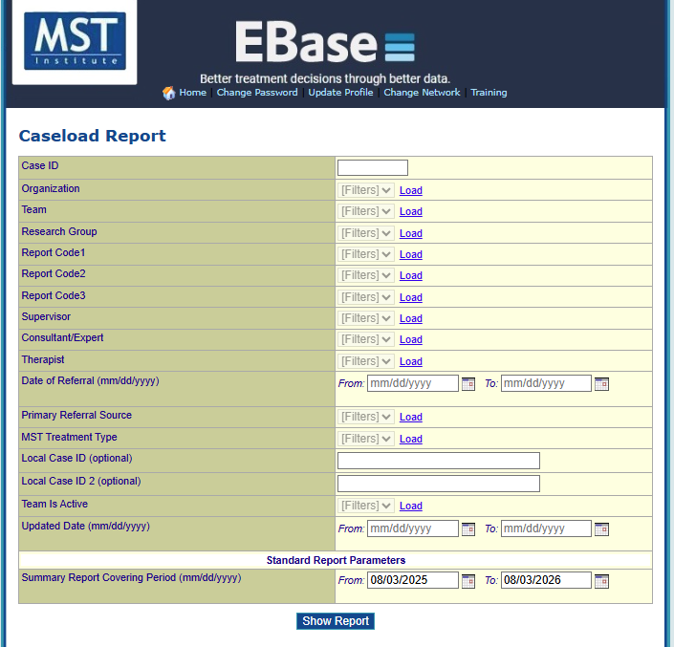
All date fields provide a calendar selection pop-up. To utilize, click the calendar icon, next to the date field you are using.
Select 'Load', to load the filter selection list for a specific field. Then make your selection.

If there are multiple teams, supervisors, or therapists for this organization, you will need to select 'Load', in order to load the filter selection list for the specific field you want to filter by. Some of the drop-down menus may only allow one or certain selections. This would reflect that there is only information in the database for these selections. When loading the information for supervisor or therapist, you will also see names listed that do not appear as names.

When a user is made inactive on the website, the system automatically deletes the person’s name. The name of the user is then stored with the first initial of the first and last name, and their MSTI ID number. Therefore, when running reports, you will see these de-identified user’s names along with the full names of the active staff in the filter dropdowns.

Please see screenshot below for an example of what this looks like. You can remove these de-identified names from the reports themselves by filtering by active staff, when that option is available.

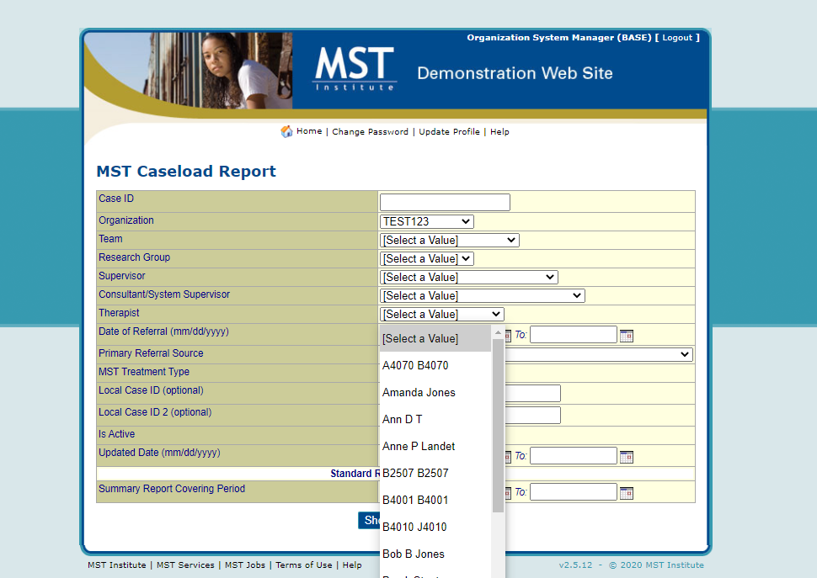
Based on the name of this therapist, you can easily see that they are inactive on the website.

The Research Group drop-down can be left with the default value of “Select a Value” unless your organization wants to be able to run a report on a certain group that has been pre-selected. The Report Codes 1-3 can be left with the default value of “Not Specified” unless you choose to run a report with a certain group. Then you would select the letter from the drop down that symbolizes the specific group you want to run a report on. The Summary Report Covering Period date range at the bottom of the Report Field Filters screen is required to customize a report.

Monitoring Caseloads

MST Census Report

To run this report:
- Click “Select” for the MST Census Report in the Report Menu
- On the Report Field Filters screen, select the team, supervisor, therapist, or other filters of interest
- At the bottom of the Report Field Filters screen, enter the dates of interest in the Summary Report Covering Period fields (e.g., tracking census over the period of a year, quarter or month)
- Click “Show Report”

MST Census Report is useful in monitoring total program census per team according to the time period selected in the Summary Report Covering Period fields. The Census Report lists the number of open cases prior to start date given, number of cases enrolled and discharged within the report period and number of open cases at the end date given.

The most common use for this report is to provide program administrators an easy way to report program utilization to their stakeholders. They can select the report period needed to generate reports of annual (or quarterly) service utilization per team.

MST Caseload Report

To run this report:
- Click on MST Caseload Report in the Standard Report Menu
- On the Select Records screen, select the team, supervisor or other filters of interest
- At the bottom of the Select Records screen, enter the dates of interest in the Summary Report Covering Period fields
- Click “Continue”

The MST Caseload Report lists the current, active cases assigned to each therapist with date of referral, first visit date, length of treatment. It is suggested that the report period selected should be the past week up to the current date as this report is helpful in monitoring current caseloads and in anticipating upcoming case openings as cases move towards their upper end of target treatment duration. This report includes only the youth who are currently enrolled and not yet discharged at the end of the designated reporting period. Clicking on the Case ID will bring up the enrollment form.

The MST Caseload Report should be run as frequently as needed for monitoring although it is recommended that this report be reviewed with the team’s weekly paperwork. If the data has been entered accurately, there should be a case in the report that corresponds to each weekly summary. Questions to ask include:
- Does list include all current open cases?
- Are therapist assignments accurate?
- Are there cases that need to start planning for closure?
- Are there cases already closed that need a discharge form completed?

By monitoring this report weekly, teams will begin to develop the habit of keeping case information up to date. Other case information that can quickly be monitored is the caseload size for each therapist and how long each case has been in treatment.

If there is initial paperwork on a case that does not appear on the report, the team should enter the case enrollment form for that case. If a case appears in the report that was already closed, then the case discharge form has not been completed. Sometimes, a case will be made “inactive,” but someone will forget to complete the discharge form. Also printed in the report are the names of the team and therapist associated with each case. If these are incorrect, the Case Enrollment form should be edited.

Duplicate cases can be identified when a case appears more than once in the report (one name would have been spelled differently). In this case, the team will need to identify which case is correct and email the MSTI Helpdesk at msti@mstinstitute.org to have the duplicate case removed.

MST Utilization Report

To run this report:
- Click on MST Utilization Report in the Standard Report Menu
- On the Select Records screen, select the team, supervisor or other filters of interest
- In the field “Enter Average Caseload Expected by Model”, enter the number for the treatment being delivered by the team, e.g., for standard MST enter “5.”
- At the bottom of the Select Records screen, enter the dates of interest in the Summary Report Covering Period fields. The “To” date will be the last date column to appear on the report and the other dates are determined by the number of days between the “From” and “To” dates. So, if the date range is 7 days, there will be 13 dates for which data is displayed going back at 7 day intervals. This would cover approximately a single quarter of the year. If a month’s range is used it will provide data covering a year. It is recommended that the interval between dates be 31 days or less in order to provide the most accurate picture of utilization.
- Click “Continue”

Data needed to run the report
In addition to the case and therapist data normally collected, this report needs information on the “expected average caseload” and the “number of therapist positions on the team”. The number of therapist positions is entered in the Team Form by the MSTI Helpdesk at the time of the team registration. The registration forms ask for this information. If contracts/budgets change so that the number of therapists change, a request to update that data must be sent to the MSTI Helpdesk at msti@mstinstitute.org. The expected average caseload is a required field and is entered by the user on the selection screen.

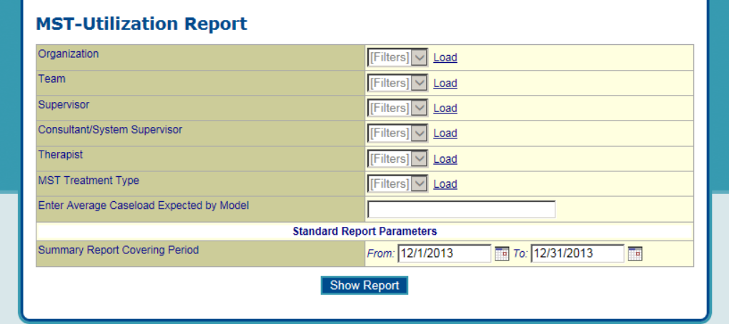
Consult with your Expert if you are unsure of the treatment model expectations

The MST Utilization Report has been developed to illustrate the percent of expected utilization a team, organization or network has at 13 user defined intervals. It will provide a snapshot of the number of active cases, the FTE for therapists assigned to those cases, the average caseload and percent of expected model utilization at the specific dates displayed in the column headers. This report is available to all users except therapists and data managers. An example report is provided at the end of this document.

“Expected model utilization” is based on the number of therapist positions budgeted/contracted for a team multiplied by the model’s targeted average caseload. So, for example, an average caseload of 5 is targeted for standard MST but an average caseload of 4 is targeted for MST-CAN. Therefore, an MST team of 3 therapists is expected to serve 15 cases and an MST-CAN team of 3 is expected to serve 12 cases.

“Percent Model Utilization” is the number of active cases divided by the expected model utilization.

“Overall average percent model utilization” combines the data for all the teams in the report to get an overall average. The exception is when a team has no open cases. In this case the numbers for that team are not included in the calculation of the overall average.

Monitoring Outcomes

MST Case Discharge Summary Report

To run this report:
- Click “Select” for the MST Case Discharge Summary in the Report Menu
- On the Report Field Filters screen, enter the team, supervisor, therapist, or other filters of interest
- At the bottom of the Report Field Filters screen, enter the dates of interest in the Summary Report Covering Period fields
- Click “Show Report”

The Case Discharge Summary Report lists all the data from the discharge form for all cases discharged within the report period including relevant dates, length of treatment, case progress review, instrumental outcomes, and ultimate outcomes. It provides an overview of outcome data across families, sorted by therapist. Teams should verify accurate data entry by running this report monthly and comparing it to hard copies of the discharge form. A discharge form can be easily accessed for editing by clicking on the number in left column.

It is critical that the information on the case discharge form reflects a consensus decision between the therapist, supervisor and the MST expert. Therefore, procedures should be established and followed routinely. Each case is evaluated at discharge in three areas:
Did the youth and family complete treatment and, if not, why not (Case progress review)?
Were there sufficient changes in the key factors associated with problem behaviors to indicate that changes are likely to be maintained post discharge (Instrumental Outcomes)?
How was the youth doing in three areas of primary interest to most stakeholders (Ultimate Outcomes)?

The Ultimate Outcome items provide basic information about how the youth is functioning at the time of discharge. The meaning of the terms (e.g., ‘arrests’) may vary from county to county, state to state, and country to country; therefore, it is difficult for the MST Institute to establish a “one-size-fits-all” definition. The operational definition of each of the Ultimate Outcomes should be made clear for each MST program and documented in the Goals and Guidelines document.

Monitoring Program Practices

Add a Program Review Form

To add this form:
- Click on “Add” for Program Review Form
- Select a team in the Select a Team drop down menu for the team that you want to add the form to and click “Select”.

The Program Review Form is used for entering, editing, and listing of program practices and characteristics. It includes potential factors that indicate drift or risk to program sustainability. The data from these forms inform the Program Drift Monitoring Report and the Program Implementation Data Report. The Program Review Form should be completed following every booster, either by the MST Supervisor or the MST Consultant/Expert. The answers should be reviewed by both and revised if necessary. While it is recommended that the status of the program be reviewed quarterly using the program review form, the “need” areas indicated on this form are still only addressed twice a year in the standard Program Implementation Report (PIR). This written report is prepared by the MST Supervisor and the MST Consultant/Expert to provide guidance to local stakeholders on recommended next steps to increase adherence. Typically, the Consultant/Expert conducts a “fit” of the identified struggles and challenges and Intermediary Goals/Interventions will be developed to address the primary drivers. Progress on these Goals will be assessed at the time of the next PIR.

The Program Review Form has separate sections for strongly recommended/required program practices and characteristics (items 1- 18), additional recommended program practices and characteristics (items 19 - 26), and factors that have been identified as potential indicators of future or on-going challenges to program adherence and successful implementation (items 27- 38). For each item where a practice is not met or a potential challenge is identified, users are given an opportunity to insert the reason in the blank field provided.

The Program Review Form items 9, 21, 30, 31, 32, 34, 35, 38 have been demonstrated through analysis of MSTI data as critical items that have potential to provide meaningful information to the Expert and the Program Leadership about potential risks to the team, as well as strengths to leverage for sustainability. The Program Review Form has been modified so that these items will be displayed in bold font on the reports. If the answer to an item is unknown, the MST Consultant/Expert or Supervisor should respond with “no” and then include “answer unknown” in the text field. This will ensure that the item will show up in the report and can be discussed with stakeholders to get an answer. To view a list of all Program Review Forms for an entire organization or a specific team, run a list report.

List Program Review Forms

To run this report:
- Click “View/Edit” for Program Review Form
- Click on the column header that you wish to sort by.
- Click on "Add a Filter" if you wish to filter your results by a certain field

For a copy of all the responses to items on the Program Review Form, run a list report then click on the number in the left column of the form of interest. However, to have a report that highlights only those areas that may require intervention, you should run a Program Drift Monitoring Report.

Other Report Options

Additional reports are available to monitor a program’s overall performance, a description of these reports is provided in the Program Performance Reports Guide.

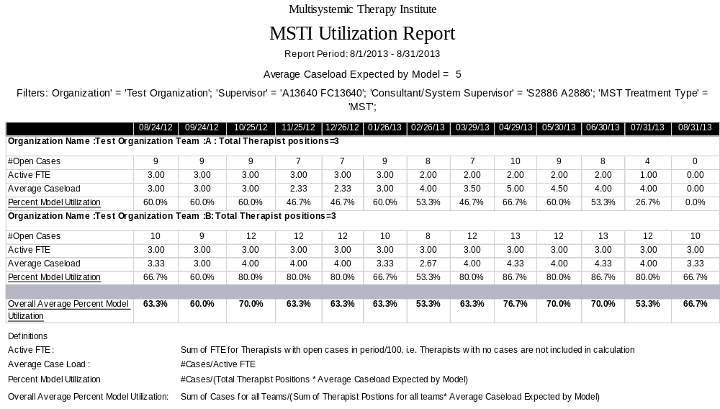
Number associated with team on Team Form
Number entered from selection screen

