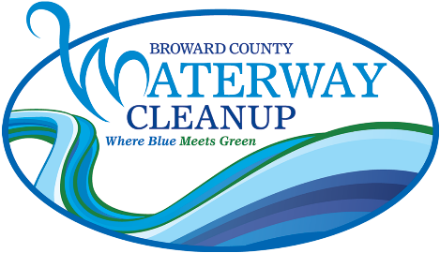

Broward County Waterway Cleanup
Recycled Art Contest Guidelines

The Marine Industries Association of South Florida is conducting a recycled art contest for middle and high school students in conjunction with the Broward County Waterway Cleanup. Each art project should be made using materials that would otherwise be thrown away or recycled. The art contest is broken down into three (3) different grade categories: Middle School (Grades 6-8), High School (Grades 9-10), & High School (Grades 11-12). One winner of the art contest from each grade category will be awarded a $250 scholarship and will be announced at the Waterway Cleanup Trash Bash.

COMPETITION RULES

- Entries must be original and not previously submitted anywhere else.
- Only one entry per applicant will be accepted.
- Entries must incorporate or have a marine-related theme.
- Entries may be no larger than 24”x36”.
- All materials must be cleaned prior to use.
- Applicant must complete and attach the enclosed application form to his or her entry. Name and address of the writer should not appear on the art project.
- Entries may be dropped off at or mailed to: MIASF – Waterway Cleanup, 221 SW 3rd Avenue, Fort Lauderdale, FL 33312.
- All possible care is taken with the submissions, but MIASF is not responsible for loss or damage. Entries will not be returned.
- Entries must be delivered no later than Friday, February 14, 2025.

Broward County Waterway Cleanup Recycled
Art Contest Application

APPLICANT INFORMATION:

Name Last __________________________ First _____________________ Middle Int. ____

Address Street _________________________________________________ Apt. ____________

City ____________________________________ State ______ Zip _______________

Phone: Home ( ) _______________________ Other ( ) _____________________

Date of Birth: ___________________ Email: __________________________________

Grade level: _________________

SCHOOL INFORMATION:

Teacher Name ____________________________________ Email: ____________________________

School Name ________________________________________________________________________

Address Street __________________________________________________________________

City ________________________________ State _______ Zip ___________________

Phone: ( ) _________________________ Fax: ( ) _________________________

TITLE OF WORK:
_____________________________________________________________________________________

