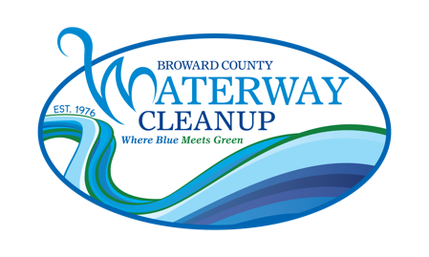
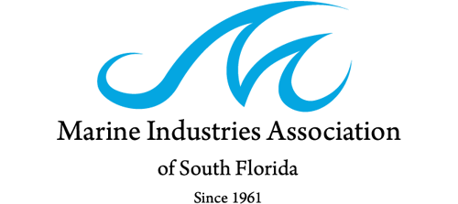

Official Broward County Waterway Cleanup Poster Contest
Rules & Design Guidelines
Your design must include the following elements:
- The official Broward County Waterway Cleanup logo (you can download from www.waterwaycleanup.prg/poster-contest)
- Event Name, Website, Date and Time:
  - 48th Annual Broward County Waterway Cleanup
  - www.waterwaycleanup.org
  - Saturday, March 1, 2025
  - 9:00 AM – 1:00 PM
- The upper right corner of your design must include a blank line with the words “Nearest Location” underneath the line
- A 2” space along either the right side or bottom of the artwork for sponsor logos (to be added by MIASF)
Additional Design Guidelines:
- Artwork cannot include:
  - other company, association, or business logos
  - profane or demeaning language or images
  - copyrighted material (not owned by you)
- Design should be submitted electronically in as a high resolution JPEG, PNG, Adobe Illustrator, Adobe Photoshop, or press quality PDF format.
  - Hand drawn/illustrated artwork is accepted but must be scanned in high resolution and submitted digitally.
- Final poster design should be 16” x 20” (landscape or portrait orientation is up to you); your design must include a 2” space for sponsor logos to be added by MIASF staff.
Official Rules:
- Only one entry may be submitted per student.
- To be considered, all entries must be submitted electronically to info@miasf.org by January 10, 2025, with the email subject line “WWCU25 Poster Contest”.
- All entries must also include a completed application form which can be found online at https://waterwaycleanup.org/scholarship-opportunities.
- All entries must be created by a student currently enrolled in a K-12 public or private school in Broward County, Florida.
- The winning design will become property of MIASF
- The winning poster design may, at the discretion of MIASF staff, also be reproduced for the event flyers and volunteer t-shirts for the 2025 Broward County Waterway Cleanup.

Broward County Waterway Cleanup Poster Contest Application

STUDENT/APPLICANT INFORMATION:

Name Last:________________________ First:________________________ Middle Int.:____

Address Street:_____________________________________________________

City:________________________ State:_________________ Zip: ___________

Phone: __(_______)______-__________ Other: __(_______)______-__________

Date of Birth: _____/_______/_____ Email: ___________________________________

Grade Level: ______

SCHOOL INFORMATION:

Teacher Name: ____________________________ Email: ____________________________________

School Name: ____________________________________

Address Street:_____________________________________________________

City:________________________ State:_________________ Zip: ___________

Phone: __(_______)______-__________ Other: __(_______)______-__________

Student and Parent/Guardian Signatures (REQUIRED):
By signing below, you acknowledge that you have read and agree to the official rules for the 2024 Broward County Waterway Cleanup Official Poster Contest.
_________________________________ __________________________________
Student Signature Date

_________________________________ __________________________________
Parent/Guardian Signature Date

