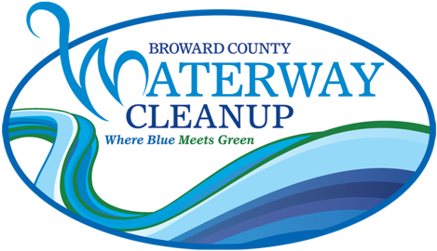

Broward County Waterway Cleanup Essay Contest Guidelines

The Marine Industries Association of South Florida is conducting its annual essay contest for Broward County high school students, in conjunction with the Broward County Waterway Cleanup. The essays should focus on the importance of Broward County waterways to our community, including, but not limited to, their historic, economic, or environmental impact.

The winner of the essay contest will be awarded a $750 scholarship and will be announced at the Waterway Cleanup Trash Bash!

COMPETITION RULES
- Entries should be a minimum of 800 words and a maximum of 1200 words in length.
- Entries must be original and not previously published.
- Any entries created with the use of Artificial Intelligence, or containing AI-generated text, will not be accepted.
- Only one entry per applicant will be accepted.
- Entries must contain information regarding Broward County waterways/marine life researched by the applicant. Submissions must include a Bibliography.
- All entries must be typewritten, double-spaced on one side of 8 1/2 x 11" paper. Pages should be numbered.
- Text only; entries with illustrations will not be accepted.
- Applicant must complete and attach the enclosed application form to his or her entry. Name and address of the writer should not appear on the manuscript.
- Do not submit your only copy. All possible care is taken with manuscripts, but the MIASF is not responsible for loss or damage. Entries will not be returned to applicants.
- Email entries or inquiries to info@miasf.org. Entries also may be mailed to: MIASF – Waterway Cleanup, 221 SW 3rd Avenue, Fort Lauderdale, FL 33312.
- Entries must be submitted no later than February 20th, 2026

Broward County Waterway Cleanup Essay Contest Application

APPLICANT INFORMATION:

Name Last __________________________ First _____________________ Middle Int. ____

Address Street _________________________________________________ Apt. ____________

City ____________________________________ State ______ Zip _______________

Phone: Home ( ) _______________________ Other ( ) _____________________

Date of Birth: ___________________ Email: __________________________________

Grade Level: _________________

SCHOOL INFORMATION:

Teacher Name ____________________________________ Email: _____________________________

School Name ________________________________________________________________________

Address Street __________________________________________________________________

City ________________________________ State _______ Zip ___________________

Phone: ( ) _________________________ Fax: ( ) _________________________

TITLE OF WORK:

_____________________________________________________________________________________

