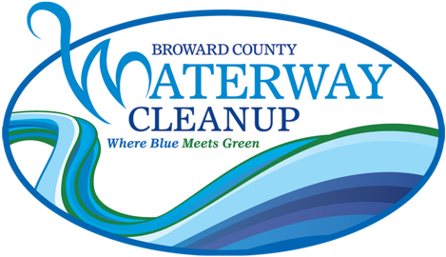

Broward County Waterway Cleanup
Short Story Contest Guidelines

The Marine Industries Association of South Florida is conducting a short story contest for middle school students in conjunction with the Broward County Waterway Cleanup. Each short story entry should reflect the importance of our local waterways to our community, including but not limited to their historic, economic, or environmental role.

The winner of the short story contest will be awarded a $250 scholarship and will be announced at the Waterway Cleanup Trash Bash!

COMPETITION RULES

- Entries should be 600-800 words.
- Entries must be original and not previously published.
- Only one entry per applicant will be accepted.
- Entries must include information regarding waterways/marine life researched by the applicant.
- All entries must be typewritten, double-spaced on one side of 8 1/2 x 11" paper. Text only; entries with illustrations will not be accepted.
- Applicant must complete and attach the enclosed application form to his or her entry. Name and address of the writer should not appear on the manuscript.
- Do not submit your only copy. All possible care is taken with manuscripts but the MIASF is not responsible for loss or damage. Entries will not be returned.
- Email entries or inquiries to info@miasf.org. Entries also may be mailed to: MIASF – Waterway Cleanup, 221 SW 3rd Avenue, Fort Lauderdale, FL 33312.
- Entries must be postmarked no later than Friday, February 14, 2025.

Waterway Cleanup Short Story Contest Application

APPLICANT INFORMATION:

Name Last __________________________ First _____________________ Middle Int. ____

Address Street _________________________________________________ Apt. ____________

City ____________________________________ State ______ Zip _______________

Phone: Home ( ) _______________________ Other ( ) _____________________

Date of Birth: ___________________ Email: __________________________________

Grade level: _________________

SCHOOL INFORMATION:

Teacher Name ____________________________________ Email: ____________________________

School Name ________________________________________________________________________

Address Street __________________________________________________________________

City ________________________________ State _______ Zip ___________________

Phone: ( ) _________________________ Fax: ( ) _________________________

TITLE OF WORK:

_____________________________________________________________________________________

