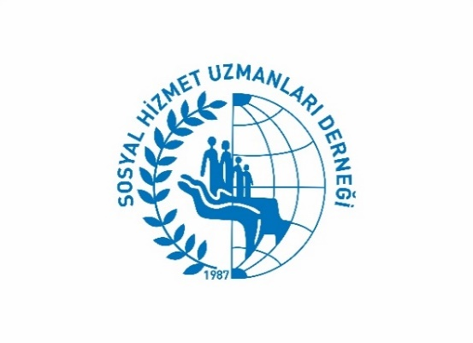

MUGLA METROPOLITAN MUNICIPALITY & MUGLA BRANCH of TURKISH ASSOCIATION OF SOCIAL WORKERS

SUMMER CAMP FOR SOCIAL WORK STUDENTS

CLIMATE CHANGE, SOCIAL WORK & SOCIAL DEVELOPMENT

20 th July – 25th July 2020
DRAFT CAMP PROGRAM
VENUE: İnlice Bay, Göcek, Fethiye MUĞLA/TURKEY
CAMP COORDINATORS
Ertan ÖZTÜRK: Muğla Metropolitan Municipality - Social Worker, Head of Turkish Association of Social Workers Mugla Branch
Turgay ÇAVUŞOĞLU: Social Worker,Turkish Association of Social Workers İzmir Branch
Hakan ACAR: Lecturer, Liverpool Hope University
Ergin BALCI, Social Worker, (Turkish Association of Social Workers)

Date & Hours |  | Theme/Activity | Responsible Tutor or Unit
20 July 2020 Monday | 12.30 | Transport from Fethiye Coach Station (Turkish Students only) and Dalaman Airport (Shuttle) to Camp Venue at 12.30 | Mugla Metropolitan Municipality (MMM) Dept. of Social Services
 | 13.00- 14.00 | Lunch | MMM Dept. of Social Services
 | 14.00- 19.00 | Meet up, camp program, rules & expectations & setting up the tents | Mrs. Zeliha BALIK – Scout Leader
 | 19.00- 20.00 | Dinner | MMM Dept. of Social Services
 | 20.00-20.30 | Teaser Trailer of Muğla | MMM Dept. of Social Services
 | 20.30-23.00 | Welcome Party | All Applicants (We expect you to bring 5 party songs from your countries)
Date & Hours Theme/Activity Responsible Tutor or Unit  21 July 2020 Tuesday 08.00-09.00 Breakfast MMM Dept. of Social Services  10.00-18.00 *There will be info by the guide during the trip. MMM Dept. of Social Services  10.00 Arrival to Dalyan and taking boats  13.00 Caunos Ancient City enterance  14.00 Lunch box will be provided during the trip  17.00-18.00 Departure to Kamp Area  18.00-19.00 Lecture 1: (TBA)  19.00-20.00 Dinner MMM Dept. of Social Services  20.00-21.00 Lecture 2: Social Work and Climate Change Prof. Michael Lavalette/Liverpool Hope University |  |  |  | 22 July 2020 Wednesday Date & Hours Theme/Activity Responsible Tutor or Unit  08.00- 09.00 Breakfast MMM Dept. of Social Services  09:30-11.30 Student Forum- Preperation 1 Hakan ACAR  12.30- 13.30 Lunch MBB Sosyal Hizmetler Şubesi MMM Dept. of Social Services  13.30- 14.30 Student Forum- Preperation 2 Dr. Hakan ACAR  14.30-17.00 Free time  17.00-18.00 Student Forum 1 Subject: (TBA) Hakan ACAR/  18.00-19.00 Student Forum 2 Subject: (TBA) Hakan ACAR/  19.00- 20.00 Dinner MMM Dept. of Social Services  20.00- 22.00 Lecture 3: Climate justice: Grassroots perspectives on loss, damage and adaptation Dr. Ethemcan Turhan/ Post-Doctoral Researcher at Royal Institute of Technology in Sweden.
Date & Hours Theme/Activity Responsible Tutor or Unit  23 July 2020 Thursday 08.00-09.00 Breakfast MMM Dept. of Social Services  10.00-18.00 *There will be translation by the guide during the trip. MMM Dept. of Social Services  10.00- 11.00 Arrival to Gizlikent & Saklıkent Ancient City (Fethiye)  14.00 Lunch box will be provided during the trip  17.00-18.00 Departure to Kamp Area  19.00-20.00 Dinner MMM Dept. of Social Services  20.00-23.00 Lecture 4: (TBA)  Date & Hours Theme/Activity Responsible Tutor or Unit  25th July 2020 Saturday 08.00- 09.00 Breakfast MMM Dept. of Social Services  09.00-12.00 Environmental cleanup-Leisure time MMM Dept. of Social Services  13.00- 14.00 Lunch MMM Dept. of Social Services  14.00-15.00 Certificates of Participation Ceremonies SHUDER MMM Dept. of Social Services  15.00- 17.00 Shuttle to Fethiye Coach Station/Dalaman Airport MMM Dept. of Social Services |  |  |  |  | Date & Hours Theme/Activity Sorumlu Kişi/Birim Responsible Tutor or Unit  24 July 2020 Friday 08.00- 09.00 Breakfast MMM Dept. of Social Services  09.00-12.00 Hand Craft Workshop (Colorful T shirts) MMM Dept. of Social Services  13.00- 14.00 Lunch MBB Sosyal Hizmetler Şubesi MMM Dept. of Social Services  17.00-19.30 Beach Volley Award of Beach Volley Competition MBB Sosyal Hizmetler Şubesi SHUDER MMM Dept. of Social Services  19.30-20.30 Dinner MMM Dept. of Social Services  20.00- 22.00 Farewell Party MMM Dept. of Social Services

