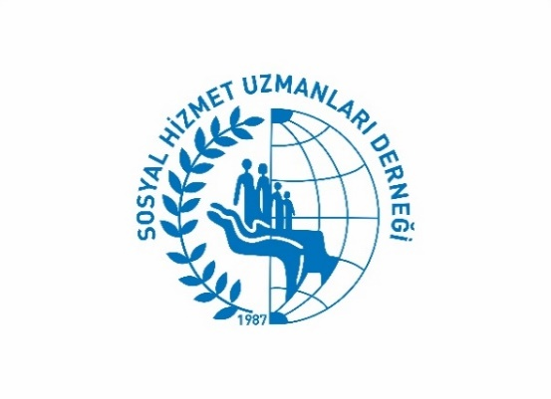
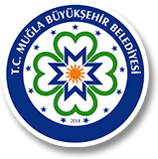

Mugla Metropolitan Municipality
Mugla Branch of Turkish Association of Social Workers
Liverpool Hope University

SUMMER CAMP PROGRAM

THE ROLE OF SOCIAL WORKERS IN ADVANCING A NEW ECO-SOCIAL WORLD

2nd – 7th September 2024

VENUE: Kille Bay-Dalaman-Mugla-Turkey

Date & Hours |  | Theme/Activity | Responsible Tutor or Unit
Monday, 2nd September 2024 | 12.30 | Transport from Dalaman Coach Station, Dalaman Airport)  Free transport (shuttle bus) to Camp Venue will be provided at Dalaman Coach Station. | Mugla Metropolitan Municipality (MMM) Dept. of Social Services
 | 13.00- 14.00 | Lunch | MMM Dept. of Social Services
 | 14.00- 19.00 | Meet up, camp program, rules & expectations & setting up the tents-  Swimming- Kille Bay | Mr. Berkem YENİCE Scout Leader
 | 19.00- 2030 | Dinner | MMM Dept. of Social Services
 | 20.30-23.00 | Welcome Party | All Applicants (We expect you to bring 5 party songs from your countries)
Date & Hours Theme/Activity Responsible Tutor or Unit  Tuesday, 3rd September 2024 08.00-09.00 Breakfast MMM Dept. of Social Services  10.30-12.00 Lecture 1: An Introduction to Social Work/Social Services and Social Problems in Turkey Visit to MBB Fethiye Sosyal Hizmet Birimi (Short Break Service Unit & Elderly Club of Mugla Metropolitan Municipality) Hakan Acar/ Liverpool Hope University  12.00-13.00 Lunch MMM Dept. of Social Services  13.00-15.00 Visit to Kayaköy, Fethiye  15.30-17.00 Free Time in Fethiye  17.30 Transport to the Camp Area  19.00-20.00 Dinner  20.30-22.00 Lecture 2: Ana Radulescu & Herbert Paulischin |  |  |  | Wednesday, 4th September 2024 Date & Hours Theme/Activity Responsible Tutor or Unit  08.00- 09.00 Breakfast MMM Dept. of Social Services  10.00 -12.00 Student Forum- Preparation Facilitators: Rose Devereux & Kellie Thomson  12.30- 13.30 Lunch MMM Dept. of Social Services  13.30- 14.30 Student Forum- Preparation Facilitators: Rose Devereux & Kellie Thomson  15.00-16.00 Leisure time activities Organized by MBB  16.00-17.00 Student Forum 1 (Group Presentations) Moderator: Rose Devereux & Kellie Thomson  17.00-18.00 Student Forum 2 (Group Presentations) Moderator: Gonca Polat-Ankara University  19.00- 20.00 Dinner MMM Dept. of Social Services  20.30- 21.30 Lecture 4: Cross Cultural Competencies-Philomena Harrison  22.00-24.00 Film showing Inconvenient Truth/Green Book/Cathy Come Home

Date & Hours Theme/Activity Responsible Tutor or Unit  Thursday, 5th September 2024 08.00-09.00 Breakfast MMM Dept. of Social Services  10.00- 19.30 Akyaka Boat Trip inc. lunch all day (750 TL per person)  MMM Dept. of Social Services  20.30-21.30 Dinner MMM Dept. of Social Services  Free time  Date & Hours Theme/Activity Responsible Tutor or Unit  Saturday, 7th September 2024 08.00- 09.00 Breakfast MMM Dept. of Social Services  09.00-10.00 Environmental clean-up-Leisure time  10.00-11.00 Closing Ceremony (Certificates)  12.00- 13.00 Lunch  13.30 Shuttle to Dalaman Coach Station/Dalaman Airport | Date & Hours Theme/Activity Sorumlu Kişi/Birim Responsible Tutor or Unit  Friday, 6th September 2024 08.00- 09.00 Breakfast MMM Dept. of Social Services  10.00-11.30 Lecture 6: Lecture 5 Multi-agency information sharing for promoting and protecting the welfare of children- Kellie Thompson and Rose Devereux  11.30-12.30 Lecture 7: Ezgi Ergenç-UNDP  13.00- 14.00 Lunch MMM Dept. of Social Services  14.00-19.30 Dalyan Kaunos Tour (inc. boat tour)  19.30-20.30 Dinner MMM Dept. of Social Services  22.00- 24.00 Farewell Party MMM Dept. of Social Services

