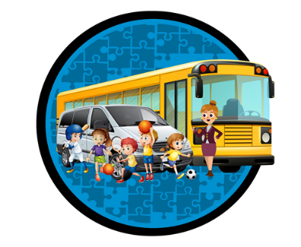

“**SAFE, RELIABLE AND PERSONALIZED TRANSPORTATION FOR KIDS AS WELL AS CHILDREN WITH SPECIAL ABILITIES.”**

[www.kidsonwheels.ca](http://www.kidsonwheels.ca) **647-224-2879** info@kidsonwheels.ca

**Employment Application form**

**Personal Information:**

First Name: Last Name:   
Home Address:   
Date of Birth: S.I.N.:  
Phone #: Email:   
Emergency Contact:   
**Vehicle Information:**

Model:

Make:

Color:

Year:   
Plate #:  
Drivers Licences:

Class of Licenses:

**Work History & References:**

|  |  |  |  |
| --- | --- | --- | --- |
| EMPLOYER: |  | ADDRESS: |  |
| JOB TITLE: |  | TO: | FROM: |
| SUPERVISOR NAME: |  | CONTACT NUMBER: | EMAIL: |

|  |  |  |  |
| --- | --- | --- | --- |
| EMPLOYER: |  | ADDRESS: |  |
| JOB TITLE: |  | TO: | FROM: |
| SUPERVISOR NAME: |  | CONTACT NUMBER: | EMAIL: |