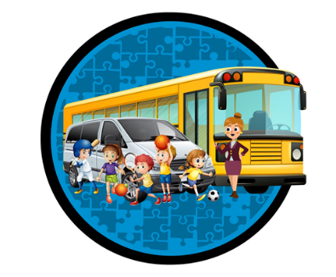
“SAFE, RELIABLE AND PERSONALIZED TRANSPORTATION FOR KIDS AS WELL AS CHILDREN WITH SPECIAL ABILITIES.”
www.kidsonwheels.ca 647-224-2879 info@kidsonwheels.ca

APPLICATION FOR PRIVATE TRANSPORTATION 2020 – 2021

Child’s first name: |  | Child’s last name:
Home Address: |  |  | Apt#:
Postal Code: | City: | Home phone:
Date of Birth: MM/DD/YYYY | Gender: | Child’s Health Card:

Mother’s name: | Work #: | Cell #:
Email Address:
Father’s name: | Work #: | Cell #:
Email Address:

Emergency contact name: |  | Relationship to child:
Phone #: | Drop-off location:

Does your child have allergies/medical history that we should be aware of/or could require
immediate treatment? If so, please specify:

Morning Pick up Address:
Drop-off daycare/school Name: | Phone#:
Address:

Afternoon Pick up Address:
Drop-off daycare/school Name: | Phone#:
Address:

Start date: |  | End Date: |  |  | Grade:
Supervision Begins: |  | Bell Time AM: |  |  | Bell Time PM:
Mon: | Tues: |  | Wed: | Thurs: |  | Fri:

Notes/ Comments:

Booster seat required: YES / NO
Special needs if any:
Signature of parent/guardian: | Date:

