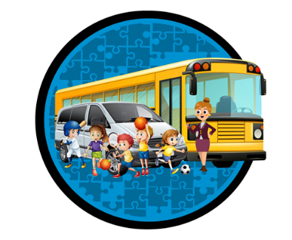
“SAFE, RELIABLE AND PERSONALIZED TRANSPORTATION FOR KIDS AS WELL AS CHILDREN WITH SPECIAL ABILITIES.”
www.kidsonwheels.ca 647-224-2879 info@kidsonwheels.ca

APPLICATION FOR PRIVATE TRANSPORTATION 2021 – 2022

Child’s first name: |  | Child’s last name:
Home Address: |  |  | Apt#:
Postal Code: | City: | Home phone:
Date of Birth: MM/DD/YYYY | Gender: | Child’s Health Card:

Mother’s name: | Work #: | Cell #:
Email Address:
Father’s name: | Work #: | Cell #:
Email Address:

Emergency contact name: |  | Relationship to child:
Phone #: | Drop-off location:

Morning Pick up  Address: | Afternoon Pick up  Address:
Bell Time AM: Supervision begins: | Bell Time PM: Supervision ends:
Morning Drop-off  Daycare/school/ special program Name:  Address:  Phone#: | Afternoon Drop-off:  Daycare/special program/ home Name:  Address:  Phone#:

Start date: |  | End Date: |  |  | Grade:
Mon: | Tues: |  | Wed: | Thurs: |  | Fri:

- Kids on Wheels reserve the right to take pictures for media purposes

Does your child have allergies/medical history that we should be aware of or could require immediate treatment? If so, please specify:

Booster seat required: YES / NO
Special needs if any:
Notes/ Comments:

Signature of parent/guardian: | Date:

