Organize Your Freezer to Save Time and Money
Pam Cantrell Apple Valley Ward

- What You Will Learn
  - How leveling up your food storage must involve your freezer
  - The advantages of buying in bulk for your freezer
  - How to package food for your freezer for best efficiency (time/money)
  - How to manage your freezer food inventory
  - How to save frozen food in the event of a power outage

- Level Up Your Food Storage
  - Level I: Immediate (60 days)
    - Mostly fresh or frozen food
    - 60 days of meals + 3 days of water (minimum)
    - Integration of freezer, refrigerator, and pantry
  - Level II: Short Term (1-2 years)
    - Canned goods including home canned, dehydrated foods, frozen foods, some home freeze dried foods
    - Vacuum sealing, oxygen absorbers, bins
    - Shelf stable foods in original packaging
  - Level III: Long Term (Beyond 2 years)
    - Grains, beans, rice, powdered milk, sugar, etc.
    - 5 gallon buckets, mylar bags, #10 cans of freeze dried foods

- Buying in Bulk
  - Big box stores—Costco, Sam’s Club, US Foods Chefstore, Walmart, etc.

- Packaging Frozen Foods—buy big, package small
  - Determine serving size and package individual servings to family size

- Managing Freezer Inventory
  - Use graph paper to represent bins. Enter number of packages and mark off as you use.

- Saving Freezer and Refrigerator Food During a Power Outage
  - See video below. Set up backup power via gas/solar generator.

- RoseRed Homestead Videos
  - Level Up Your Food Storage https://youtu.be/2vAaB0182z0
  - Organizing Our Freezer https://youtu.be/ESH59p5Ya60 (Shows our “before” freezer and then how we package veggies for the new organization plan.)
  - Sharing Our Freezer Organization https://youtu.be/P8moLjVued4 (Shows two freezers, two different ways to organize, and our inventory system.)
  - Preparing Chicken for the Freezer https://youtu.be/M8N8KRCV8Gc (shows prepping for the freezer as well as broth for the freezer and for canning. We also captured some explosive siphoning in the canner in this video!)
  - Make & Freeze Cilantro Chicken https://youtu.be/-T9Knmsfgag
  - RRH Class: Efficient Multiple Meal Prep https://youtu.be/NURf-KE3-q0 (We make over 20 meals for our family in one operation.)
  - Powering Our Freezers Off Grid https://youtu.be/3sPIpzalLms (Shows our family of 4 Bluetti solar stations and which work to power our freezers. Shows setup with solar panels.)
  - Food Safety During a Power Outage https://youtu.be/8hxxwVOweos (Shows how long cold/frozen food will last in a power outage.)

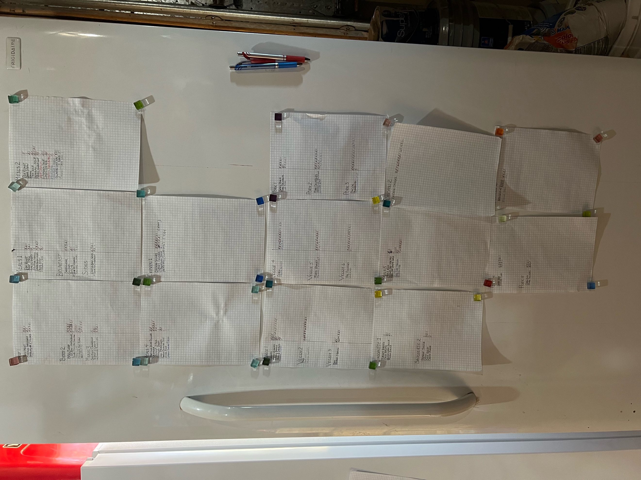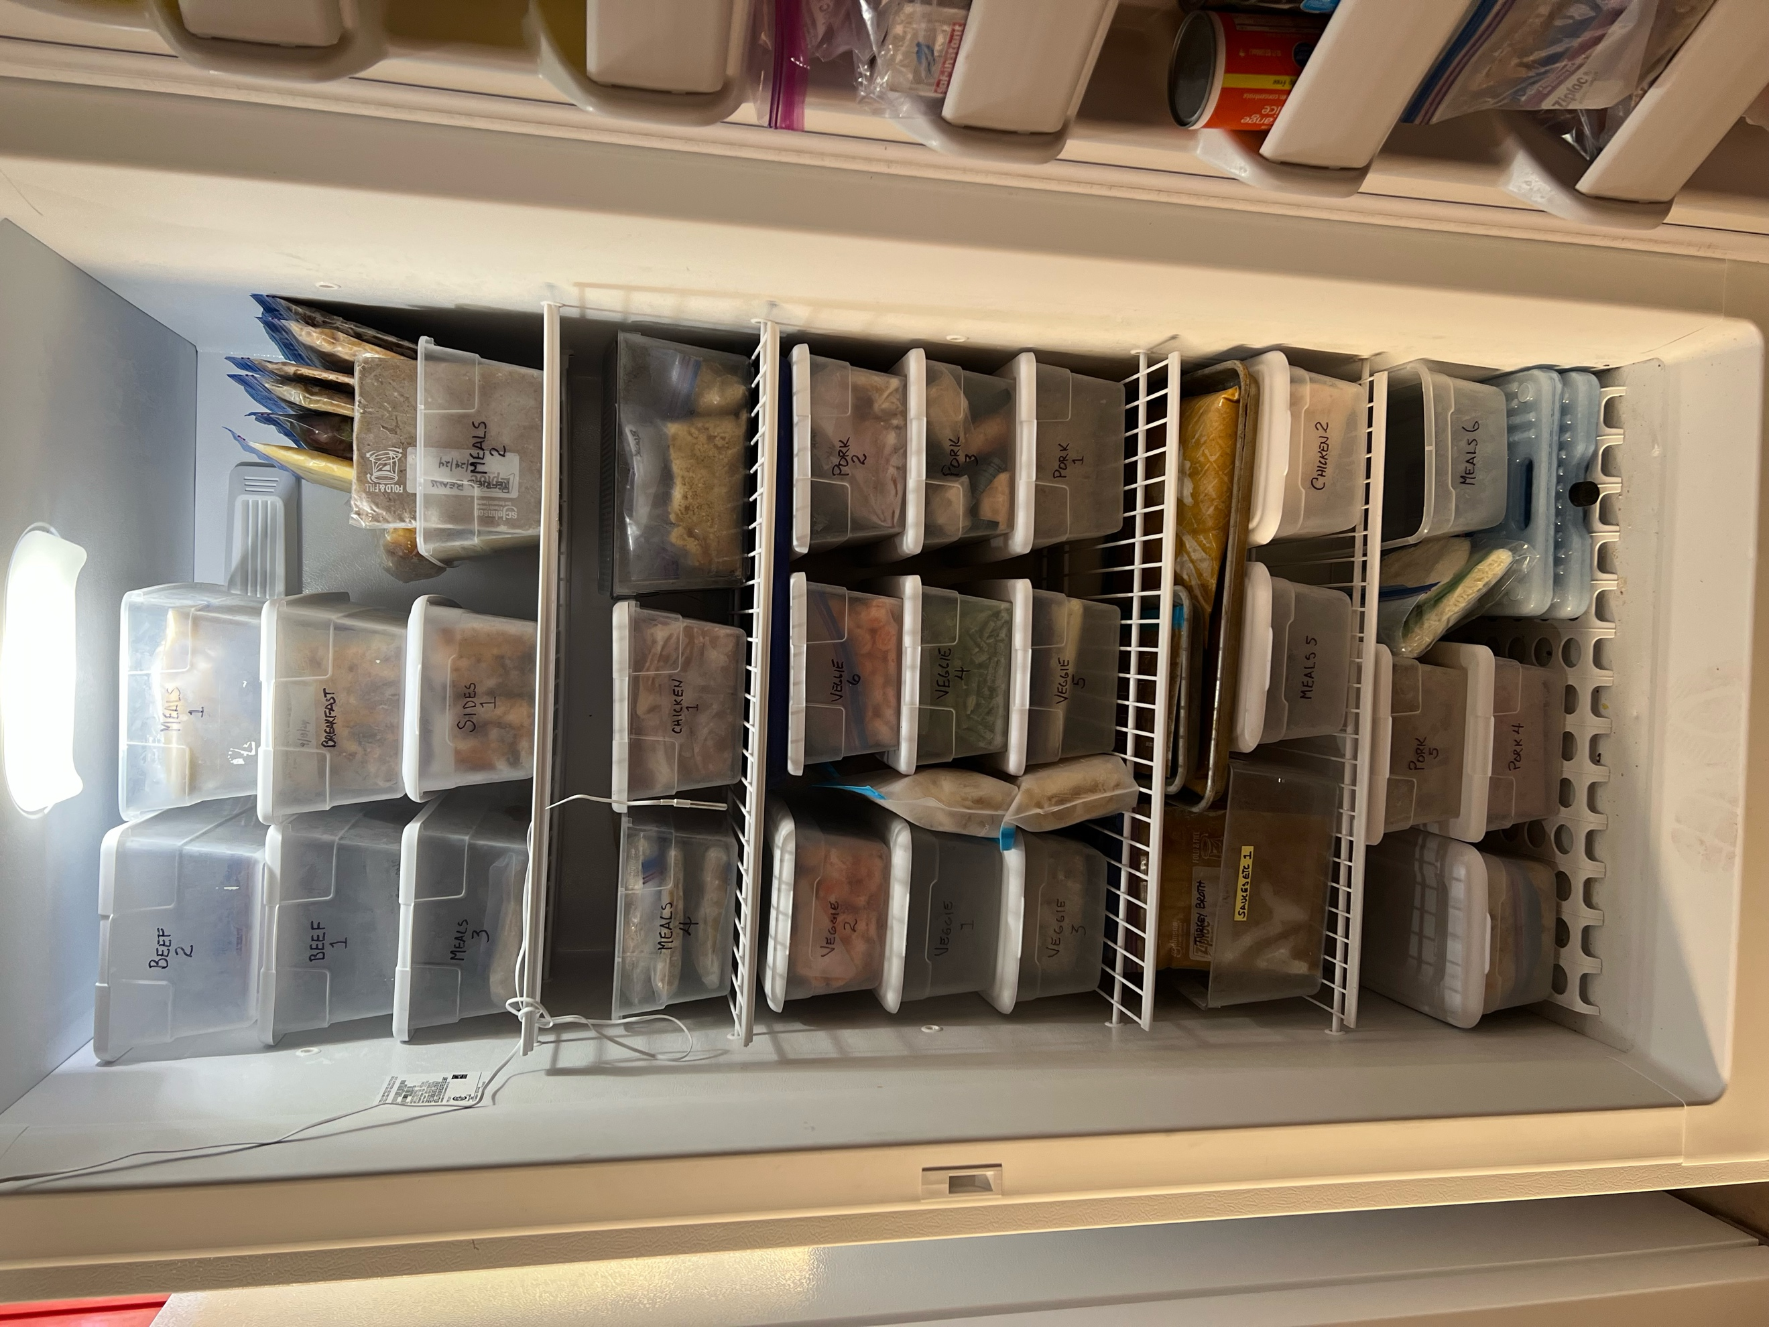
Freezer with inventory pages Inside view

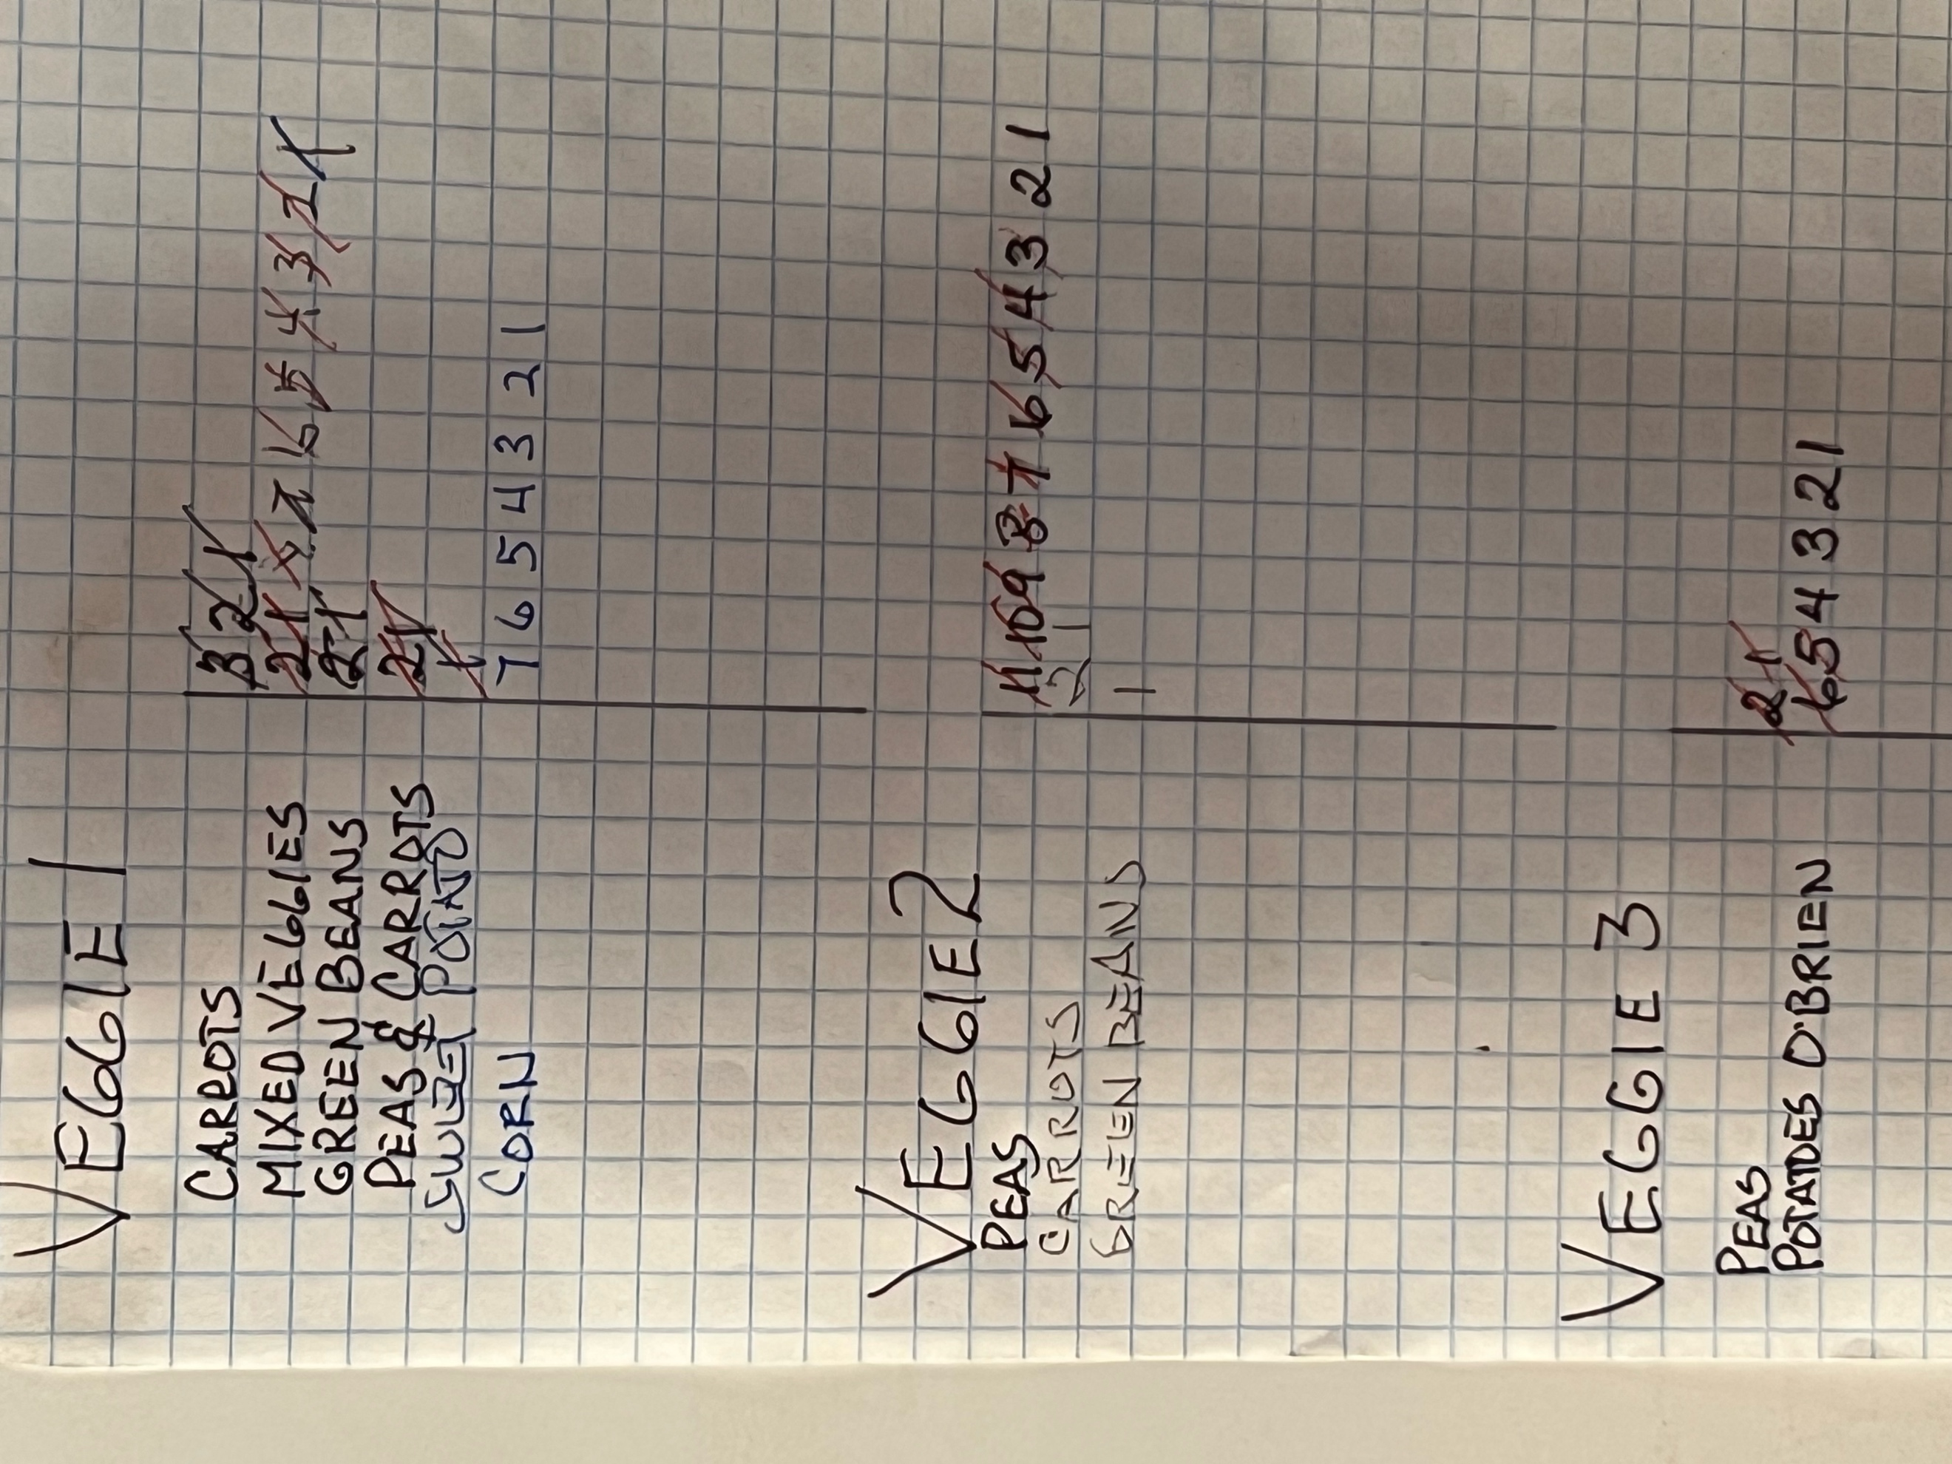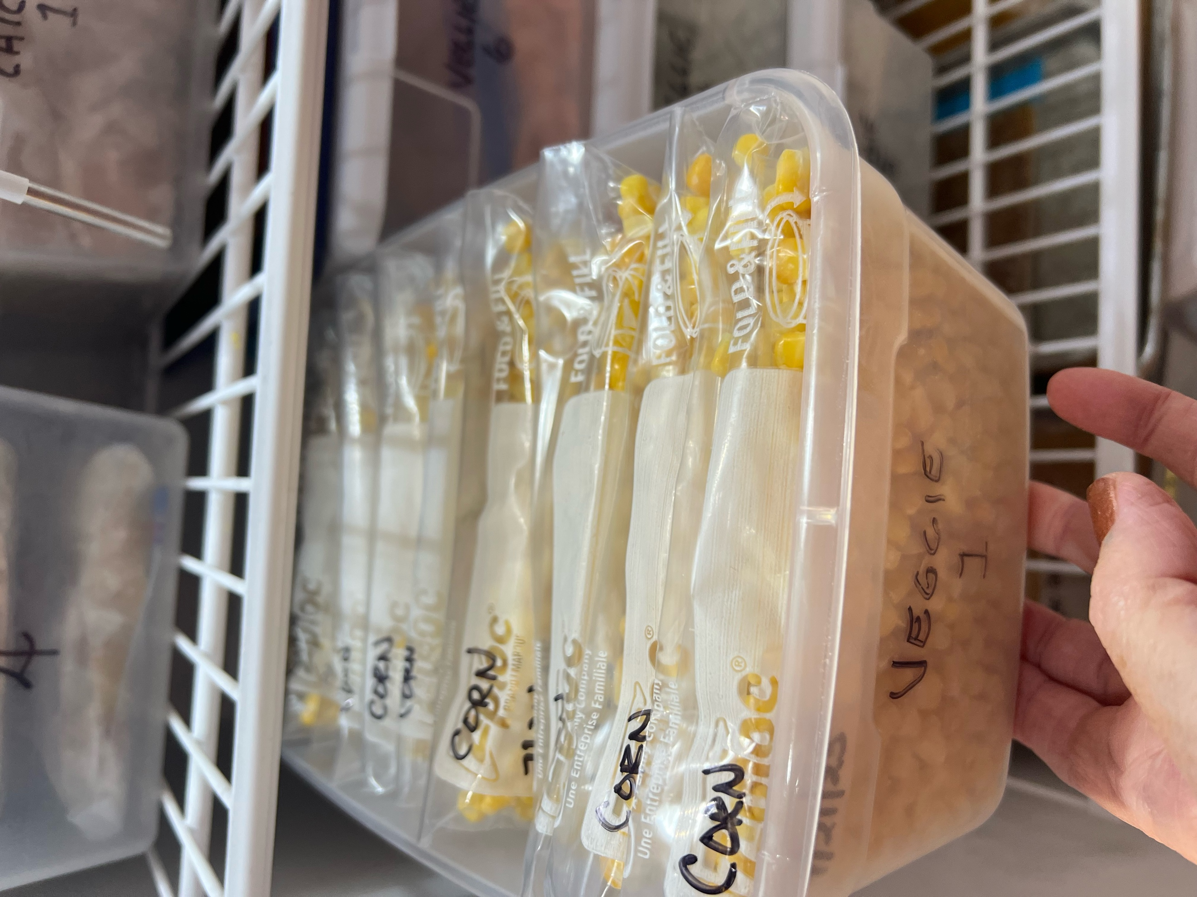
Closeup of Inventory Sheet Closeup of Veggie 1 Bin
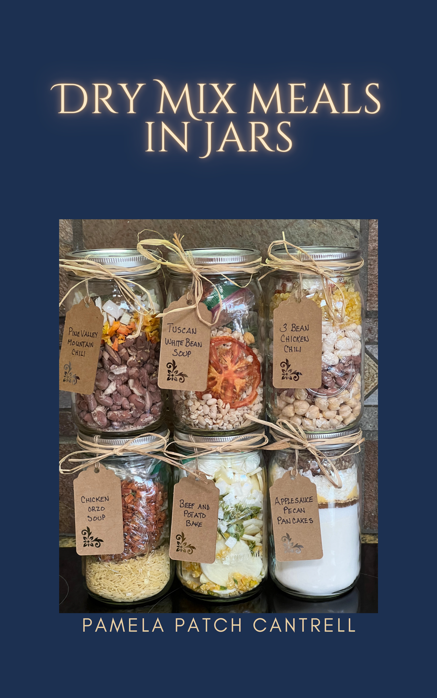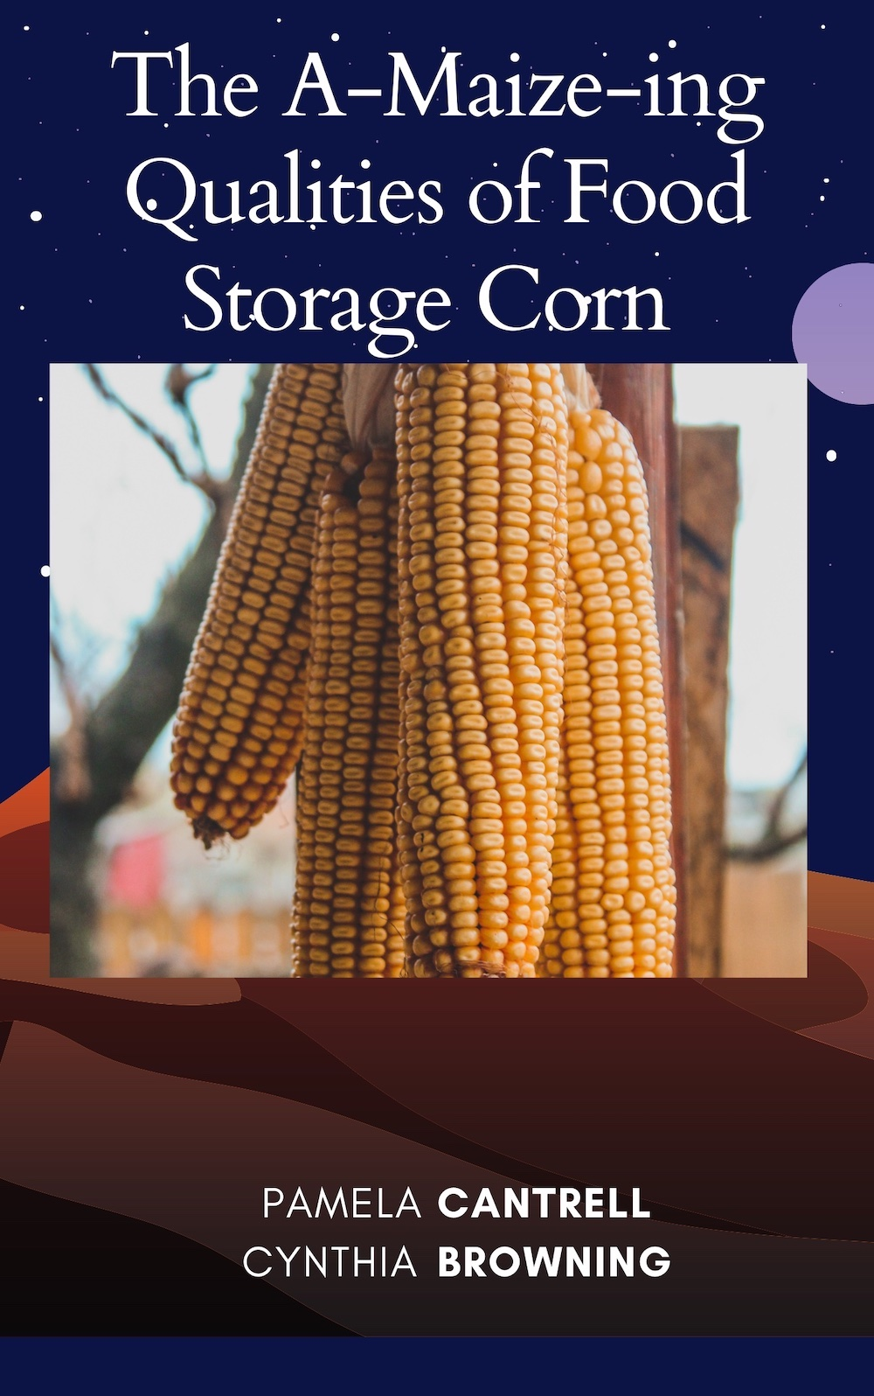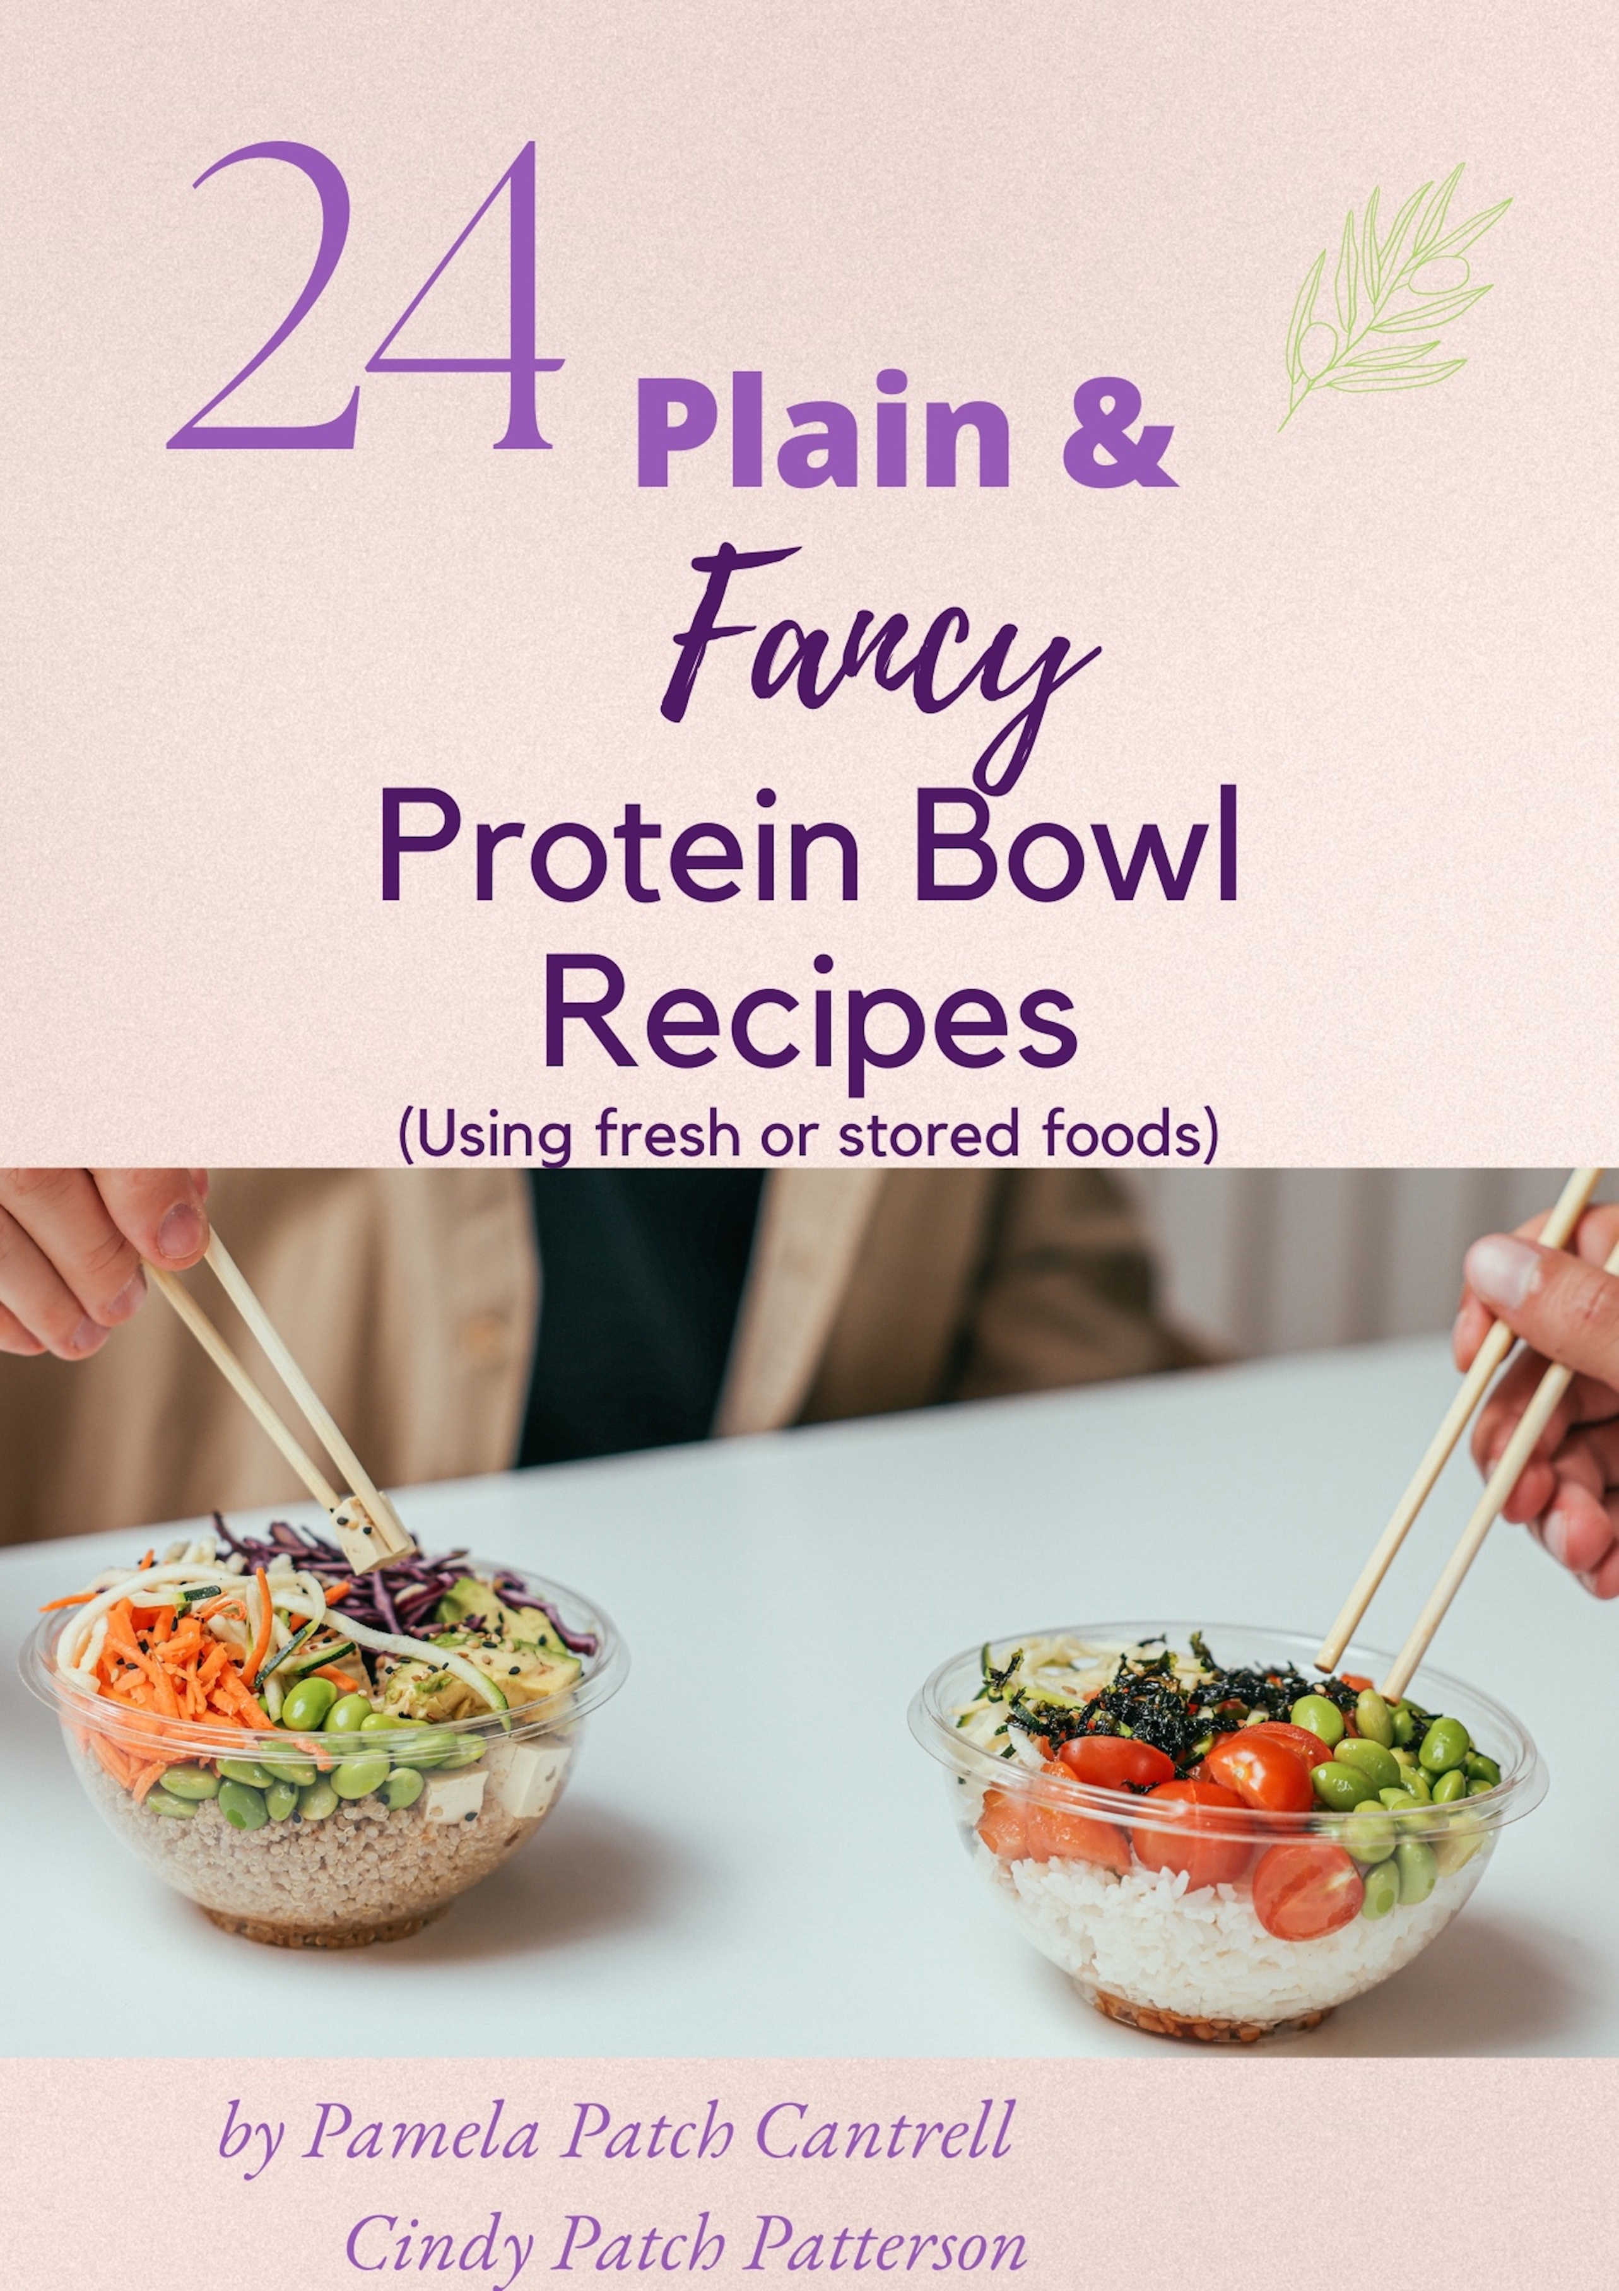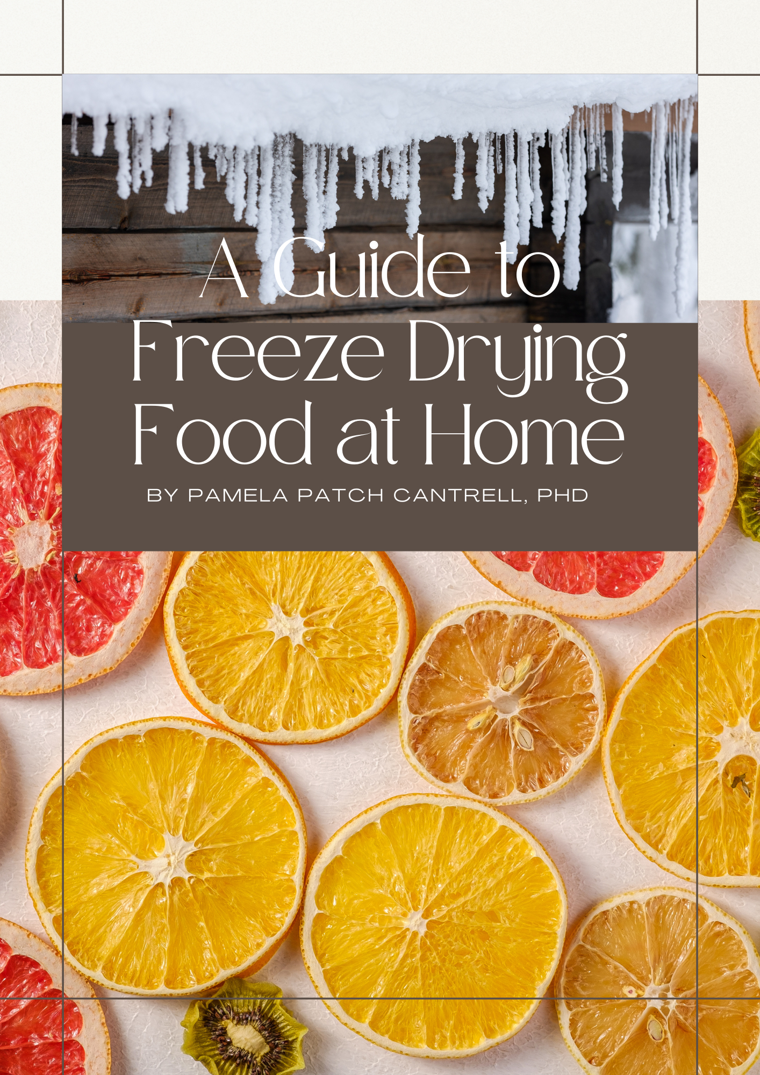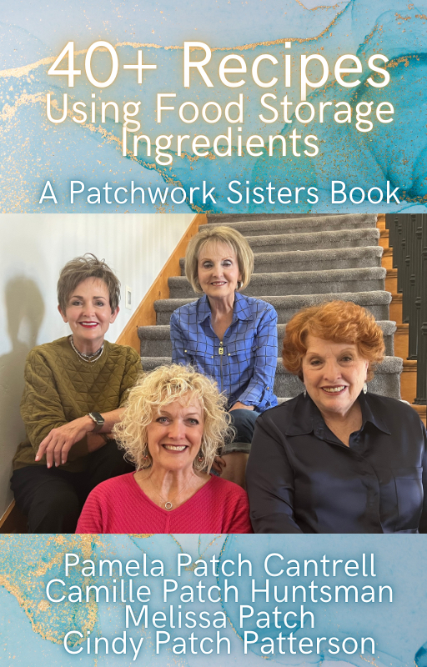

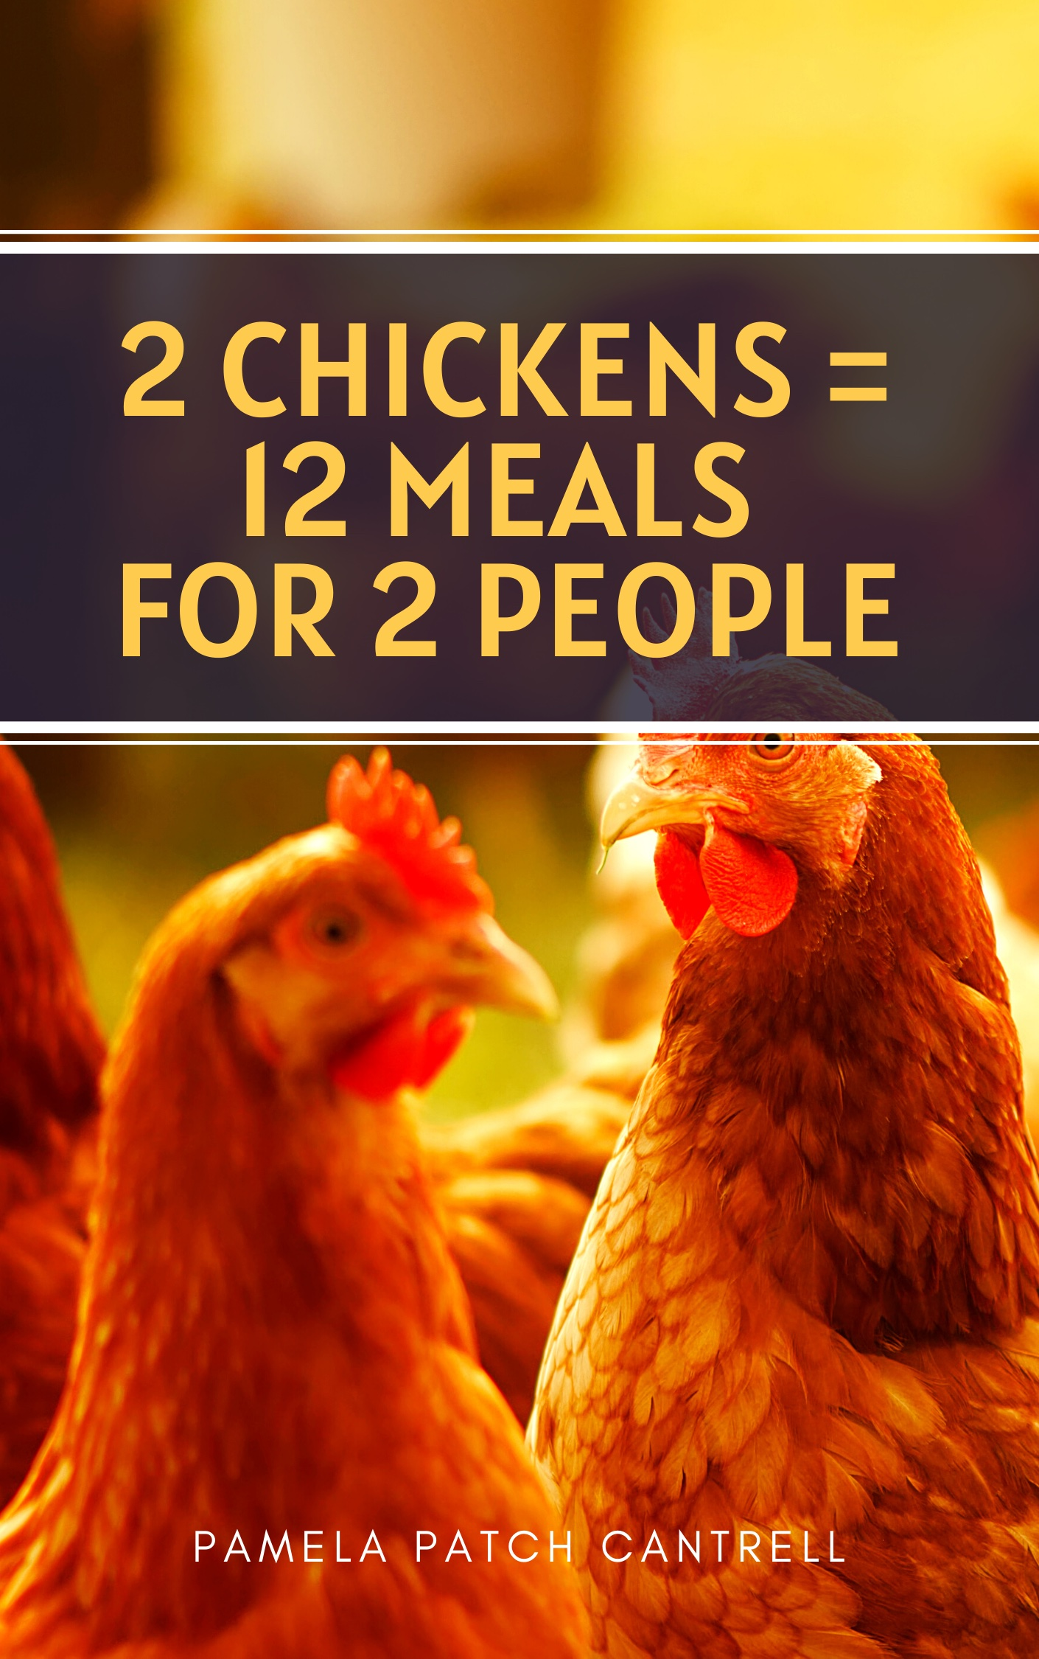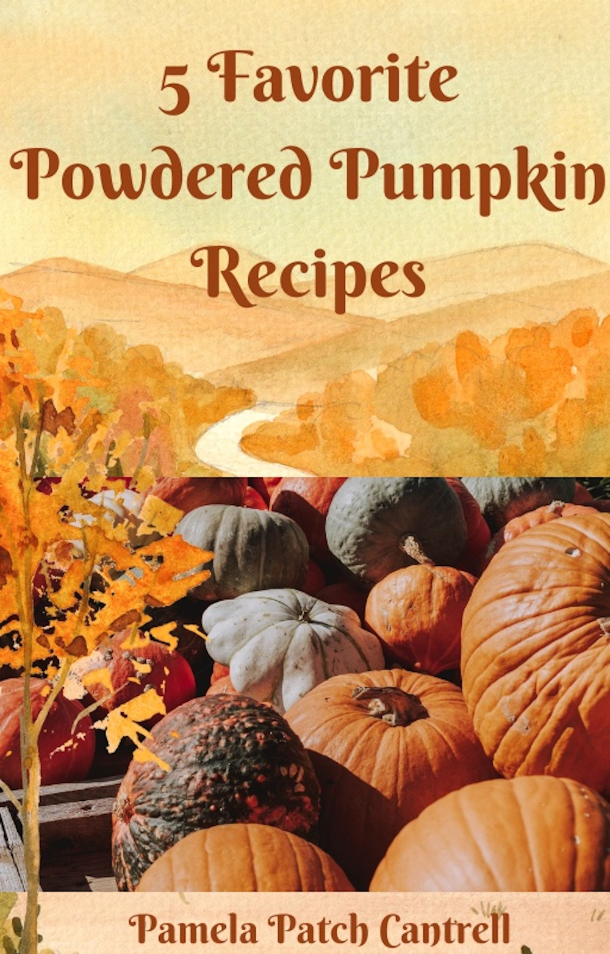
https://www.youtube.com/roseredhomestead

Website: www.roseredhomestead.com

Bookstore: https://payhip.com/roseredhomestead

https://www.youtube.com/roseredhomestead
Bookstore: https://payhip.com/roseredhomestead

https://www.youtube.com/roseredhomestead
Bookstore: https://payhip.com/roseredhomestead

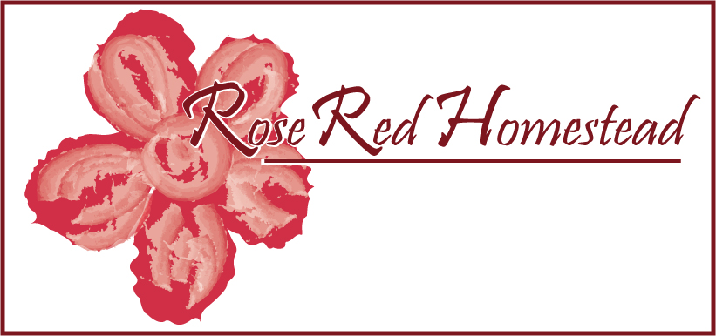
https://www.youtube.com/roseredhomestead

Website: www.roseredhomestead.com

Bookstore: https://payhip.com/roseredhomestead

https://www.youtube.com/roseredhomestead
Website: www.roseredhomestead.com
(Amazon Store link on home page)
Bookstore: https://payhip.com/roseredhomestead

