Meal Planning

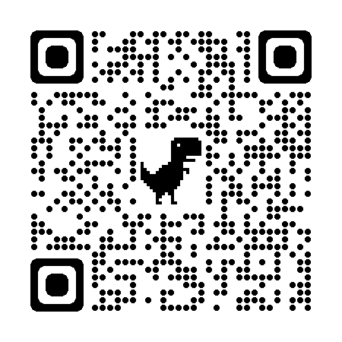
Principles
- Balance-My Plate Guidelines—use QR code at right for more info
- Nutrition-Nutrient Density- complex carbs, lean protein, healthy fats
- Variety-Try new foods and food combinations
- Flexibility-Scrap the meal plan and eat cake!
https://www.myplate.gov/
Steps
- Plan
  - Know family preferences and dietary constraints
  - Know what you have on hand in your freezer, refrigerator, pantry
  - Plan and calendar meals
  - Identify all ingredients needed for recipes
  - Make grocery list and go shopping
- Prepare
  - Large batch vs small batch cooking/prepping
  - From scratch or pre-prepared
  - Double dip ingredients throughout the week
  - Double dip equipment use
- Preserve
  - Love your leftovers—make intentional leftovers
  - Build supply of ingredients for future meals in your freezer as you go

Practice Exercise
Select a day when your family is at home and plan for breakfast, lunch, and dinner.

Menu | Ingredient List | Shopping List
Breakfast

Lunch

Dinner

Below, draw a plate diagram of each of your meals.
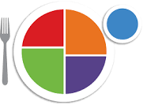
Dinner
Breakfast
Lunch

Menu for 3-Day Trailer Trip
Menu | To Take | Shopping List
Monday  Breakfast (at home)  - Yogurt and granola  Lunch (at camp)  - Cottage cheese  - Ham & cheese rollups  Supper (at camp)  - Pot roast  - Fruit salad | Cottage cheese  Deli ham  Colby cheese slices  Pot roast dinner (freezer)  Cantaloupe  Bananas  Home canned pineapple  Apples  Strawberries | Cantaloupe  Bananas  Strawberries  Deli ham
Tuesday  Breakfast (at camp)  - Mini ham & cheese quiche  - Toast  Lunch (on the trail)  - Pinwheel sandwiches  - Chips  - Veggie strips  Supper (at camp)  - Mexican Stuffed Pasta Shells  - Cottage cheese and pears | Quiches (freezer)  Loaf of bread  Ghee  Honey  Pinwheel sandwiches (pre-made and wrapped in foil)  Bag of veggie strips (carrots, celery, jicama)  Stuffed shells (freezer)  Can of pears  Salsa | Jicima  Canned pears  Chips
Wednesday  Breakfast (at camp)  - Instant oatmeal cups  - Toast  Lunch (at camp)  - Quesadillas  - Fruit  Supper (at home)  - Beef stroganoff (freezer)  - Corn (freezer)  - Sliced tomatoes | Oatmeal cups (pre-made)  Flour tortillas  Cheddar cheese, shredded
Snacks  - Dehydrated fruit  - Fig bars  - Cookies  - Crackers & cheese  - String cheese | Dehydrated apples  Dehydrated mixed fruit  Fig bars  Cookies  Wheat Thins  Colby cheese slices  String cheese | Fig bars  Cookies  Wheat Thins  String cheese
Menu | Ingredients Needed | Shopping List
Example menu item:  - Pinwheel Sandwiches | Flour tortillas  Mayo  Greek Yogurt  Ranch seasoning  Chili powder  Deli ham  Deli turkey  Colby cheese slices  Swiss cheese slices  Baby spinach | Deli ham  Sliced Swiss cheese

