Safely Adjusting Tested Recipes
Part I: Learn

Where to find tested recipes
- USDA Complete Guide to Home Canning
  - Free download: https://nchfp.uga.edu/publications/publications_usda.html#gsc.tab=0
  - RRH Amazon Store: https://amzn.to/3TH7EC0
- All New Ball Book of Canning and Preserving https://amzn.to/47gPpq6
- Other Ball Blue Books and Bernardin books
- State Extension Offices
- Healthy Canning website: https://www.healthycanning.com/
- See RRH video: Finding Tested Recipes Online https://youtu.be/5rWZW9fwIFw

Guided Notes

- Are all tested recipes, even from years ago, safe to use today?

- What are the parameters for the following substitutions or additions?

  - Herbs and spices

  - Salt and sugar
Stronger

pH of Canning Acids
Cider vinegar 3.1
White vinegar 2.4-3.4
Lime juice 2.8
Lemon juice 2.0-2.6

  - Acids

  - Types of fresh peppers

  - Types of onions

  - Jar size

Part II Apply

How to update an older tested recipe
- Compare the ingredients to today’s standards. If all ingredients are currently used, go to the next step.
- Locate a similar recipe among current tested recipes and check the proportions for each ingredient. Adjust proportions to match current recipe.
- Compare the process to today’s standards. If the process is identical, proceed. If not, adjust to current process standards, or abandon the recipe.
Here are 2 recipes from the Ball Blue Book 1999. To the right of each one, explain any changes you would make and what your final choice would be about whether or not you would can it.

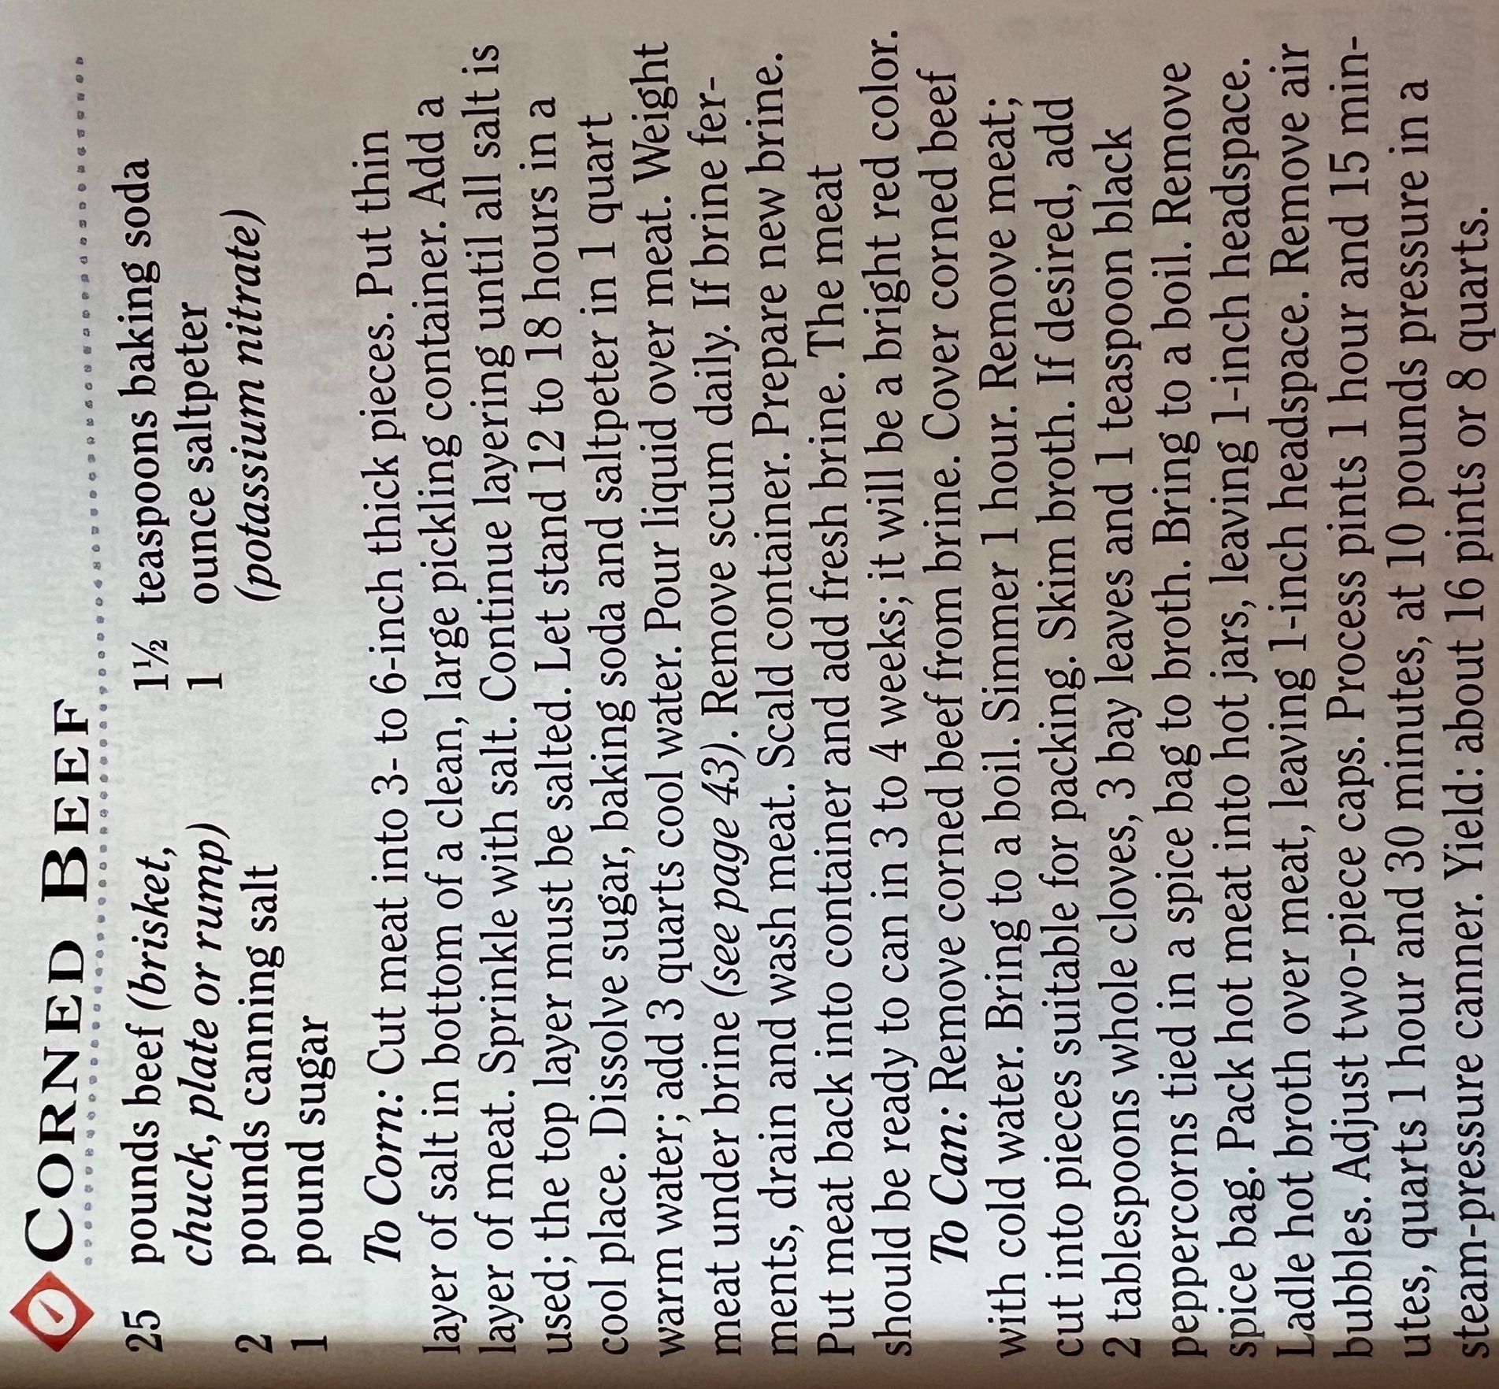

Part III Learning Check
Circle YES or NO for each question and explain your answer.
- The USDA has a tested recipe for bottling apple juice and I want to add some fresh ginger for taste and health. Is it safe? Yes. No.

- The tested recipe calls for 1 tbsp cider vinegar for acidification. I plan to substitute 1 tsp lemon juice. Is it safe? Yes. No.

- I am following the USDA tested recipe for canning pinto beans and plan to add 1 strip of bacon to each jar. Is it safe? Yes. No.

- I found an old recipe that I love and it matches a current tested recipe except that it calls for 2 tsp salt. I want to reduce the salt to ½ tsp. Is it safe? Yes. No.

Part IV: Review
- Don’t shorten processing time.
- Don’t use a processing method other than that which has been recommended (don’t water bath when the directions call for a pressure canner).
- Don’t use a pressure cooker (electronic or otherwise) instead of a proper pressure canner (don’t do it even if the manufacturer says it is okay).
- Don’t use a pressure canner if water bath is called for (for quality reasons).
- Don’t add food items that alter a recipe in ways other than seasoning.
- Don’t add thickener when a recipe does not call for it.
- Don’t use a type of thickener other than the recipe allows for.
- Don’t use fresh herbs when the recipe specifies dried unless the recipe says you may.
- Don’t can food items for which there are no modern tested recommendations.

Related RRH videos
Safely Canning Your Own Soup Recipes: https://youtu.be/UgetgOVcQVk
Making Sense of Low Acid vs. High Acid Foods: https://youtu.be/hYKyhnWBRCA

