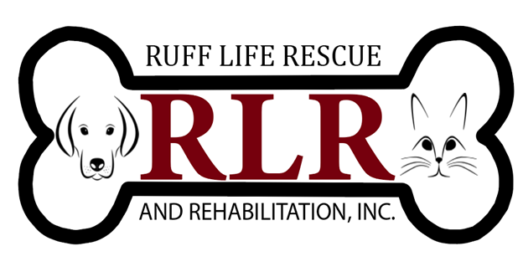
Ruff Life Rescue & Rehabilitation, Inc.
Thank you for your interest in providing volunteer services to Ruff Life Rescue!

Name: ____________________________________________________________
Address (City, State, & Zip): __________________________________________________________________
Cell Number: _______________________________________________________
Email address: ______________________________________________________
Do you have a Facebook Account: _____Yes _____No
Although we always need foster homes so we can save more dogs and cats, we also need assistance with many other areas. Every volunteer is important to our organization. These are some of the volunteer opportunities available:
• Areas of interest (check all that apply):
- Animal foster home (Please check one) Dogs/Puppies __ Cats/Kittens __
- Fundraising/Events
- Transportation of animals (from foster home to vet appointments, adoption events, etc. (Valid driver’s license & proof of insurance required)
- Checking references for potential adopters/fosters
- Matching potential adopters with available dogs/cats
- Follow up on adopted dogs/cats
- Grant writing
- Social Media
- Posting dog/cat bios on our Facebook page
- Video & Photography for dog/cat bios
- Veterinary or Veterinary Tech Experience
- Foster Buddies Program (support as needed for current fosters)
Cats_____ Dogs_____ Both_____; Weekly _____ Daily _____ Over-Nights _____
As Needed_____; In-Home _____ Foster’s Home_____
- Other (specify) ____________________________

Acknowledgement and Waiver of Liability/Confidentiality

Please read, sign, and date below. In signing, you are waiving certain rights and you are urged to do so only if you are financially able to be responsible for your injuries or illnesses.

Animals behave in unpredictable ways when injured, ill, frightened, or agitated. This can be especially true for animals being housed in a shelter environment and subject to numerous strangers.

For my safety and that of the animals, I agree to the follow Ruff Life Rescue’s instructions for safe animal handling.

I further acknowledge that I am aware of the risk of physical injury that can result from feral or domesticated animals and I have assumed all risks of being in proximity to animals.

I agree to hold Ruff Life Rescue & Rehabilitation, Inc., its directors and volunteers, and any third party harmless for any legal or financial responsibilities for any personal injuries or loss of property I may sustain as a result of my volunteer activities.

Volunteers are strongly urged to carry adequate health insurance coverage for any illness or injury that may result from proximity to animals.

For those who do not wish to assume these risks or who do not have insurance, Ruff Life Rescue welcomes your interest in volunteering for activities that will not bring you in close proximity to animals.

I grant permission to add my email address to Ruff Life Rescue’s newsletter. You will have the option to unsubscribe to this newsletter at any time.

I irrevocably authorize Ruff Life Rescue to copy, exhibit, publish or distribute my likeness in any photograph in any and all of its publications, written or electronic, including but not limited to websites and social media.

I further acknowledge that I will abide and follow all rules and procedures set forth by Ruff Life Rescue.

I am aware of my obligation to respect confidentiality. I know that I am obliged to maintain the absolute confidentiality of personal, confidential and proprietary information. I further agree to not disclose such information even after my participation with Ruff Life Rescue has ceased. I further agree to comply with all privacy laws and regulations, which apply to the collection, use and disclosure of personal information.

Signature: _________________________________________ Date: ___________________

Ruff Life Rescue & Rehabilitation Witness Signature: __________________________________

