Solstice Recreation Group
Marine Adventure Guide Training

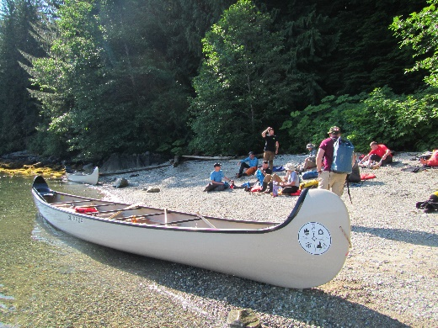
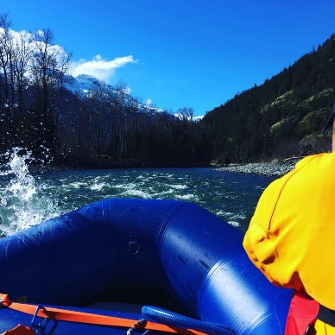

Certifications include:

- White Water Rafting Guide Certification or
- Sea Kayak Day Guide Certification
- Big Canoe Day Guide
- Swift Water Rescue Training Certification
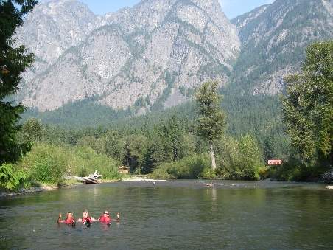
- Marine First Aid Certification
- Expedition Essentials Course
- SDV-BS (Formerly SVOP)
- Marine Radio Operator (ROC-M)
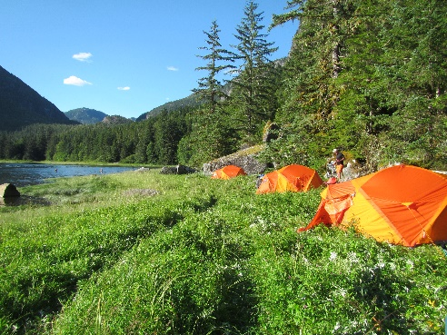
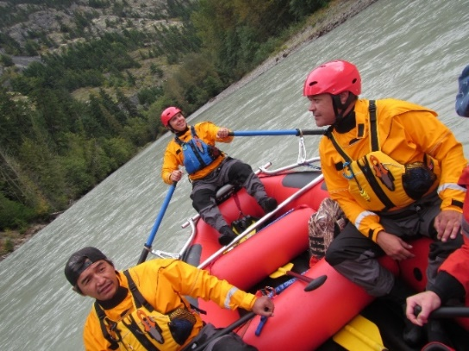

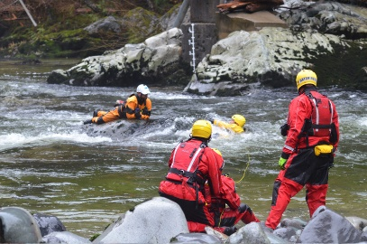
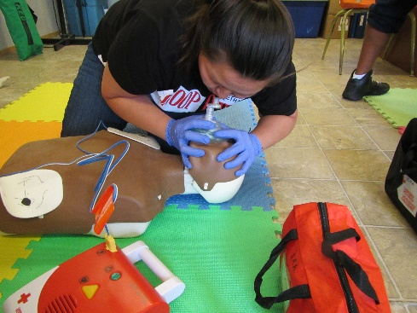

Contact us: 250-218-1513 or email info@solsticerecreationgroup.com www.solsticerecreationgroup.com

Details: Course runs M-F 8:30 – 4:30 daily. Training last for 17 – 20 days. All equipment included, personal items (wetsuits, dry suits, PFD’s, helmets, manuals). Funding is available through eligible sponsorship agencies.

Our training partners:
