Solstice Recreation Group
River Adventure Guide Training – Bella Coola Valley

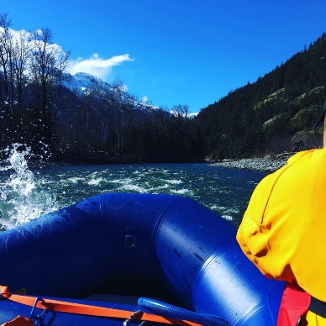
April 26 – May 11,2021
August 30 – Sept.21,2021
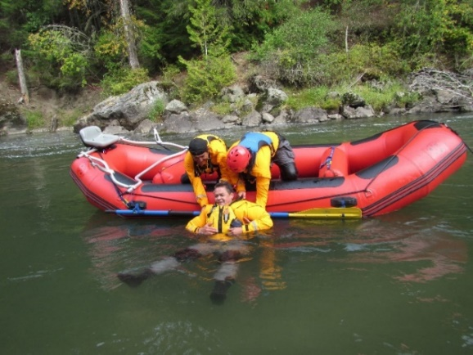
Certifications include:

- White Water Rafting Guide Certification
- Swift Water Rescue Training Certification
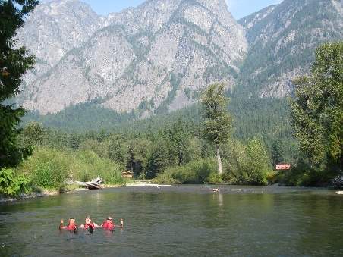
- Standard First Aid Certification
- Commercial Bear View Guide Certification
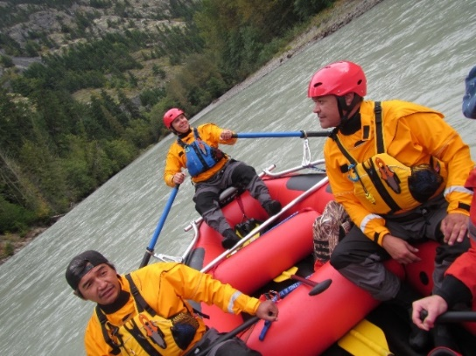
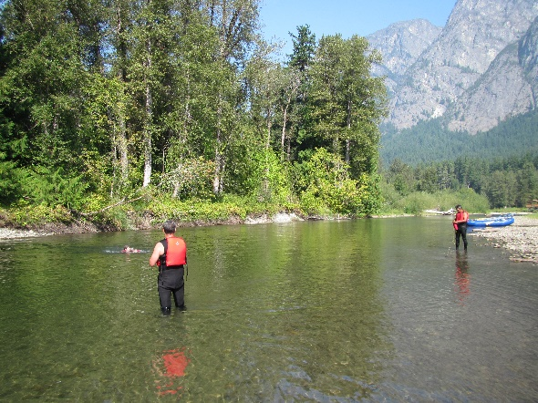

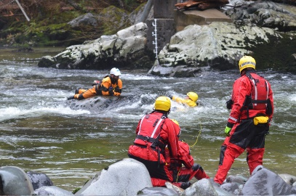
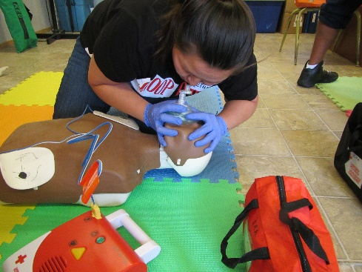

Contact us: 250-218-1513 or email info@solsticerecreationgroup.com www.solsticerecreationgroup.com

Details: Course runs M-F 8:30 – 4:30 daily. All equipment included, personal items (wetsuits, dry suits, PFD’s, helmets, manuals). Funding is available through eligible sponsorship agencies / First Nation Education.

All Training is in accordance with the BC Commercial River Rafting 2002 Guide, Transport Canada’s – Special Purpose Vessel Regulations SOR / 2008 – 121. NFPA 1006 / 1670 guidelines are also adhered to with training. Solstice Recreation Group is a member of the BC River Outfitters Association

Our training partners:
