*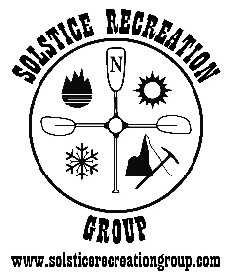Solstice Recreation Group*

2020 Adventure Guides Training

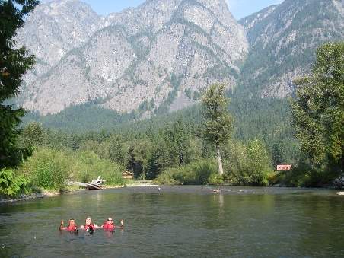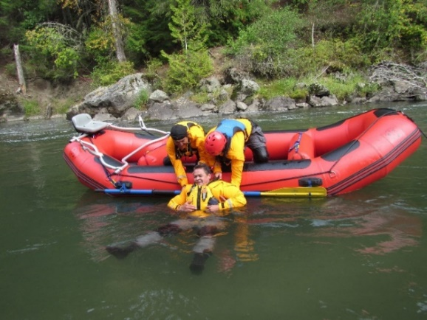

***Employment and Leadership Skills***

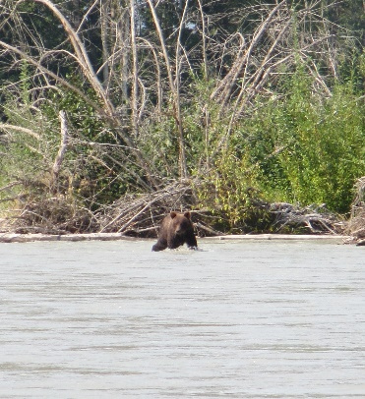 ***Certifications Include:***

* 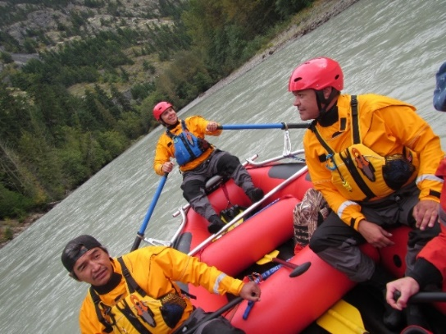**White Water Rafting Guide Training (Class 2)**
* 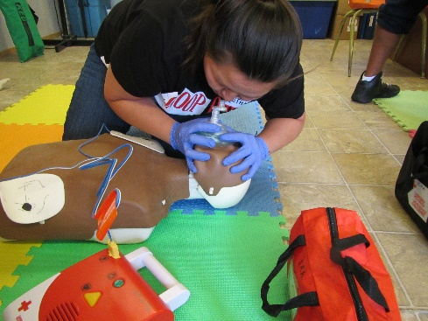**Swift Water Rescue Training**
* **Marine Basic First Aid (MBFA)**
* **Commercial Bear View Guide Certification**

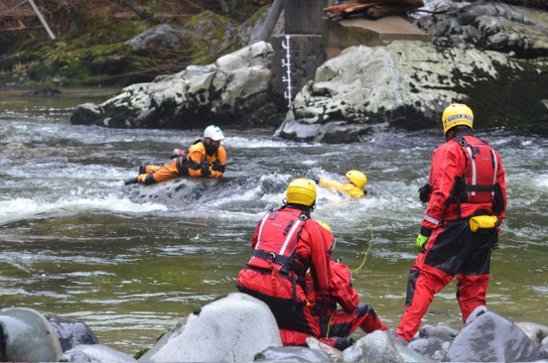

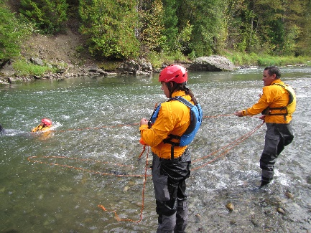

**Location - Bella Coola Valley, (July 6 – July 26)**

**Cost:** $3950.00 plus GST

**Funding -** Band Education Sponsorship, EI Sponsorship (WorkBC), ISETS Sponsorship available.

**Details: -** All course transportation, and equipment is provided.

Please visit [www.solsticerecreationgroup.com](http://www.solsticerecreationgroup.com) for course application and further details.

**Contact us:** 250-218-1513 or email [**info@solsticerecreationgroup.com**](mailto:info@solsticerecreationgroup.com)

*All training in accordance with the Registrar of Commercial River Rafting of British Columbia (2002) and Transport Canada Commercial River Rafting Regulations (2007). Swift Water Rescue Training is in accordance with NFPA Regulation 1006 / 1670 (2017).*

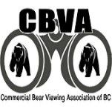**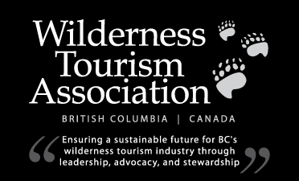***Our training partners:*

**BC River Outfitters Association** 