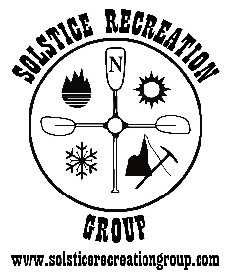
Solstice Recreation Group
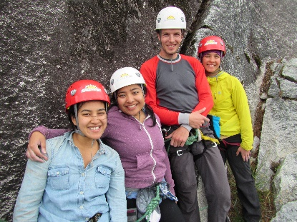
Adventure Guides Training

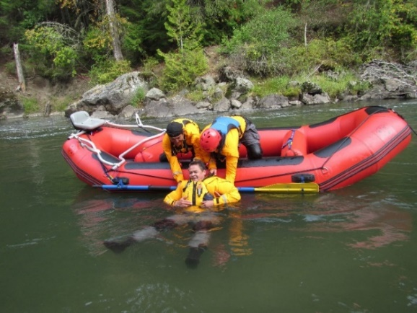
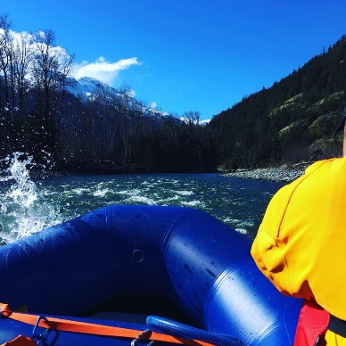
Employment and Leadership Skills
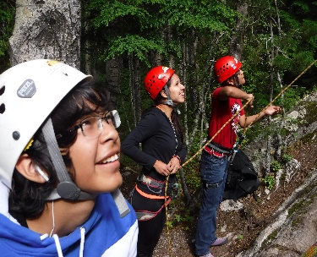
Certifications Include:

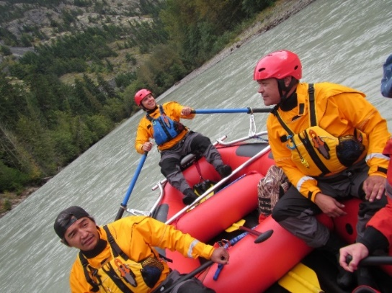
- White Water Rafting Guide
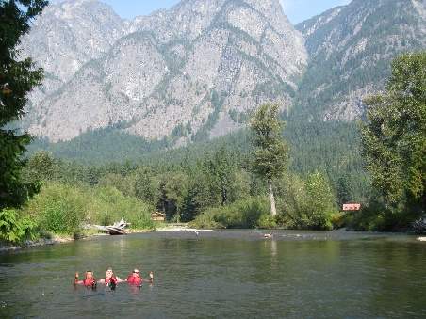
- Swift Water Rescue Training
- Rock Climbing Belay Cert.
- Wilderness First Aid
- Marine Basic First Aid (MBFA)
- Commercial Bear View Guide Certification
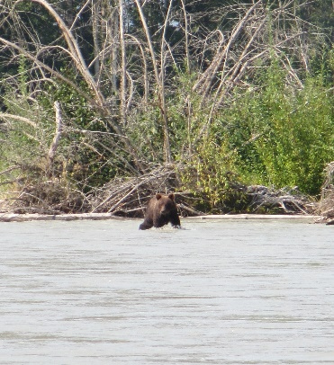
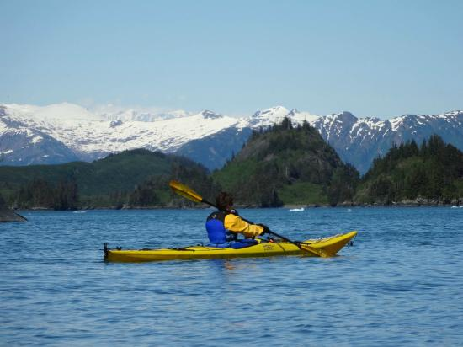
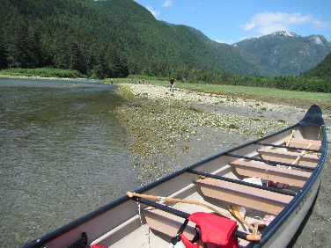
- Sea Kayak Instructor Certificate
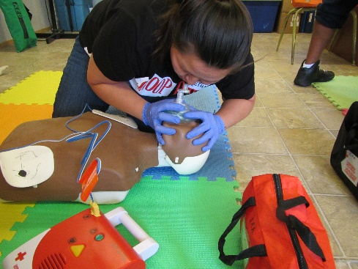
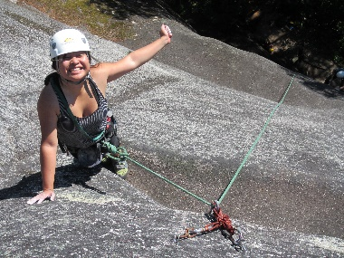
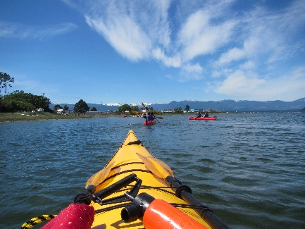
- Big Canoe Instructor Certificate

Intake # 1 March (Campbell River), Intake #2 June (Bella Coola), Intake #3 Sept. (C.River)
(April 6 – May 8) (July 6 – Aug. 7) (Sept 8 – Oct. 9)

Funding - Band Education Sponsorship, EI Sponsorship (WorkBC), ISETS (MCFNTS / NVIATS / TRICORP) Sponsorship available.

Details: - All course transportation, snacks, and equipment is provided. Please visit www.solsticerecreationgroup.com for course application and further details.

Contact us: 250-218-1513 or email info@solsticerecreationgroup.com www.solsticerecreationgroup.com
Our training partners:
